From: Acton, Michael Rex [mailto:michael.acton@dnvgl.com]
Sent: 17 March 2015 14:47
To: Jane Haswell; g.goodfellow@penspen.com
Cc: neil.jackson@nj-se.co.uk
Subject: Surveillance graph in IGEM/TD/2

Jane, Graham

I spotted that the graphs for the surveillance factors are different in Edition 1 and Edition 2 of IGEM/TD/2 (PD8010 Pt 3 is not quite identical to either of them). I wasn’t aware that any new work was done on surveillance factors between the two editions of TD/2, so I think it must be an IGEM printing/plotting error.

This is how it appears in TD/2 Edition 2:
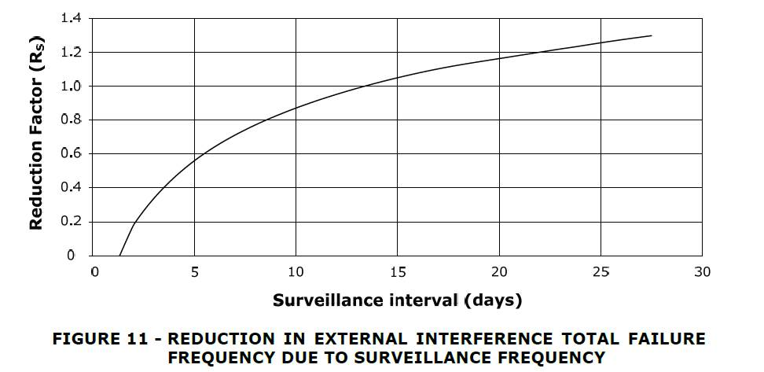

The problem came to light because a client is making daily surveillance patrols, which apparently eliminates the risk from third party damage completely according to TD/2.

I’ll say that this version is wrong and that Edition 1 is correct, but do you think this should be corrected sooner than the next major revision of TD/2?

If Graham agrees, perhaps Neil could add this to the agenda for the next FARWG in Ambergate.

Regards,

Mike

for GLIS UK Ltd.
Dr. Mike Acton B.Sc., D.Phil., C.Phys.
Senior Principal Consultant
Risk Advisory Services
DNV GL – Oil & Gas

