UKOPA GOOD PRACTICE GUIDE
Managing Encroaching Development and Societal Risk Around Pipelines
Part 1 – Population adjacent to Ethylene Pipelines

1 Introduction

As codes and standards for cross-country pipelines have developed since the 1960s, assessment of the risk to population living near major accident hazard pipelines (MAHPs) such as natural gas and ethylene has been included as a requirement. This has resulted in design and routing requirements for pipeline in classified as rural (Class 1) areas, with more stringent design requirements in suburban (Class 2) areas including lower design factor resulting in thicker wall pipe.

Most of the UK ethylene pipeline network was constructed before the population classification and engineering requirements for Category E substances were published in BS 8010 in 1989, so significant sections are location in Class 2 (suburban) populated areas with standard wall pipe rather than thick wall pipe. In addition, subsequent population encroachment has occurred along several sections of pipeline routes since they were commissioned, possibly resulting in higher population categorisation.

During 2012-13, ethylene pipeline operators therefore decided that the network should be subject to population surveys and the resulting population densities compared to maximum allowable population densities based on an assessment of the societal risk criterion F-N line published in PD 8010 Part 3. Comparison with this screening tool allowed any higher population sections to be identified, and some of these sections were subject to site-specific societal risk assessments. Where required suitable additional mitigation measures were identified to reduce the risk.

2 Scope

PD 8010 Part 3 Pages 14-15 states:-

“Societal risk is of particular significance to pipeline operators because the location of pipelines might be close to populated areas, so the impact of multiple fatality accidents on people and society in general should be taken into account. The original routing of the pipeline is expected to have taken into account the population along the route, but infill and incremental developments might increase the population in some sections of the route.

Societal risk assessment allows these developments to be assessed against the original routing criteria where a location class 1 (rural) area has a population density of up to 2.5 persons per hectare. When the societal risk has increased significantly, the pipeline operator might then need to consider justifiable mitigation measures to reduce the risk.

The criterion for societal risk is expressed graphically as an FN criterion line, showing the cumulative frequency F (usually per year) of accidents causing N or more casualties. For application to pipelines, it is necessary to specify a length over which the frequency and consequences of all accident scenarios are collated.

In the absence of product-specific risk curves, it is therefore suggested that the FN criterion line given below should be used to assess societal risk due to MAHPs. This allows the assessment of the residual risk from a specific pipeline to be compared with the risk from the average class 1 pipeline population density (i.e. up to 2.5 persons per hectare) adjacent to each 1 km length of pipeline, where the population is assumed to be located in a strip centred on the pipeline from the Minimum Distance to Occupied Buildings (MDOB), extending out to the hazard distance of the worst case event from the pipeline.”

The societal risk criterion line is therefore the limiting risk level which divides the ALARP risk from the “negligible/broadly acceptable” risk.

F-N curves can be derived for populated sections by assessing the frequency of the various failure mechanisms, the probability of different hole sizes, ignition probability, and consequence events, and from these the frequency of various harmful events causing casualties at various hazard distances from the release point on the pipeline. The calculations generate hazard zones for immediate and delayed fires based on the Maximum Allowable Operating Pressure (MAOP) of the pipeline.

For each release point, there are several events each having a different frequency and each with a different hazard distance. Within each hazard distance (assumed to be circular for fireball and jet fire events, elliptical for flash fire events) any population present are assumed to become casualties. By computing all the different outcomes, each event has its own frequency (f) and causes a different number (N) of casualties at each point along a fixed length of the pipeline.

The various pairs of f and N are then sorted into ascending lists of N, and collated such that the total frequency ∑f for each N is obtained. Finally, the cumulative frequency F is obtained by adding the frequency of ∑f for each value of N, starting with the highest number N and adding the frequency for each reducing number N. This is carried out using the computer code PIPERISK™ software package.

From a series of hazardous events, it is then possible to construct a site specific F-N curve – the frequency of an event (F) causing N or more casualties, which is plotted on a log-log scale. The F-N curve can then be compared with the PD 8010 Part 3 criterion line as shown above. If the F-N curve lies below the criterion line, the risk is considered “negligible/broadly acceptable”. However if crosses the line, then further risk reduction should be considered to reduce the risk. If the cost of reducing the risk proves to be “disproportionate” using established cost benefit analysis, then the risk is considered ALARP – “as low as reasonably practicable”.

3 Applying the F-N Criterion to obtain Screening Limits

A pipeline designed to the maximum stress parameters (design factor 72% SMYS) with the maximum population density of 2.5 persons per hectare outside the Minimum Distance to Occupied Buildings MDOB (as shown below), could be seen as meeting the requirements of PD 8010
.
Pipeline operating at 72% SMYS
Minimum Distance to Occupied Buildings
Minimum Distance to Occupied Buildings
Maximum Hazard Distance from pipeline
Maximum Hazard Distance from pipeline
Population Density 2.5 persons per hectare in this area
Population Density 2.5 persons per hectare in this area
No Population in this area
No Population in this area

This case should therefore align with the maximum population density which still meets the F-N criterion line described above from PD 8010 Part 3.

Several of the UK ethylene pipeline design parameters were assessed by increasing the MAOP to a level such that the design factor became 72% SMYS, and the population outside the MDOB was set at 2.5 persons per hectare.

In each case the societal risk F-N curve was assessed and it was shown that the curves were just below the criterion line from PD 8010 Part 3, as shown below.
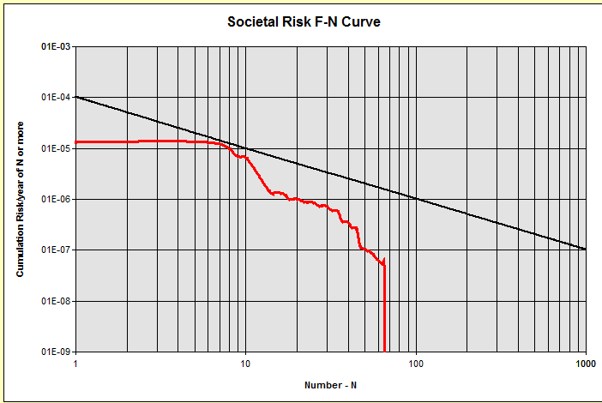

This demonstrated that a pipeline which satisfies the design and population requirements of PD 8010 also meets the societal risk requirements of PB 8010 Part 3.

However, most of the ethylene pipelines in the UK have a design factor which is significantly below the maximum of 72% SMYS. As a result the societal risk F-N curve is well below the PD 8010 criterion line for a population density of 2.5 persons per hectare outside the MDOB.

It is therefore possible to increase the population density beyond 2.5 persons per hectare, and still meet the PD 8010 Part 3 F-N criterion line. This allows a higher population to be tolerated next to lower stressed pipelines.

By incrementally increasing the uniform population above 2.5 per hectare until the derived F-N curve just touches the criterion line, it is then possible to derive the limiting population which just meets the PD 8010 criterion line.

This uniform population density can then typically be applied for screening purposes in 100m sections as shown below, in this case with the uniform population density applying to the areas immediately adjacent to the pipeline:-
Maximum Population
= 12 persons in this section

= 4 persons
per hectare
Pipeline
100 m
300m
Maximum Population
= 12 persons in this section

= 4 persons
per hectare
100 m
300m
NO POPULATION IN THIS SECTION
Pipeline
100 m
300m
Maximum Population
= 24 persons in this section

= 8 persons
per hectare
100 m
300m

Because several hazard scenarios have a maximum hazard distance less than 50m, if there is a buffer zone of 50m between the pipeline and the population, the outer area population can be higher and still meet the criterion as shown below:-

Maximum Population
= 30 persons in this section

= 12 persons
per hectare
Pipeline
100 m
250m
Maximum Population
= 30 persons in this section

= 12 persons
per hectare
100 m
250m
No Population
No Population
50m
50m
NO POPULATION IN THIS SECTION
Pipeline
100 m
250m
Maximum Population
= 60 persons in this section

= 24 persons
per hectare
100 m
250m
No Population
50m

So if there is population within 50m of the pipeline (i.e. no buffer zone) the highest level of risk is applied to this population and so the maximum population density within the whole 300m hazard zone is relatively low.

If there is no population within 50m of the pipeline but there is population between 50m and 100m (i.e. 50m buffer zone) the limiting population between 50m and the hazard distance of 300m can be significantly higher than with no buffer zone, and still meet the F-N criterion line limit.

Similarly if there is no population within 100m, but there is within 200m, the limiting population between 100m and the hazard distance of 300m can be higher still, although the increase is less significant than between no buffer and 50m buffer, because the reduction in risk between 50m and 100m is less significant.

A smaller reduction applies for the case where there is no population within 200m, but there is some within 300m.

The screening process was carried out by assessing the population in 100m sections adjacent to the pipeline out to a distance of ~300m each side of the pipeline (this being ~ the typical maximum HSE outer zone distance for ethylene pipelines).

4 Population Surveys and Screening Limits

Population surveys along the route of the pipelines were carried out by two methods:-

a) Aerial survey – surveys were carried out by RSK Orbital of several of the ethylene pipelines using fixed wing aircraft. The results were transferred to Google Earth maps showing the pipeline route and black dots within the specified hazard zone identifying every populated building which could be interrogated to show details and population count. The results were further analysed to show the population in 100m steps along the pipelines within specified distances from the pipeline, as shown below.

The resulting population within any 100m step was then compared with the maximum permitted populated calculated from the PD8010 Part 3 risk criterion line for the population proximity (within 50m, 50-100m, 100-200m, 200m-300m). If the actual population was below the specified limit, the result was “OK” and if above the limit the result was “Exceeded”. In the case shown below, the village section exceeded the limit for Rural (Class 1) population, but this section was constructed in heavy wall pipe, so the population limit was much higher, and this was not exceeded by the village population, so the result was “OK”.

Note that occasional buildings were identified within the 50m MDOB, as shown in the example below. In this case the risk was considered acceptable.

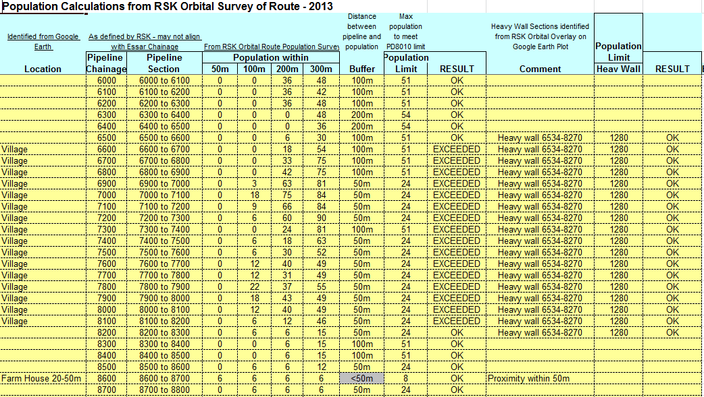

Using this approach, some sections which exceeded the limit for extended length could be identified and these were then subjected to site specific assessments.

b) Manual survey – detailed maps of the pipeline route were updated with current populated developments, and the population clusters were identified along the pipeline route. Sections which exceeded the population limits were then identified, and subjected to site-specific assessments. This method tended to result in more site specific assessments, as well as taking more time to carry out the route assessment.

Care was applied when clusters of population were identified along the pipeline route, such as large gathering places (e.g. supermarkets, leisure parks or sports stadium) which might have very large populations for limited duration, or large vulnerable populations (schools, hospitals, or care homes) where evacuation in an emergency would be difficult. These were subject to site-specific assessment.

In one case, it was also possible to take account of a lower operating pressure (MAOP) in a downstream section resulting in lower stress levels and therefore pipeline failure rate, so the maximum allowable population was higher.

Use of the lower operating pressure along the route of the pipeline only applies to point-to-point (i.e. one way direction) dense-phase ethylene pipelines because it would take several hours to pump up the pressure to the MAOP in the whole pipeline if the delivery end valve is closed, and instrumented alarm and trip systems are in place to stop the pumps in the event of unexpected pressure rise along the route of the pipeline.

5 Site-Specific Societal Risk Analysis

If the actual average population in several adjacent 100m sections was found to significantly exceed the calculated limits, or a vulnerable population cluster was identified, then a site-specific assessment was carried out. This required detailed population assessment along the identified section such that the location relative to the pipeline could plotted on a chart, and the detailed F-N curve calculated using PIPERISK™ for the actual population in that section.

In most cases, the population section was identified using Google Earth and divided into 100m sections so that the population could be transferred onto the risk grid, as shown below.

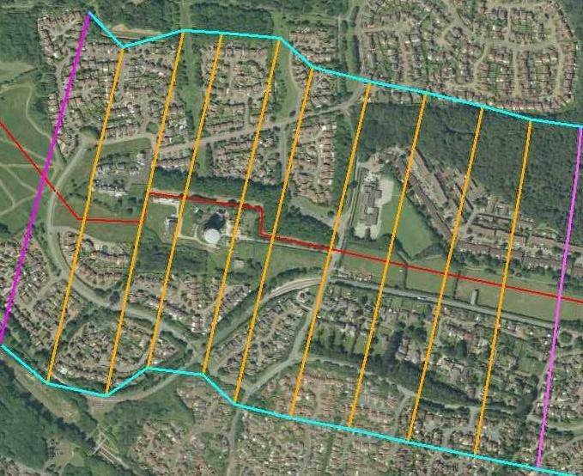

This population was then transferred to the risk plot as shown below:-

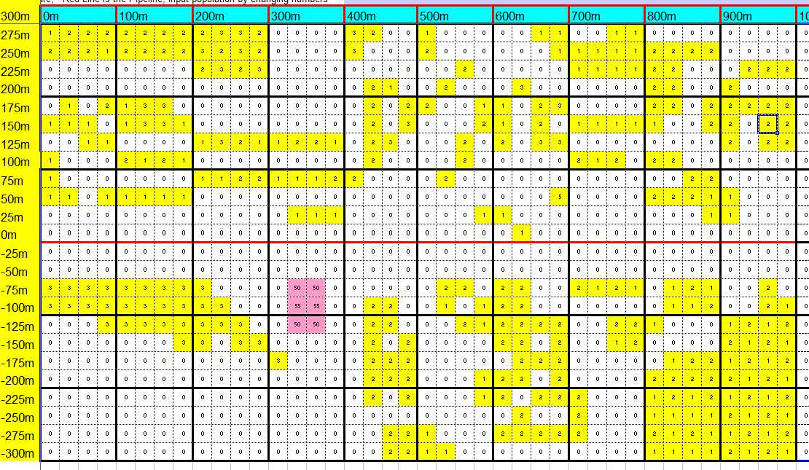

PIPERISK™ was the used to derive the F-N Curve as shown below:-

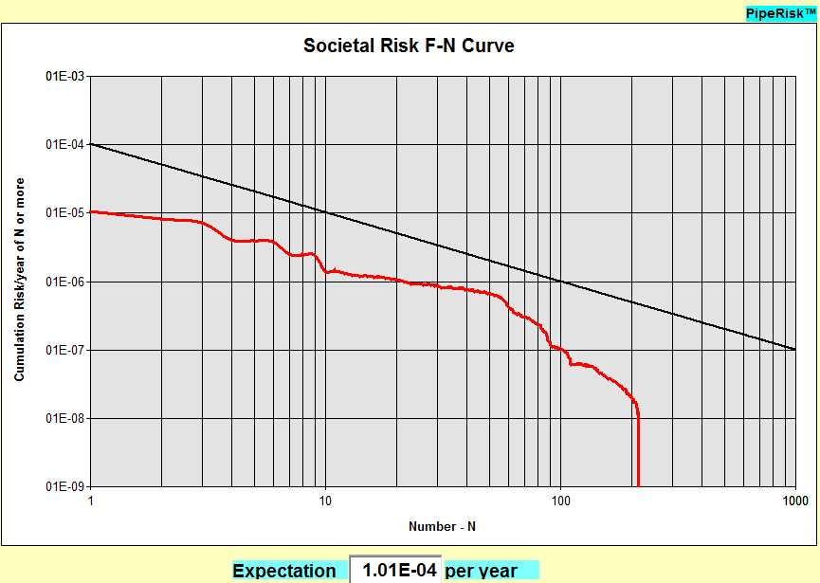

The F-N curve is significantly below the PD 8010 Part 3 Criterion line, so in this case, the populated section is within the requirements and no further risk reduction need be considered.

A few cases were found to be close to the limit, and in these cases risk reduction measures were recommended. Such measures can include:-

- Increase awareness of landowners and occupiers of the location of the pipeline
- Improve marker posts and visible evidence of the pipeline
- Increase the surveillance frequency to reduce probability of external interference to the pipeline
- Increase the depth of cover over the pipeline
- Provide concrete slabbing over the pipeline
- Re-lay the pipeline in thick-wall pipe
- Divert the pipeline round the populated areas.
One risk reduction applied to several sections of ethylene pipelines is an increase in surveillance frequency, to weekly rather than 2-weekly.
PD 8010 Part 3 provides the following risk reduction curve for external interference resulting from increased surveillance:-

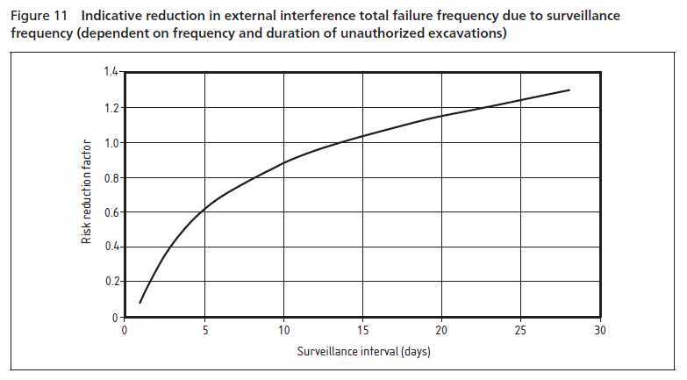

6 Conclusion

This paper has explained the way in which ethylene pipeline operators have reviewed the risks from existing and encroaching population adjacent to their pipelines. It has described a robust methodology using a published risk criterion to define whether the existing situation is “broadly acceptable” or if further risk reduction needs to be applied to specific populated sections. In most cases the existing situation has proved satisfactory, but in a few cases further risk reduction measures have been considered.

R A McConnell

8 June 2015

Revised 10 September 2015

