UKOPA/GP/XX
Edition 0.1

UK ONSHORE PIPELINE OPERATORS’ ASSOCIATION - INDUSTRY GOOD PRACTICE GUIDE
ASSESSING RESIDUAL DRAIN-DOWN FROM OIL PIPELINES

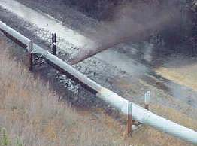

Comments, questions and enquiries about this publication should be directed to:

The United Kingdom Onshore Pipeline Operators’ Association
Pipeline Maintenance Centre
Ripley Road
Ambergate
Derbyshire
DE56 2FZ
e-mail: enquiries@ukopa.co.uk

Document History | Date
Edition 0.1 | February 2016

Planned revision date February 2017

Disclaimer
This document is protected by copyright and may not be reproduced in whole or in part by any means without the prior approval in writing of UKOPA. The information contained in this document is provided as guidance only and while every reasonable care has been take into ensure the accuracy of its contents, UKOPA cannot accept any responsibility for any action taken, or not taken, on the basis of this information. UKOPA shall not be liable to any person for any loss or damage which may arise from the use of any of the information contained in any of its publications. The document must be read in its entirety and is subject to any assumptions and qualifications expressed therein. UKOPA documents may contain detailed technical data which is intended for analysis only by persons possessing requisite expertise in its subject matter.

Copyright @2016, UKOPA. All rights reserved

CONTENTS

CONTENTS 3
1 INTRODUCTION 4
2 SCOPE AND APPLICATION 4
2.1 Scope 4
2.2 Application 4
3 STAGES OF DRAIN-DOWN FOLLOWING A LEAK 5
3.1 Stage 1 – Leak identification, pumps operating 5
3.2 Stage 2 - Pipeline contents depressurisation 5
3.3 Stage 3 - Vacuum-induced drain-down 5
3.4 Stage 4 - Gravity-induced drain-down. 5
4 CALCULATION OF VACUUM AND GRAVITY DRAIN-DOWN 6
4.1 Vacuum Drain-Down 6
4.2 Calculation of Vacuum Drain-Down 6
4.3 Effect of Intermediate Valves 8
4.4 Gravity or air-ingress drain-down 8
5 RISK PRIORITISATION APPLIED TO CROSS-COUNTRY VALVES 9
5.1 Size of Leak 9
5.2 Frequency of Leak 9
5.3 Safety Consequences – Populated Areas 10
5.4 Consequences – Environmental Factors 10
5.5 Drain Down Quantity 10
5.6 Current Code Requirements 11
5.7 Optimum Location of Remotely-Operated Valves 12
6 CALCULATION OF DURATION OF DRAIN DOWN BASED ON LEAK RATE 12
6.1 Main Input Data Required 13
6.2 Stage 1 – Calculation of Pressure at Leak Point 13
6.3 Stage 2 – Calculation of Hole Size from Leak Rate 13
6.4 Stage 3 – Pumps are Stopped, Drain-down is Calculated 14
6.5 Stage 4 – Vacuum Drain-down, Calculation of Rate and Duration 14
6.6 Stage 5 - Drain-down Rate and Duration for Gravity Drain-down 14
7 THE DRAIN-DOWN CALCULATOR IN AN EMERGENCY SITUATION 15
8 REFERENCES 16

INTRODUCTION

The need to assess drain-down from an oil pipeline leak is required to allow the location of section isolating valves to be identified as stated in Section 6.12 of PD 8010 (Ref 1) as follows:-
For pipelines designed to convey category B substances, section isolating valves
should be installed at locations which would limit drain down of pipeline contents at any low
point.
UKOPA pipeline operators have further identified that in the event of a leak from a cross-country pipeline, part of the information required to handle the emergency is the quantity of oil which could be released based on the location of the leak, the potential size and duration of the leak, and the effect of closing remotely-operated cross-country valves or manual valves adjacent to the leak point.
A drain-down calculator has therefore been developed to calculate how much would be released at any given location along a pipeline, and the effect of closing adjacent valves. It also allows the optimum location for cross-country valves to be identified.

SCOPE AND APPLICATION

Scope

The guidance in this document is applicable to oil pipelines operated by the UKOPA member companies. These pipelines can be categorised as:
- Crude oil pipelines;
- Refined liquid pipelines, such as multi-product and aviation fuel pipelines.

Application

The guidance in this document represents what is considered by UKOPA to represent current UK pipeline industry good practice within the defined scope of the document. All requirements should be considered to be guidance and should not be considered to be obligatory against the judgement of the Pipeline Owner/Operator. Where new and better techniques are developed and proved, they should be adopted without waiting for modifications to the guidance in this document.

STAGES OF DRAIN-DOWN FOLLOWING A LEAK
Following a leak or rupture of a pipeline when a liquid transfer is taking place, there are four stages of release of liquid -

Stage 1 – Leak identification, pumps operating
The release rate during this period depends on the size of the leak, and on how long it takes before the pumps are switched off. For the worst-case scenario of a large hole or pipeline rupture, the release rate could be as high as the full flow rate, typically varying between 150 m³/hour and 600 m³/hour depending on the pipeline. Response time for the control operator to shut off the pumps depends on how quickly the leak is identified and confirmed, usually by the leak detection system, and confirmation to the operator that the leak is real. For 5 minutes response time, 12-50 m³ could be released.

Stage 2 - Pipeline contents depressurisation
Product oils are slightly compressible, the compressibility of the liquids is ~ 70 x 10⁻⁶ per bar per m³. For typical pumped systems at an average pressure of 50 bar, compressibility volumes which could be released are typically 3.5 m³ per 1000 m³ of pipeline volume.
However the location of the leak point will govern the final residual pressure profile in the pipeline so the quantity released would be lower for high level leak points where the lower sections remain at pressure. Also, operating procedures usually require the delivery terminal valve to be left open so allowing most of the liquid to de-pressurise to the receiving tank.

Stage 3 - Vacuum-induced drain-down
Drain down then starts to occur from the pipeline due to vacuum formation in high points along the pipeline route. The highest points are likely to drain first. Large quantities of liquid (100s of m³) can be released over the period of several hours. This process is described in more detail below.

Stage 4 - Gravity-induced drain-down.
Finally, after the vacuum-induced drain-down has finished, sections of pipeline adjacent to the leak point are then likely to drain due to gravity and air ingress. The amounts are usually much smaller than for vacuum drain-down. Again, this is described in more detail below.

CALCULATION OF VACUUM AND GRAVITY DRAIN-DOWN

Vacuum Drain-Down
The following indication of where drain-down occurs is obtained from a Chevron presentation :
Figure 1 – Drain-Down Along a Pipeline Section
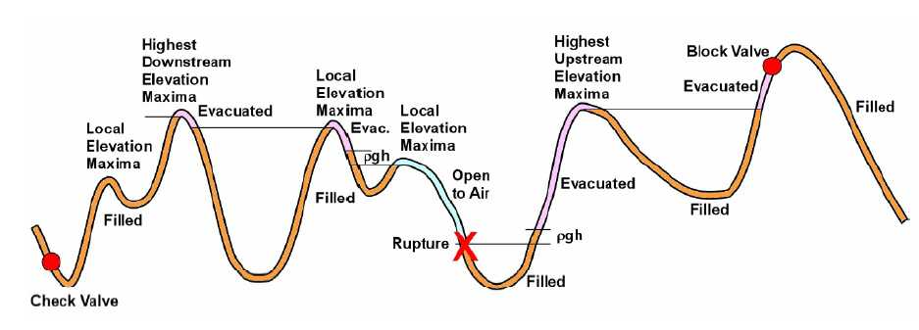
This shows vacuum formation causing vacuum-induced drain-down in the purple sections followed by gravity / air ingress drain-down shown in the blue section. This clarifies where vacuum-induced drain-down occurs and confirms that:-
- Vacuum-induced drain-down occurs due to vacuum formation in downhill sections facing the leak point in both directions along the pipeline.
- Intermediate valleys remain filled with liquid.
- Subsequent high points further away from the leak point only drain-down to the height of the closer high point.
- The ρgh (density x gravitational constant x height) term in the nearest section is the height of liquid equivalent to 1 atmosphere which induces the vacuum above the liquid surface.
- For multi-product lines 760 kg/m³ density is assumed for gasoline so for 1 atmosphere, the height is 13.6 metres, and for aviation fuel 800 kg/m³ the height is 12.9 metres.
The quantity draining down is therefore obtained by calculating the length (and therefore volume) of the purple sections shown in Figure 1 where vacuum has formed.

Calculation of Vacuum Drain-Down
A computer program has been written in Visual Basic using Excel spreadsheet data input and results presentation. The data requirements for the program are:-
- a table of the pipeline elevation above sea level for every 100 metre section along the length of the pipeline – this data is usually available from the x-y-z Intelligent Inspection Tool (pig), and
- a table showing the location (chainage) of the intermediate valves.
To calculate vacuum drain-down quantities, the start point is taken from the leak point, or the chainage at this point from the pumped (or higher pressure) end of the pipeline.
Moving downstream from the leak point in 100 metre steps, the program identifies where the elevation exceeds 13.6 metres (for gasoline) above the leak point. This is the start of a section where vacuum drain down occurs. The program continues downstream until the elevation begins to fall again – this represents the end of the first drain down section, and the distance from the start to end of that section is the length (and therefore the volume) draining down from that section.
The program continues moving downstream until a higher section above the elevation of the end of the previous drain-down section is identified. This is the start of the next section where vacuum drain down occurs. Again the program continues until the elevation begins to fall again – this represents the end of the second drain down section, and the distance from the start to end of that section is the length (and therefore the volume) draining down from that section.
The program continues downstream, identifying all the high points and high elevation sections, until it reaches the end of the pipeline.
The program then starts at the leak point again, and this time moves upstream in 100 metre steps, and identifies where the elevation exceeds 13.6 metres above the leak point in the upstream direction. The program continues upstream until the elevation begins to fall again – this represents the end of the first upstream drain down section, and the distance from the start to end of that section is the length (and therefore the volume) draining down from that section. The program continues upstream, identifying sections which drain down, until it reaches the start of the pipeline.
In this way, all the sections draining down are identified and the total quantity from each direction can be calculated.

Effect of Intermediate Valves
The location of valves (chainage from the pumped or higher pressure end of the pipeline) is entered as part of the input data, and the program identifies the closest valve to the leak point in the upstream and downstream directions.
The program calculates drain-down with the intermediate cross-country valves open and closed as separate operations.
With the valves closed, as the program is stepping along the pipeline, it stops searching for high points when it reaches a valve, so drain-down is reduced when the valves are closed.

Gravity or air-ingress drain-down
Gravity drain down is likely to occur after vacuum drain down, and is a relatively slow process as air ingress replaces the oil in the pipeline.
Figure 3 – Gravity Drain Down in 100 metre Sections
These sections drain down
Leak point
Greater than pipe radius
100 metre sections of pipe
Less than pipe radius
higher
Drain down stops here
Drain down stops here

Figure 3 shows a section of a pipeline in 100 metre lengths. The height of each 100 metre length is recorded as a single value. The calculator assumes that the minimum amount likely to drain out due to vacuum is half the 100 metre section in which the leak occurs.
The computer program then moves in 100 metre steps upstream and downstream identifying sections which are at a higher location than the leak point by more than the pipe radius. If the next section is less than the pipe radius higher than the previous section, gravity drain down is assumed to stop because there is not enough height to drive the liquid out of the leak. Because of this, long flat sections are assumed to not drain out. The pipe radius is used because the pipeline leak is more likely to occur in the top half of the circumference (e.g. due to 3rd party excavation).
If the leak was in the lower half of the circumference, then it would theoretically be possible for long flat sections to drain down due to gravity; however, when actual profile drawings are studied, local undulations in height are evident which would stop local gravity drain down. Such undulations are not apparent when averaged 100 metre heights are used as in this analysis.
For lower sections (i.e. when the pipeline starts to go downhill), gravity drain down is also assumed to stop.

RISK PRIORITISATION APPLIED TO CROSS-COUNTRY VALVES
Following a leak or rupture of a pipeline when a liquid transfer is taking place, there are a number of factors which help to decide whether intermediate valves should be installed: -
a) Size of leak,
b) Frequency of leak - location of leak relative to populated areas or other risks,
c) Safety consequences of leak – location relative to people and populated areas,
d) Location of leak relative to environmental factors, rivers, geology, SSSIs etc.,
e) Quantity likely to drain out,
f) Codal requirements.
Each of these is considered below.

Size of Leak
The size of leak governs the response time required to minimise the leak and therefore whether an intermediate valve would benefit from being remotely-operated rather than manually operated. A remotely-operated valve would be normally be closed 3 to 5 minutes after the leak occurrs whereas a manual valve might take 2 hours for someone to be called out to close it.
A small leak (leak rate less than 5 m³/hour with hole size less than ~ 5 mm circular diameter) would typically take 50-150 hours to drain down, so the benefit of closing a valve remotely rather than manually is marginal. Small holes such as this typically occur due to corrosion or small pipe-wall defects.
For larger hole sizes >25 m³/hour (typically 10-19 mm hole diameter) the benefit of rapidly closing an intermediate valve becomes more apparent, and above 100 m³/hour (hole size 20-35 mm) rapid closure of remotely-operated valves substantially reduces the amount draining down compared to waiting 2 hours to close a valve. Large hole sizes are more likely to occur due to 3rd party excavation, so remotely-operated valves have most benefit when they minimise spillage quantities from areas of higher risk of 3rd party excavation.

Frequency of Leak
Larger leaks due to 3rd party excavations are more likely in populated areas. The UKOPA database indicates that 3rd party excavations causing damage to a pipeline are four times more frequent in suburban areas.
Therefore the requirement for remotely-operated valves is greater where large quantities of product could drain down into lower-level suburban areas.

Safety Consequences – Populated Areas
The safety consequences of a release of highly flammable liquids such as gasoline from a multi-product pipeline are usually considered to have immediate effects (e.g. spray fire, pool fire etc.) and are dependent on the initial circumstances of the release (pumping rate, hole size, ignition probability etc.); subsequent drain down after the pumps have been stopped has only a secondary effect on the immediate safety consequences.
Therefore the benefit of having remotely-operated valves is of secondary importance for minimising the immediate safety hazards from a pipeline leak.
However, other factors (pollution, extended fires, increased adverse publicity, public reaction, effects on infrastructure, transport disruption, suburban environmental effects etc.) justify minimising the consequences of leaks in suburban areas.

Consequences – Environmental Factors
Minimising the potential effect on the environment is the main reason for installing intermediate valves. As discussed above, larger leaks justify closing valves more quickly, so remotely-operated valves are justified where particularly vulnerable or sensitive areas are at risk from substantial quantities of drain down from higher elevation sections of the pipeline.

Drain Down Quantity
As discussed above, the amount draining down is dependent on the elevation above sea level of the leak point relative to higher level sections of the pipeline. The amount likely to drain out at the highest point on the pipeline route is almost zero (after the pumps are stopped), so intermediate valves have no benefit for high level sections.
Therefore intermediate valves can reduce the amount draining down when the leak has occurred in low level sections of the pipeline. The best location for an intermediate valve is at the bottom of a slope next to a vulnerable section (e.g. populated section) as demonstrated in the example below showing the typical output from the computer calculation:-
Figure 4 – Reducing Drain Down – Location of Existing Valve
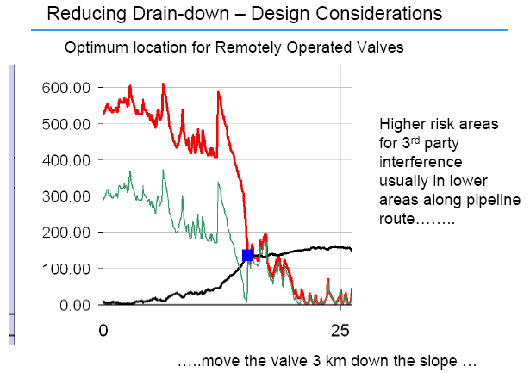
The Y-axis shows the drain down quantity in m3 for the red and green lines, and shows elevation above sea level in metres for the black line. The black line is the elevation (height profile) of the pipeline. The X-axis is the distance (chainage) along the pipeline from the pumping station.
The red line shows the drain down quantity with the remotely-operated valve open, whereas the green line shows the quantity with the valve closed. If the valve is moved 3 km down the slope, the quantity of drain down reduces substantially as shown below.
Figure 5 – Reducing Drain Down – Better Location of Valve
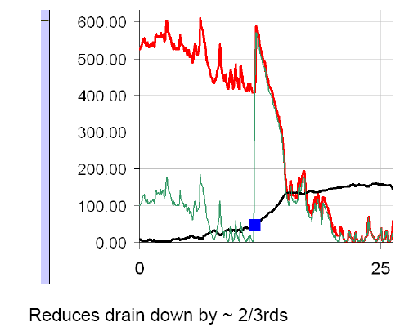

Current Code Requirements
The requirements for section isolating valves in BSI Code PD 8010-1:2015
(Ref.1) are described below for reference. It should be noted that most UK liquid fuel pipeline networks pre-date the requirements of this code.
6.12 Location of section isolating valves

Section isolating valves should be installed at the beginning and end of the pipeline, and at a spacing along the pipeline appropriate to the substance being conveyed to limit the extent of a possible leak. The spacing of section isolating valves should reflect the conclusions of any safety evaluation prepared for the pipeline and should preferably be installed below ground. The location of section isolating valves should take account of topography, ease of access for operation and maintenance, protection from vandalism and proximity to normally occupied buildings. Section isolating valves should be installed at either side of a major river or estuary crossing where the pipeline could be damaged, e.g. by ships’ anchors or scouring of the riverbed, unless otherwise justified by a safety evaluation.
For pipelines designed to convey category B substances, section isolating valves should be installed at locations which would limit drain down of pipeline contents at any low point.
For pipelines designed to convey category C, category D or category E substances, section isolating valves should be installed at intervals calculated by means of a safety evaluation.
For pipelines designed to convey category D, category E or toxic category B substances, automatic or remotely controlled section isolating valves should be installed unless non-installation can be justified to a statutory authority as part of a safety evaluation for the pipeline. Automatic or remotely controlled section isolating valves should be installed on pipelines conveying category C or non-toxic category B substances, when necessary.
The second paragraph of 6.12 above appears to be a general statement of requirement which requires interpretation for each specific case.

Optimum Location of Remotely-Operated Valves
From the above, the optimum location of remotely-operated valves is:-
- Recognising where the risks of 3rd party external interference excavation are highest;
- To minimise drain down into populated areas;
- To minimise drain down into environmentally vulnerable or sensitive areas;
- Where significant reduction in drain down can be achieved;
- At the bottom of slopes from higher ground.

CALCULATION OF DURATION OF DRAIN DOWN BASED ON LEAK RATE

The Excel calculator program is also able to calculate the duration of drain-down based on the leak rate and location of the leak. This allows emergency teams to assess the potential for stopping small leaks and assessment of total quantity spilled to plan containment and recovery of spilled oil.

Main Input Data Required
Two items of data are required to calculate the rate of drain-down at any point along pipeline, these being:-
- The distance from the high pressure end of the pipeline (chainage) in km
- The leak rate in m³/hour
In addition the pressure at the inlet and exit to the pipeline is required to back-calculate the hole size based on the leak rate, and the subsequent pressure profile once the pumps are switched off.

Stage 1 – Calculation of Pressure at Leak Point
Calculation of the pressure at the leak point is based on the simple assumption that the pressure drop along the pipeline is uniform along the length of the pipeline. So if the start pressure is 95 bar and the end pressure is 15 bar, the pressure half way along the pipeline is (95+15)/2 = 55 bar.
However, superimposed on this is the elevation of the pipeline. The higher the leak point above the pipeline inlet, the lower the pressure. As elevation of the leak point below the highest point decreases, the pressure at the leak point increases, and calculation of ρgh (density x gravitational constant x height below highest point) allows the pressure increases to be calculated.
For aviation fuel, 800 kg/m³ density, the height is 12.9 metres. If the elevation of the leak point in an aviation fuel product pipeline is 129 metres above the inlet, the pressure at the leak point will be 10 bar lower than the straight-line pressure drop profile would predict.
However, to calculate the actual pressure profile, it is also necessary to take into account the elevation of the pipeline inlet and outlet, so a datum of sea level (elevation = 0) is used to calculate the pressure relative to the leak point.
Note this is the pressure at the leak point with the pumps operating, and therefore the leak rate identified by the leak detection system would be at this pressure.

Stage 2 – Calculation of Hole Size from Leak Rate
Using the pressure at the leak point with the pumps operating, and the leak rate input data, the equivalent circular hole size is calculated using the standard equation for a sharp edged orifice:-
Discharge rate = Area of hole x Discharge Coefficient x √(2 x density x pressure drop)
Where Discharge Coefficient = 0.6
This has been re-arranged to calculate the hole diameter in millimetres:-
Hole diameter = 2000 x √([m³/hour x density/3600]/[600 x √( 0.2 x density x pressure at leak point] / Pi)
This result is calculated and displayed within the spreadsheet.

Stage 3 – Pumps are Stopped, Drain-down is Calculated
At this point the pumps are stopped, and the program calculates the quantity of the vacuum and gravity drain-down. For each of the vacuum drain-down cases, the chainage and elevation of the start and end point of each section draining down is identified, and from these, the length and therefore the volume draining down from each section is calculated.

Stage 4 – Vacuum Drain-down, Calculation of Rate and Duration
For each drain-down calculation, the start and end section of pipeline draining down is identified. The calculation identifies the start and end section elevation, and from this calculates the pressures in bar above leak point pressure assuming the pumps have now stopped and the pipeline contents are static. From these pressures the drain-down rate is calculated knowing the hole size, using the equation:-
Start Point Drain-down Rate = Area of hole x Discharge Coefficient x √(2 x density x Start Point Pressure)
End Point Drain-down Rate = Area of hole x Discharge Coefficient x √(2 x density x End Point Pressure)
The drain-down rate is averaged for the start and end point, and the volume draining down is divided by the averaged drain-down rate to obtain the time taken to drain-down:-
Drain-down Duration = Volume Draining Down / (Start Point Drain-down Rate + End Point Drain-down Rate)/2

Stage 5 - Drain-down Rate and Duration for Gravity Drain-down
Gravity drain-down is likely to occur after the entire vacuum drain-down product has leaked out, and will occur at a slower rate.
In many cases there is no gravity drain-down from either upstream or downstream, and in some cases, none from either direction. In these cases, it is assumed that a quarter of the length of the 100 metre section drains down, typically taking half an hour depending on hole size, from each of the upstream and downstream directions.
So if there is no drain-down from either direction, the total amount is assumed to be the volume in half the 100 metre section, and this takes 1 hour to drain. This is based on study of actual profiles when local undulations in the as-laid pipeline sections are evident which limit the amount draining down due to gravity. Using the full 100 metre section would be over-conservative.
For leak points where there is significant gravity drain-down, the final 100 metre section with the highest elevation is identified and the net pressure above the leak point is calculated for this section. This pressure is then used in the leak rate calculation for sections upstream and downstream as follows:-
Gravity Drain-down Rate Upstream = Area of hole x Discharge Coefficient x √(2 x density x Highest Point Pressure Upstream)
Gravity Drain-down Rate Downstream = Area of hole x Discharge Coefficient x √(2 x density x Highest Point Pressure Downstream)
From these rates, the drain-down duration for upstream and downstream is calculated knowing the volume draining down from each direction.
It should be noted that in most cases, the pressures above the leak point are often low for gravity drain-down, in some cases less than 1 bar. The above equation may not be valid below 1 bar, so the drain-down rate and duration should be treated as an approximate guide only. This is not considered to be a serious problem because gravity drain-down is usually a minor part of the total drain-down.

THE DRAIN-DOWN CALCULATOR IN AN EMERGENCY SITUATION
Information Required if a Leak Occurs
- Where is the leak?
From:
- public / emergency services / Environment Agency phoning in
- road patrol / air surveillance / landowner
- leak detection system
- How quickly is the oil leaking out?
By observation “minor”, “small”, “large”, “massive”
- leak detection system - m³/hour
- loss of pressure in system
- need to convert observation to leak size
- How much is likely to leak out?
- from drain-down calculator
- essential information for emergency response teams, emergency services,
Environment Agency, clean-up teams
- Which remotely-operated valves should be closed?
- from drain-down calculator
- rapid action required to minimise spillage
- How long will it take for the oil to leak out?
- from drain-down calculator
- how long the leak is likely to go on for
- how quickly teams need to get to the leak site
- leak rate estimate can help decide whether repair is possible or worth considering
- if leak period is long (hours or days) start taking decisions such as:
- can spillage be stopped / clamped?
- how can spillage be contained? Or recovered?
- where is spillage going? Streams, rivers, watercourses
- what people / equipment / facilities are required?
The drain-down calculator is designed to help answer Questions 3,4,5,& 6

REFERENCES

- PD 8010-1:2015 Code of Practice for Steel Pipelines on Land

“Emergency Flow Restriction Device (EFRD), Adequacy Evaluation”, presentation by Joel Jensen and Nathan Marx, Chevron Houston Texas, 4 April 2006, website http://gis2.esri.com/library/userconf/pug06/papers/efrd.pdf

