Good Practice Guide
Remaining Life Assessment of Pipelines and Associated Installations
UKOPA/GP/018 Edition B
September 2018

GUIDANCE ISSUED BY UKOPA:
The guidance in this document identifies what is considered by UKOPA to represent current UK pipeline industry good practice within the defined scope of the document. All requirements should be considered guidance and should not be considered obligatory against the judgement of the Pipeline Owner/Operator. Where new and better techniques are developed and proved, they should be adopted without waiting for modifications to the guidance in this document.

Comments, questions and enquiries about this publication should be directed to:
UK Onshore Pipeline Operators’ Association
Pipeline Maintenance Centre
Ripley Road
Ambergate
Derbyshire
DE56 2FZ
E-mail: enquiries@ukopa.co.uk
Website: www.UKOPA.co.uk

Disclaimer
This document is protected by copyright and may not be reproduced in whole or in part, by any means without the prior approval in writing of UKOPA. The information contained in this document is provided as guidance only and while every reasonable care has been taken to ensure the accuracy of its contents, UKOPA cannot accept any responsibility for any action taken, or not taken, on the basis of this information. UKOPA shall not be liable to any person for any loss or damage which may arise from the use of any of the information contained in any of its publications. The document must be read in its entirety and is subject to any assumptions and qualifications expressed therein. UKOPA documents may contain detailed technical data which is intended for analysis only by persons possessing requisite expertise in its subject matter.
Copyright @2018, UKOPA. All rights reserved
Revision and change control history
Planned revision:
Edition | Date | No. of pages | Summary of changes
A | 27.12.2017 | 7
B | 11.09.2018 | 11 | Incorporates Subgroup additions
C
1

Contents
1. Executive Summary 1
2. Objectives 2
3. Introduction 3
3.1 Background 3
3.2 Scope 3
3.3 Application 3
4. Methodology 1
4.1 Remaining Life Assessment Process 1
4.2 Assessment Requirements 1
5. Results of Remaining Life Assessment 6
6. References 7
Appendix 1 Corrosion Assessment Methodology 8
Appendix 2 Fatigue Assessment Methodology 9
Appendix 3 Vibration 11

Executive Summary
This UKOPA good practice guide has been developed by the UKOPA Pipeline Integrity Working Group to provide guidance on the assessing the remaining life of pipelines and associated installations. The guidance within the document is applicable to assets operated by the UKOPA member companies.

The document provides advice on the assessments and studies that should be carried out in accordance with the recommended practice presented in the Technical Specification ISO/TS/12747 Petroleum and natural gas industries - Pipeline Transportation systems – Recommended practice for pipeline life extension.
The document considers the assessment process and requirements recommended in ISO/TS/12747, and provides guidance on the requirements for data compilation and the assessment of the technical integrity of the pipeline system and future threats to onshore pipeline systems. The document then provides advice and guidance based on UK pipeline codes and standards for on the assessment of:
- Risk
- System design
- Integrity management during extended life
- Update of systems and procedures.

Objectives
The objectives of this good practice guide (GPG) is to provide guidance to pipeline operators on a consistent approach to the assessment of the remaining life of UK onshore pipelines and associated installations based on the assessment process and requirements recommended in ISO/TS/12747, and the requirements of UK pipeline codes and standards.

Introduction

Background
Pipelines are long life assets, and their safe operation is controlled by legislation, which requires integrity assessments to confirm fitness for operation. Some UK pipelines were constructed in the 1950s, and more than 50% by length of pipelines operating in the UK are over 50 years old. There have been a number of changes in the design, construction, operation and maintenance requirements of the pipeline codes and standards in this period.
The requirement for an operator GPG for the life extension of pipelines and associated installations was identified in the UKOPA Strategy Review carried out in 2015. This document is the first draft for review, comment and development.

Scope
This GPG provides guidance on assessing the remaining life of onshore UK pipelines and their associated installations. The scope of the assets covered is shown in Figure 1.

Application
The guidance in this document is applicable to assets within teh scope shown in Figure 1 operated by the UKOPA member companies, including:
• Above 7 barg natural gas pipelines.
• Petrochemical liquids and gas pipelines.
• Oil and refined liquid pipelines.
Within this document:
Shall: indicates a mandatory requirement.
Should: indicates good practice and is the preferred option.

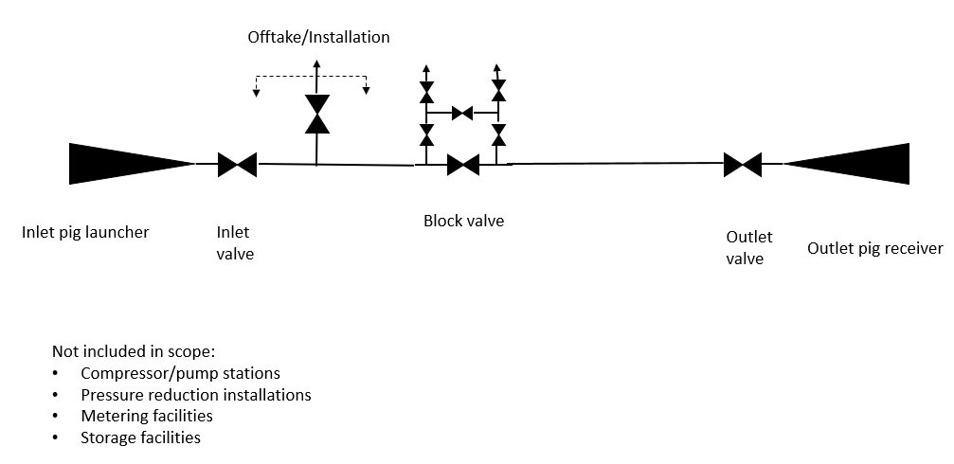
Figure 1 Extent of Pipeline System covered by GPG

Methodology
Guidance on the remaining life assessment of pipelines and installations presented in this GPG is informed by the methodology presented in ISO/TS/12747.
The design life of pipelines and installations is specified to prevent failure due to time and duty dependant degradation mechanisms such as corrosion and fatigue. As operator pipeline integrity management systems (PIMS) control the integrity of the system through inspection, maintenance and repair throughout the operating life, the pipeline and installations are likely to be fit for purpose at the end of the design life, and formal extension of the design life will be desirable if there is a continued need for the assets.

Remaining Life Assessment Process
Where the pipeline system is to be operated beyond the original design life, an assessment of the remaining life should be performed. A flowchart for the remaining life assessment of the pipeline system is given in Figure 2. This includes:
- Requirements for initiating the remaining life assessment
- Identification of time and duty dependent threats
- Identification and screening of existing defects, repairs and features
- Methods and guidance for assessment of fatigue, corrosion and vibration
- Assessment of remaining life and remediation actions

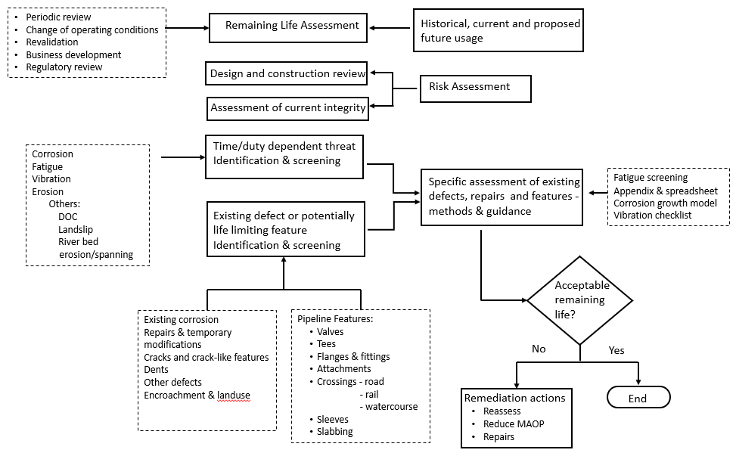
Figure 2 Process for Assessment of Remaining Life

Assessment Requirements
The assessment requirements are summarised below taking account of the relevant requirements of UK pipeline codes and standards, and UKOPA GPGs.

Historical, Current and Propose Futured Usage
Life extension of pipelines may be required for one of several reasons:
- Continued operation for transport of the same product (or product group) at the same operating conditions;
- Future operation for transport of the same product (or product group) at different operating conditions;
- Future operation for transport of a different product (or product group) at the same or different operating conditions.
This document addresses i) and ii) above where the future operating pressure and temperature range do not exceed historical values. Where future operating pressure and temperature range exceed the historical values, pipeline uprating in accordance with IGEM/TD/1 or PD 8010-1 is required. Where future operation is required for a different product or product group at the same or different operating conditions, pipeline change of use and possible uprating in accordance with PD 8010-1 is required.

Risk Assessment
The purpose of the risk assessment is to evaluate the risk posed by the pipeline and associated installations to population and infrastructure in the vicinity. The risk assessment must take into account development which have occurred over the life of the pipeline system, and the occupancy of these developments.
Risk assessment of pipelines must be conducted in accordance with the UK risk assessment standards IGEM/TD/2 for natural gas pipelines, and PD 8010-3 for other pipelines. The failure frequencies due damage mechanisms should be taken from the UKOPA Pipeline Product Loss Incidents and Faults Report. The assessment of age and duty based damage mechanisms (corrosion, fatigue and vibration) should be reviewed taking into consideration the results of the integrity assessment described in Section 4.2.4.
The pipeline risk assessment should take into consideration the deterioration of control measures such as loss of depth of cover, marker post degradation etc. which may not be directly linked to time. Reference should be made to UKOPA GPGs 1 – Managing Pipelines with reduced depth of cover,5- Managing pipeline sleeves, 6 – Specification for concrete slabs, 7 – managing the risk of 3rd party thefts, X1 - Managing Encroaching Development and Societal Risk Around Pipelines where requirements are captured by pipeline codes.
Risk assessment of installations should be conducted in accordance with the principles of IGEM/TD/2 and PD 8010-3. Specific consideration shall be given to:
- Identification of generic loss of containment events and relevant failure rate databases;
- The scenarios for significant product release from above ground pipework and vessels, below ground pipework, and the potential impact of releases on adjacent pipework, vessels and equipment;
- The contribution of equipment failures and reliability;
- Releases in enclosed and congested spaces;
- The assessment of dispersion, fire and explosion of all release scenarios;
- The impact of external events, including intentional damage;
- Assessment of domino events.
- The calculation of individual and societal risk levels i) inside the site security fence and the impact on personnel, and ii) outside the site security fence and the impact on members of the public.
Risk levels for installations should be assessed using the individual and societal risk criteria given in IGEM/TD/2 and PD 8010-3.
Guidance on the acceptability of risk and target PoFs given in ISO 16708 should be applied.
(is an appendix covering this needed?)

Design and Construction Review
Design and construction details for the pipeline and installations should be reviewed against the requirements of the current pipeline standards IGEM/TD/1 and PD8010-1. As a minimum the review should take account of:
The adequacy of material properties, design criteria and testing of the pipeline and associated installations. Specific assessment should be carried out of the design and construction of:
- Pipeline as route maps and installation drawings
- Installation of isolation valves
- Pressure control and emergency shut down systems
- Depth of cover.
- Pipeline sleeves,
- Pipeline and Pipework supports and anchors.
- Road, rail and water crossings (including any changes to traffic routes and reassessment of traffic volumes).
- Above ground crossings.
- Evaluation and mitigation of internal corrosion.
- Evaluation and mitigation of external corrosion (including AC and DC induced corrosion, SCC, MIC).
- External coating integrity
- Proximity to and crossing of other pipelines and services.
- Pipeline protection measures.
- Assessment of changes in environmental loading, including effect of adverse ground conditions, ground movement (due to land sliding, subsidence and settlement), frost heave, buoyancy due to changes in the water table and erosion at river banks, vehicle loading and seismic events.
- Route survey to identify any infrastructure and population density infringements, and risk assessment of identified infringements.
The above assessments should include a review of original design and construction records. Where primary records (material certificates, pressure test records, Original Equipment Manufacturer’s (OEM) records, construction inspection records) are not available, secondary records (other construction records such as data sheets or material orders, company database entries, primary records for equivalent materials/components from the same manufacturer procured at the same time, evidence of company quality control procedures in place at the time) may be considered.
Where secondary records are used for the design and construction review, the effect of data uncertainty should be taken into account and demonstration of the acceptability of the data assessment should be documented based on:
- a cautious best estimate quantification of the uncertainty associated with each source of data, and combination of uncertainties for comparison with a justified acceptable limit, or
- a qualitative algorithm or semi-quantitative ‘points-scoring’ model developed to evaluate the adequacy of given levels of available data.
A documented fitness for purpose assessment should be carried out on any features or components which do not meet current design and construction standards.
Reference should be made to the pipeline standards IGEM/TD/1 and PD 8010-1, IGEM/TD/2 and PD 8010-3, and UKOPA GPGs 5- Managing pipeline sleeves, 6 – Specification for concrete slabs, X1 - Managing Encroaching Development and Societal Risk Around Pipelines where requirements are captured by pipeline codes

Current Integrity of the Pipeline System
The current integrity of the pipeline and associated installations should be evaluated against the operation and maintenance requirements of the current pipeline standards IGEM/TD/1 and PD8010-1. A full operations and maintenance review shall be undertaken including:
          - Modifications and repairs since construction
          - Operating service history
          - Product quality records
          - CP monitoring results and actions
          - Condition monitoring (CIPS, DCVG) results and actions
          - Inspection results and actions
          - Assessment of defects
          - Maintenance results and actions
          - Leak detection records
          - Pressure cycling/fatigue history
          - Proximity and population density infringements and area classification.
          - Operating temperature history
          - Products carried previously in the pipeline
          - Susceptibility to stress corrosion cracking
          - Residual construction and operating stresses, including those due to ground movement (eg associated with deep mining, quarrying and landslips)
          - Stress analysis of any associated installation and components included in, or attached to, the pipeline
          - Proximity of third party equipment
          - Inspection of special crossings (road, rail, water)
          - Condition of aerial and pipeline markers
          - Condition and performance of primary protection devices, isolation valves and isolation valve actuators
          - Condition of pipework, pig traps and pressure vessels
          - Condition of anchors and supports
          - Condition and performance of electrical, instrumentation and control equipment
          - Condition of the pipeline route (including recording of encroachments, damage to above ground or exposed assets, evidence of third party activities, change in land use, adverse ground conditions)
          - Condition installation sites – (including land, buildings, security fence and gates)

It is noted that the majority of essential information should be recorded in the operator’s PIMS.
Reference should be made to the pipeline standard for integrity management, PD 8010-4, and UKOPA GPGs 1 – Managing Pipelines with reduced depth of cover, 2- Inspection and maintenance of buried pipelines, 4 – Managing pipeline dents, 5 - Managing pipeline sleeves, 6 – Specification for concrete slabs, 7 – Managing the risk of 3rd party thefts, 13 – Managing the impact of wind farms, 14 – Managing the impact of solar farms, X1 - Managing Encroaching Development and Societal Risk Around Pipelines where requirements are captured by pipeline codes.

Corrosion Assessment
A detailed corrosion assessment should be carried out using the in-line inspection results history.
For non piggable pipelines and buried pipework at installations, an assessment of the corrosion incident rate should be carried out using CP, CIPS and DCVG data. This data should be used to develop a probability of failure model for the prediction of failure frequency due to corrosion in non piggable pipelines and buried pipework at installations. Target failure frequency levels should be established using the target safety levels for onshore pipelines given in ISO 16708 Petroleum and natural gas industries – pipeline transportation systems – Reliability-based limit state methods.
An example of a corrosion assessment methodology is given in Appendix 1.
Note, if detailed data for buried pipework at installations is not available, relevant data for the inlet and outlet pipelines should be used. In addition, relevant fault rates for pipelines can be derived from the UKOPA pipeline database.
An assessment of the susceptibility of buried pipelines and buried pipework to Stress Corrosion Cracking (SCC) should be carried out in accordance with the UKOPA GPG 9 – Managing stress corrosion cracking.

Fatigue Assessment
A fatigue assessment to determine the fatigue damage which has occurred on the pipeline and installations since commissioning and to predict the fatigue damage for future operation is required.
The assessment will involve analysis of variable magnitude pressure cycles recorded for the pipeline and installations to identify:
- Cyclic pressures resulting in hoop stresses ≥ 30% SMYS
- Rainflow or reservoir counting of pressure cycles recorded over a relevant operating period, which should include maximum pressure cycling
- Construction of a historical and future fatigue cycle spectra.

The pipeline fatigue assessment shall take account of the fatigue assessment of pipeline dents detailed in UKOPA GPG 4 – Managing pipeline dents.

Guidance on pipeline fatigue assessment is given in Appendix 2.

The fatigue assessment of installations should take into account:
- Typical pipework cyclic load spectrum comprising hoop, axial and bending stress cycles
- Component SCFs
- Where possible, pipework stress analysis results for the installation.

The fatigue assessment of pipelines and pipework should be based on hoop stress cycles assessed using an appropriate S-N model. Reference should be made to UKOPA GPG 4 – managing pipeline dents and TBN XX (this exists as PIWG/16/032 – should this could be turned into a TBN?)

Vibration Assessment
An assessment of the occurrence of and/or potential for vibration fatigue at pipeline attachments and at installations should be carried out, particularly where vibration during operation has been observed. The assessment should take into account any monitoring and assessment of vibration, and/or should recommend whether future monitoring and assessment is required. If required, vibration mitigation measures shall be identified and installed.
Simple background on pipework vibration is given in Appendix 3. Vibration assessment should be carried out in accordance with the guidance given in UKOPA GPGxxx Management of Pipework Vibration (a draft of this GPG has been developed)

Requirements for Future Integrity Management
The requirements for future integrity management shall be based on the results of the assessments detailed in sections 4.2.1 to 4.2.4 above.

Update of systems and Procedures
The update of systems and procedures shall include:
- PIMS update, including revision of inspection, surveillance monitoring and maintenance schedules
- Update of control procedures
- Scheduling of specific corrosion assessments of non piggable pipelines and buried pipework at installations
- Scheduling of specific fatigue assessments of pipelines and installations.
- Update of emergency response procedures.

Results of Remaining Life Assessment
The results of the life extension assessment shall include:
- The remaining life
- Any required approvals
- Details of deviations from the original design basis, and non conformances with current standards
- Wall thickness assessment results
- Details of corrosion, fatigue and vibration assessments
- Details of residual risks and risk mitigation measures

The results shall be documented in a remaining life assessment report, which shall include recommendations for any required remedial measures or additional inspection and assessment necessary to justify future operation.

References
To be completed

Appendix 1 Corrosion Assessment Methodology
A simple methodology for the assessment of the probability of corrosion on non inspectable buried pipelines and buried pipework at installations is described below.
Corrosion failure is defined as a leak. The assessment methodology involves:
  - Assessment of the corrosion incident probability, taking account of CP, CIPS and DCVG data
  - Application of a probabilistic corrosion growth model based on UK corrosion growth rate distributions for buried pipelines
  - Application of a corrosion failure model
  - Calculation of the probability of a leak due to corrosion
  - Assessment of the acceptability of the probability of a corrosion leak on the installation (e.g. using methodology given in ISO 26708)
The methodology is shown in Figure A1.1
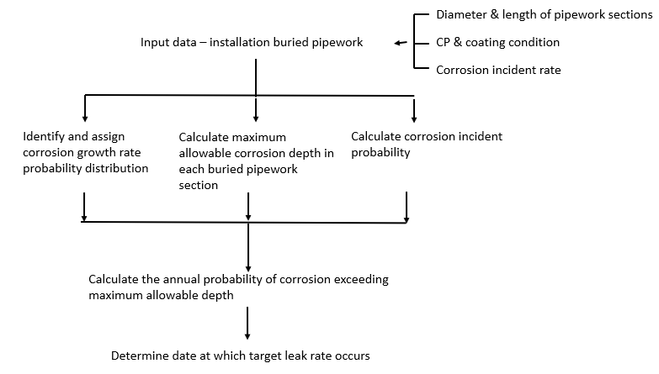
Figure A1.1 Corrosion assessment Methodology

Appendix 2 Fatigue Assessment Methodology
Assessment of Pipeline Pressure Cycle History

- Where pressure cycle data is recorded:
Use recorded pressure cycles to assess pressure cycle and number of cycles vs time. Where a complete record is not available, use analysis of recent data. Analysis of the most recent full annual history should be carried out, to assess the variation in the cyclic history.
Where there is a high variation in the cyclic pressure loading, it is recommended that 1 year in two over 6 years is used to assess variation.
Where the variation in cyclic pressure loading is low, it is recommended that the maximum annual loading over the previous 5 years is used.

Note – guidance for judgement of high and low cyclic variation to be developed.

- Where pressure cycle history is not recorded:
  - Install pressure monitoring equipment and
  - Commence recording of data at the earliest opportunity.
  - Apply cycle counting method
  - Build cycle history using operational knowledge

Note questions to obtain operational knowledge to be developed

Reasonable assumptions for immediate assessment of fatigue life to be assessed and included, based on
  - Cycles per day/month/year for gas pipelines
  - Cycles per day/month/year for liquid pipelines
The fatigue calculation methodology is given in Figure A2.1. This methodology assumes 3 annual pressure ranges, this can be extended as required.

It is recommended that factors to account for uncertainty in the estimated number of historical and future cycles are included.
The recommended safety factor to be applied to the calculated fatigue life for buried pipelines and pipework is 10.

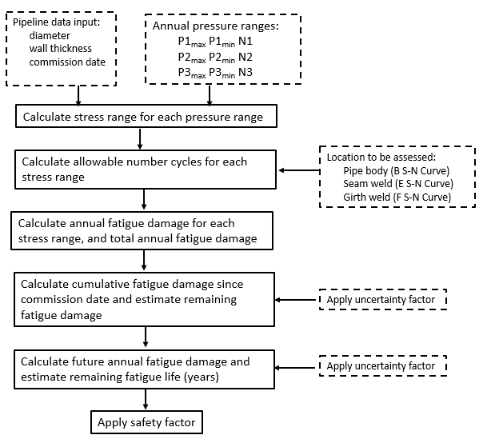
Figure A2.1 Fatigue Calculation Methodology

Appendix 3 Vibration
Pipework vibration can be categorised as:

- Low frequency (<300Hz) steady state vibration, typically excited in main pipework spans associated with reciprocating machinery. Vibration of this type can be of a high amplitude/high stress.

- High frequency (> 300Hz) steady state vibrations such as shell resonances, typically excited by high local pressure drops across component or acoustically excited by high flowrates occurring in pipework associated with centrifugal machinery. Vibration of this type is generally small amplitude/low stress.

- Transient vibration, excited by phenomena such as surge, cavitation etc. Vibration of this type must be assessed according to time related operational conditions.

Vibration on pipework installations can be induced by high fluid flow velocities and is usually characterised by high noise levels.

Vibration induces cyclic stress, and if the stress amplitude exceeds the fatigue stress threshold at a location where crack initiation is possible, fatigue failure may occur.

Typically, there is a high probability of fatigue failure in cases where the number of stress cycles exceeds the fatigue endurance limit by approximately 1x10⁷ cycles. Vibration at 300Hz will therefore result in failure in approximately 10 hours. Operational experience indicates that the primary failures occur at welded or threaded connection details which act as fatigue initiation sites, and the failure mode is a leak from a small hole. As the stress amplitude induced in the main pipe wall is low, failure of the main pipework is rare, the consequence of vibration is usually environmental noise.

The probability of a small diameter leak due to vibration induced fatigue is either:

Very high - where fatigue crack initiation sites and locations of stress concentration occur on pipework adjacent to regulators and/or centrifugal machinery in which high flows and large pressure reductions occur,
or

Negligible - where fatigue crack initiation sites do not exist or where high flows and large pressure reductions do not occur.

