Good Practice Guide
Seismic screening assessment of UK onshore pipelines and associated installations
UKOPA/GP/019 Edition 1
January 2019

GUIDANCE ISSUED BY UKOPA:
The guidance in this document identifies what is considered by UKOPA to represent current UK pipeline industry good practice within the defined scope of the document. All requirements should be considered guidance and should not be considered obligatory against the judgement of the Pipeline Owner/Operator. Where new and better techniques are developed and proved, they should be adopted without waiting for modifications to the guidance in this document.

Comments, questions and enquiries about this publication should be directed to:
UK Onshore Pipeline Operators’ Association
Pipeline Maintenance Centre
Ripley Road
Ambergate
Derbyshire
DE56 2FZ
E-mail: enquiries@ukopa.co.uk
Website: www.UKOPA.co.uk

Disclaimer
This document is protected by copyright and may not be reproduced in whole or in part, by any means without the prior approval in writing of UKOPA. The information contained in this document is provided as guidance only and while every reasonable care has been taken to ensure the accuracy of its contents, UKOPA cannot accept any responsibility for any action taken, or not taken, on the basis of this information. UKOPA shall not be liable to any person for any loss or damage which may arise from the use of any of the information contained in any of its publications. The document must be read in its entirety and is subject to any assumptions and qualifications expressed therein. UKOPA documents may contain detailed technical data which is intended for analysis only by persons possessing requisite expertise in its subject matter.
Copyright @2019, UKOPA. All rights reserved
Revision and change control history
Planned revision: 2024
Edition | Date | No. of pages | Summary of changes
1 | 30/1/2019 | 22 | Prepared by UKOPA PIWG and published

Contents
1. Executive summary 4
2. Introduction 5
2.1 Background 5
2.2 Scope 5
2.3 Application 5
3. Seismic hazard assessment 7
3.1 Report on seismic hazard to UK pipelines and associated installations 7
3.2 Review of National Grid seismic policy 9
3.3 UK seismicity levels 10
3.4 ISO committee draft 20074 10
4. Seismic assessment 12
4.1 Screening methodology for pipelines and associated installations 12
4.2 Screening methodology 12
4.3 Importance classification 12
4.4 Importance factor 13
4.5 Peak ground acceleration (PGA) 13
4.6 Screening criteria 15
4.7 Worked examples 16
5. Conclusion and recommendation 18
6. References 19
Appendix 1 Consequence Descriptions 20
Appendix 2 Worked Examples 21

Executive summary
This UKOPA good practice guide has been developed by the UKOPA Pipeline Integrity Working Group (PIWG) to provide guidance on the seismic screening assessment for UK onshore pipelines and associated installations. The guidance within the document is applicable to all buried pipelines operated by the UKOPA member companies.
The advice in this document is based on a detailed review of the requirements of published standards carried out for UKOPA, the National Grid technical specification for the seismic engineering of natural gas pipelines and associated installations operating at above 7 barg, and the ISO Committee Draft 20074 “PNGI – Pipeline Transportation Systems – Geological hazard risk management for onshore pipelines.
The detailed review of the requirements of published standards was carried out to inform compliance requirements for seismic assessment of pipelines and installations in the UK.
The National Grid technical specification was developed to comply with the requirements of Eurocode 8, the UK national annexes and BSI PD 6698, and has been provided to UKOPA by National Grid for inclusion the UKOPA guidance.
The ISO/CD 20074 is being prepared for use by pipeline operators and designers for the implementation of and improvement of geological hazard risk management for onshore pipeline systems. The pipeline system includes the pipeline, the right of way, and all associated buried and above ground facilities.
The document provides guidance on a screening methodology for the seismic assessment of operating pipelines and installations for use by UKOPA members. The screening methodology is based on:
- Assignment of importance classification according to the consequences of failure.
- Assignment of the importance factor based on the importance classification.
- Calculation of seismic action parameters:
  - Ground acceleration (using the seismic hazard map given in PD 6698);
  - Soil factor (using Table 3.3 in BS EN 1998-1);
- Application of ground acceleration criteria.
It is recommended the screening methodology presented is used to identify regions of the UK in which the seismic assessment of pipelines and installations is unnecessary, and to determine where further detailed assessment is required to ensure seismic risks are understood and managed.

Introduction

Background
The requirement for an operator GPG for a screening methodology for the seismic assessment of pipelines and associated installations has been identified by the UKOPA PIWG to ensure compliance with recognised pipeline standards.
The advice in this document is based on a detailed review of the requirements of published standards carried out for UKOPA, a briefing paper which reviewed the National Grid technical specification for the seismic engineering of natural gas pipelines and associated installations operating at above 7 barg, and the ISO TC Committee Draft Pipeline Transportation Systems – Geological hazard risk management for onshore pipelines. The detailed review of the requirements of published standards was carried out to inform compliance requirements for seismic assessment of pipelines and installations in the UK.
The National Grid technical specification was developed to comply with the requirements of Eurocode 8, the UK national annexes and BSI PD 6698. National Grid provided the technical work used to develop this specification to UKOPA for review. The results of the review are included in the UKOPA guidance.
The ISO document is being prepared for use by pipeline operators and designers for the implementation of and improvement of geological hazard risk management for onshore pipeline systems. The pipeline system includes the pipeline, the right of way, and all associated buried and above ground facilities. The guidance on the geological risk management of pipelines and installations subject to seismic hazards is summarised in this GPG.

Scope
This GPG provides guidance on a screening methodology for assessing the risks posed by seismic activity to onshore UK pipelines and their associated installations. Application of the methodology will identify regions of the UK where the seismic assessment of pipelines and installations is unnecessary and will determine when further detailed assessment is required to ensure seismic risks are understood and managed.
The extent of the pipeline system to which this GPG applies is defined as the assets from the pipeline inlet valve to the outlet valve, including any associated installations (i.e. launch and receive pig traps, block valves, pressure regulation and/or metering installations, multi junctions) and spur connections. Compressor stations, pump stations, refineries and storage facilities are not included. The pipeline system is shown in Figure 1.

Application
The guidance in this document is applicable to all buried pipelines operated by the UKOPA member companies.
Within this document:
Shall: indicates a mandatory requirement.
Should: indicates good practice and is the preferred option.

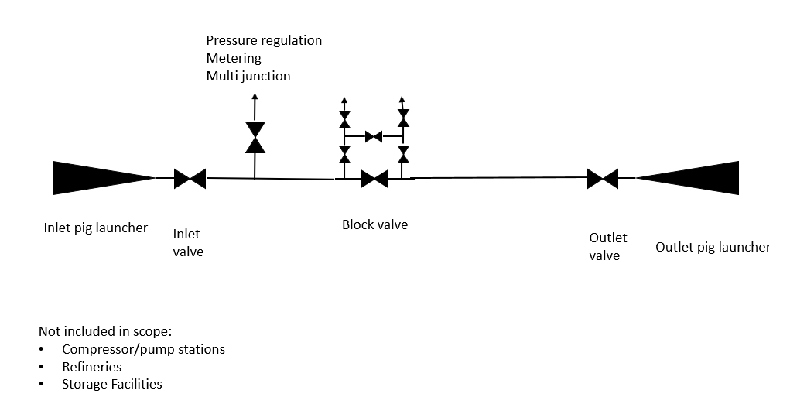
Figure 1 Extent of pipeline system covered by this GPG

Seismic hazard assessment

Report on seismic hazard to UK pipelines and associated installations
A brief description of the seismic hazard to UK pipelines and the associated installations is given below.
The history of seismic hazard assessment for engineered structures in the UK and the decisions on appropriate annual probability of exceedance values (return periods) for seismic actions are given in the References in Section 6. The underlying cause of British earthquakes is discussed based on the extensive work of the British Geological Survey (BGS). The requirements for seismic design to Eurocode 8 and the variations through UK National Annexes and guidance from PD 6698 are presented. The review clarifies the need to demonstrate the adequacy of the seismic resilience of major accident hazard pipelines and installations, either by virtue of the low seismic hazard or the low vulnerability achieved by structural design.
The inherent low vulnerability of modern welded steel pipelines to seismic hazard is demonstrated through a review of pipeline performance in past earthquakes. Seismic hazard in the UK is presented in terms of peak ground motions and seismic intensity (a measure of damage potential) at several return periods. This allows the significance of the return period on the seismic hazard to be illustrated and for the regional variation in natural seismic activity to be presented. Possible criteria are then presented and discussed for the potential screening of seismic hazard to enable an appropriate level of assessment and design to be determined.
The conclusions are summarised as:

Earthquakes
Earthquakes are a release of strain energy due to the fracture of rock and the transmission of some of that energy as seismic waves.
Natural earthquakes in the UK are attributed to the failure and movement of existing geological fault structures primarily due to crustal compression associated with tectonic plate movements.
Induced earthquakes in the UK have been attributed to underground mine collapses, rock blasting and hydraulic fracturing in deep boreholes. Hydraulic fracturing includes oil and gas reservoir stimulation, geothermal reservoir stimulation and shale gas extraction (fracking).
Earthquakes can be quantified in terms of a magnitude scale according to the amount of energy released. Several magnitude scales exist according to the determination method. The cumulative number of earthquakes in a region above a particular magnitude is found to decrease with magnitude according to the Gutenberg-Richter log-linear relationship. On average, the UK may expect a local magnitude 3.7 earthquake every year, a magnitude 4.7 earthquake every 10 years and a magnitude 5.6 earthquake every 100 years.
The threshold earthquake magnitude of engineering significance is a moment magnitude of ~4.5. There have been ~27 earthquakes across the UK of this magnitude or greater in a ~300 year period.

The anticipated maximum magnitudes for natural and induced earthquakes in the UK are:
- Natural | 5.5-6.5
- Mining | 3.2-3.5
- Geothermal | 1.9
- Fracking | ~3.0
Natural earthquake activity is variable across the UK mainland showing higher levels of activity in the west than in the south and east of the country.
Earthquake effects at surface can be measured quantitatively in terms of ground motions or assessed qualitatively through the observed damage. The normal ground motion measurement is the variation of horizontal and vertical ground acceleration with time which can be integrated to obtain velocity and displacement ground motions. Damage is assessed and assigned to a seismic intensity scale. Several intensity scales exist although the scales in most common usage are the 12-point Modified Mercalli Scale and the 12-point European Macroseismic Scale.

Seismic hazard
Seismic hazards to buried pipelines and above-ground installations include:
- Transient loading due to seismic wave propagation (ground shaking),
- Permanent ground movement due to;
  - Geological fault displacement at surface.
  - Ground movement due to slope instability.
  - Ground movement due to liquefaction.
Seismic hazard assessment in the UK has been under development since the early 1970’s with particular motivation from the nuclear industry. Earthquake instrumental monitoring in the UK has expanded since the early 1970’s to reach a current network of over 100 stations operated by the BGS.
A seismic hazard study completed in 1991 for the Department for Environment, Food & Rural Affairs, concluded that there was no justification for the inclusion of earthquake resistance into the design of conventional structures. However, certain structures whose failure could pose a hazard to a significant number of people should incorporate earthquake loading in their design. The study identified an outstanding need for guidance on how to decide if a structure or installation was sufficiently hazardous to justify a seismic design.
Eurocode 8 (BS EN 1998 Parts 1-6) for the seismic design of structures in Europe was issued in 2005 and 2006. The national annexes for the UK decisions on nationally determined parameters for the application of Eurocode 8 in the UK were issued in 2008 and 2009. The UK National Annexes are supported by PD 6698 issued in 2009.
The UK decision on seismic design is that there are no requirements for most structures, but certain types of structure may warrant an explicit consideration of seismic actions. PD 6698 identifies major hazard sites and major accident hazard pipelines as categories of structure that should be designed to withstand very low probability events, including earthquakes.
Facilities assessed as posing a large risk to the population or to the environment require a site-specific hazard assessment to establish appropriate design ground motions. Other high consequence facilities may use the peak ground acceleration according to a seismic hazard map in PD 6698 for a return period of 2500 years (annual probability of exceedance of 4x10⁻⁴).
A particular challenge for major accident hazard pipeline operators is to interpret which pipelines and installations should be considered for seismic design and whether the seismic hazard assessment approach should be based on a hazard map or a site-specific assessment.

Review of National Grid seismic policy
A comprehensive technical study by consultants working on seismic policy development for National Grid was provided to UKOPA by National Grid for review.
National Grid (NG) has used the results of this technical study to develop policy, management procedure and technical specification documents for the seismic engineering of onshore UK pipelines and associated installations operating at above 7 barg.
A review for UKOPA presents the key technical aspects of the NG specification and considers the approach relative to practices elsewhere in regions with similar levels of seismicity.
The key aspects are:
- The selection of importance classes and the assignment of return periods for the design seismic ground motion.
- The use of a partial factor to increase ground motions from a PD6698 seismic hazard map.
- A screening criterion to identify the required level of seismic design.
- The selection of an acceleration level for simplified seismic design.
The report details the screening methodology developed by NG and included in their specification for the determination of seismic design requirements. Key factors identified are:
- The NG screening methodology applies a ground acceleration value of 0.1g.
- Probabilistic hazard maps offer the best means to represent the uncertainties and establish ground motion values for design in intra plate regions such as Northern Europe, where earthquake sources are not well defined and maximum magnitude events have long return periods.
- The NG specification incorporates a partial factor yf = 1.5 to increase the ground motion from the hazard map. This accounts for the maximum horizontal component of ground motion exceeding the geometric mean and for the possibility that the hazard map will underestimate the ground motion level. There is no evidence from the USA or Europe to suggest that ground motion values from hazard maps are routinely increased to account for the measure of ground motion or the way the values are calculated. It is therefore concluded the removal of the partial factor yf = 1.5 from the NG procedure can be justified on the basis of practice elsewhere, and this will not adversely affect the rigor of the approach.
The report recommends that UKOPA should consider use of the NG approach in terms of:
- The importance classification of pipelines, piping and other structures according to the number of potential casualties within the hazard range and the importance of security of supply.
- The selection of return periods for the determination of seismic actions for design.
- The usage of ground motion values from hazard maps.
- Screening for the exclusion of seismic design, for the selection of simplified seismic design or for full seismic design.
UKOPA understands that with regard to the definition of importance classification, the NG definition cannot be directly applied to liquid pipelines and may not be directly applicable to gas pipelines where supply is a business issue and not a matter of national security. Amendments to this statement to make it more inclusive to all UKOPA members are proposed in this document.

UK seismicity levels
The implied areas of the UK classified as ‘very low’ seismicity and ‘low’ seismicity for Class IV structures to EN 1998-4:2006 are shown in Figure 2. Class IV refers to situations with exceptional risk to life and extreme economic, social or environmental consequences. Subject to national approval certain categories of structure in areas of ‘very low’ seismicity need not meet the provisions of EN 1998. Certain types or categories of structure in areas of ‘low’ seismicity may be designed according to reduced or simplified procedures.
The UK national annex to EN 1998-1 declares the whole of the UK as a region of ‘very low’ seismicity based on ag ≤ 1.8m/s² (~0.18g) for a return period of 2500 years.

ISO committee draft 20074
ISO/CD 20074 was released for consultation in June 2017. The purpose of the document is for the orderly and effective identification, assessment and mitigation of geological hazards threatening the safety of the pipeline system, to reduce risk and accidental loss as well the occurrence of pipeline damage. The pipeline system includes the pipeline, the right of way and all associated buried and above ground facilities. It is applicable to landslides, rockfalls, debris flows, land subsidence, permafrost, collapsible soil, saline soil, gully erosion, slope erosion, earthquake. The document covers preliminary engineering, route selection, detailed design and construction and operation and maintenance.
The document states that operators shall establish, implement, maintain and document a geological hazard risk management program and continually improve its effectiveness. The geological risk management program covers three operating procedures:
- Risk identification
- Risk assessment
- Risk mitigation
In terms of the operating and maintenance phase of the pipeline system, the document states that risk identification includes identified earthquake fault zones and active faults seismic ground motion parameter curves applied during preliminary engineering. Identified risks due to earthquake fault zones and active faults should be subject to risk assessment, which will then dictate risk mitigation measures. The risk assessment should assess earthquake faults taking account of location, type, predicted magnitude, displacement and return period.
A complexity classification of geological environmental conditions for earthquakes is given in Annex C of ISO/CD 20074 as:
 | Complex | Medium | Simple
Seismic PGA | Exceeds 0.2g | 0.1g – 0.2g | < 0.1g
The seismic PGA recommended for the simple classification is equivalent to the screening criterion applied in the NG screening approach.

Seismic assessment

Screening methodology for pipelines and associated installations
The seismic assessment screening methodology for application to operating pipelines and installations described below is based on that developed by NG for seismic design of new pipelines and installations, excluding partial factor yf = 1.5 to increase the ground motion from the hazard map and modified to cover environmental hazards in the definition of Importance Classification.

Screening methodology
The seismic assessment screening methodology applied to pipelines and above-ground installations in a particular location involves the following four steps:
- Assignment of Importance Classification according to the safety, economic, social and environmental consequences of failure.
- Assignment of Importance Factor based on the Importance Classification.
- Calculation of seismic action parameters:
  - Ground acceleration (using the seismic hazard map given in PD 6698)
  - Soil factor (using Table 3.3 in BS EN 1998-1).
- Application of threshold ground acceleration criteria

Importance classification
The seismic assessment requirements for pipelines and installations and pipelines are determined according to an Importance Classification defined by the safety, economic, social and environmental consequences of failure.
The importance classification is assigned as in Table 1:
Safety | Economic, Social and Environmental Consequences
Safety | Low | Considerable | Great
Low | I | II | III
Medium | II | II | III
High | III | III | III
Notes:
Class I Refers to situations where risk to life is low, and economic, social and environmental consequences of failure are low
Class II Refers to situations with medium risk to life, and considerable economic, social or environmental consequences of failure
Class III Refers to situations with high risk to life, and great economic, social and environmental consequences of failure
Table 1 Importance classification of pipelines and installations
The Importance Classification is assigned by the operator. Example descriptions of consequences are provided for guidance in Appendix 1.
Guidance on environmental risk assessment is provided by the Chemical and Downstream Industries Forum (CDOIF).

Importance factor
The importance classification is used to assign an importance factor value, ƴ_{l} , which is used to select an appropriate return period for the seismic action. The importance factor ƴ_{l} values are as in Table 2:
Importance Class | I | II | III
Importance Factor ƴ_{l} | n/a | 0.45 | 1.0
Table 2 Importance factors assigned to importance classes

Peak ground acceleration (PGA)
The ground acceleration on rock, a_{g}, is calculated as follows:
a_{g} = ƴ_{l} * a_{Gr}
Where;
ƴ_{l} is the importance factor
a_{Gr} is the reference peak ground acceleration (PGA) on rock for a return period of 2500 years, given in PD 6698
The seismic hazard map for PGA on rock given in PD 6698 for a return period of 2500 years is given in Figure 2.
The ground acceleration on soil is calculated as:
a_{g} x S
Where;
S is the soil amplification factor, given in BS EN 1998-1, see Table 3
Ground Type | Description | S
A | Rock | 1.0
B | Very dense granular deposits or very stiff clays | 1.35
C | Dense to medium dense granular deposits or stiff clays | 1.5
D | Loose to medium dense granular deposits or soft to firm clays | 1.8
E | Type C or D (5-20m) overlying rock | 1.6
Table 3 Ground type and soil amplification factors
The ground type definitions follow a convention set out by the BGS and can be referenced from the BGS Geosure dataset. Further information can be obtained in GPG020.

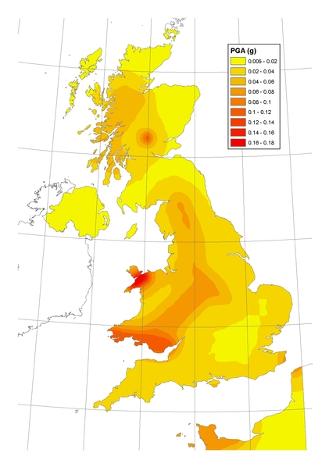
Figure 2 Seismic hazard map for PGA on rock
(Contains British Geological Survey materials ©NERC 2019)

Screening criteria
The threshold value of the ground acceleration is:
agS = 0.1g
Where agS ≤ 0.1g, seismic assessment is not required for buried pipelines in any Importance Class, and installations in Importance Class I or II.
Where a_{g}.S > 0.1g, seismic assessment is not required for buried pipelines in importance class I and II, and installations in importance class I.
Seismic assessment should be carried out for pipelines in importance class III pipelines and installations in importance class II and above.
Note: Pipeline Crossings located on bridges are subject to the seismic assessment of the bridge structure.
Seismic screening criteria are summarised in Table 4:
Importance class | $$a_{g}.S≤0.1 g$$ |  | $$a_{g}.S>0.1 g$$
Importance class | Buried pipelines | Above-ground installations | Buried pipelines | Above-ground installations
I | None
II | None |  |  | Simplified
III | None | Simplified | Full
Table 4 Application of screening criteria to pipelines and installations
For locations failing the threshold criterion of 0.1g there is a requirement for a simplified seismic assessment of above-ground Class II systems and a full seismic design for Class III & IV pipelines and structures. The implied regional extent of these requirements are indicated in Figure 3 for two ground types, Type A ‘rock’ and Type D ‘loose to medium dense non- cohesive ground or soft to firm cohesive ground’.
For Class II systems, Figure 3, the regional extent of the UK subject to some form of seismic design requirement (in this case simplified) is very limited potentially covering locations in South Wales and North West Wales.
For Class III systems, Figure 3, the regional extent of the UK subject to a full seismic assessment is fairly extensive for ‘soft’ ground sites. The regional extent is broadly aligned with the more seismically active areas of the UK.

Worked examples
Worked examples developed applying the seismic screening methodology at a PIWG Seismic Screening workshop are given in Appendix 2.

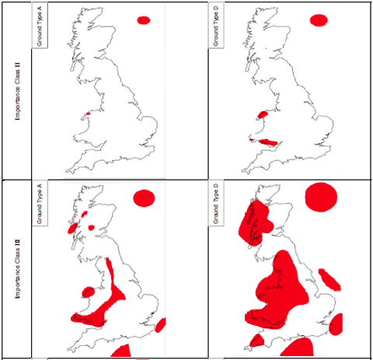
Note: Ground type A shown left, ground type D shown right.
Figure 3 Indicative regional extent (red) of seismic assessment requirements for class II installations and class III pipelines and installations

Conclusion and recommendation
It is concluded that, with the exclusion of the partial factor yf = 1.5 used to increase the ground motion derived from the PD 6698 hazard map, the screening approach for seismic design for new pipelines and installations developed by NG provides the basis of a practical screening methodology for the assessment of gas and liquid pipelines and installations operated by UKOPA members.
The seismic PGA limit of 0.1g used in the NG screening approach for seismic design and applied in the screening methodology for the seismic assessment of operating pipelines and installations aligns with the seismic PGA recommended for the simple classification of geological environmental conditions specified in ISO/CD 20074.
It is recommended the screening methodology presented in Section 4 is used to identify regions of the UK in which the seismic assessment of pipelines and installations is unnecessary, and locations where further assessment is required.

References
Seismic Hazard to Pipelines in the United Kingdom - Report for UKOPA. G Leach March 2015
National Grid Seismic Policy UKOPA Briefing Note. G Leach August 2016.
Seismic Design Screening Procedure for Pipelines. A Connell, GL Industrial Services Report Number 8885, November 2009.
BS EN 1998-4:2006. Eurocode 8: Design of structures for earthquake resistance - Part 4: Silos, tanks and pipelines. BSI. September 2006.
UK National Annex to Eurocode 8: Design of structures for earthquake resistance – Part 4: Silos, tanks and pipelines. BSI. August 2008.
PD 6698:2009. Recommendations for the design of structures for earthquake resistance to BS EN 1998. BSI. 31 July 2009.
Eurocode 8 seismic hazard zoning maps for the UK. Seismology and Geomagnetism Programme Technical Report CDR/07/125 Issue 3.0 R M W Musson and S L Sargeant. 2007.
ISO/CD 20074 Petroleum and natural gas industries - Pipeline transportation systems – Geological hazard risk management for onshore pipelines.
Chemical and Downstream Oil Industries Forum (CDOIF) Guideline – Environmental Risk Tolerability for COMAH Establishments V2.0

Appendix 1 Consequence Descriptions
A1.1 Safety
Consequence | Population density per hectare within Hazard Zone¹
Low | ≤ 2.5
Medium | >2.5 ≤ 20
High | >20
Note: 1 Hazard zone = radius of 4 x BPD (IGEM/TD/1) or 4 x MDOB (PD 8010-1)
2 Population density ≤2.5 persons per hectare ≡Rural Area (IGEM/TD/1) and Class 1 (PD 8010-1)
3 Population density >2.5 persons per hectare ≡ Suburban Area (IGEM/TD/1) and Class 2 (PD 8010-1)
4 Population density ≥20 persons per hectare is considered to represent high Suburban Area (IGEM/TD/1) and high Class 2 or Class areas (PD 8010-1)

A1.2 Economic, Social and Environmental Consequences
Consequence | Economic | Social | Environmental
Small | < £10,000 | < 1000 homes without gas supply  ≤ 1 home evacuated | Product loss < 25 m³
Considerable | £10,000 ≤  £100,000 | 1000 – 10,000 homes without gas supply  < 10 homes evacuated | Product loss 25 m³ ≤ 100 m³
Great | >£100,000 | > 10,000 homes without gas supply  > 10 homes evacuated | Product loss > 100 m³
Note: Economic threshold must be determined by the operator based on their business risk profile.

Appendix 2 Worked Examples
Case | Importance class (IC) | Importance factor (IF) ƴl | PGA (Seismic hazard map) a_{Gr} | a_{g} = ƴ_{l} * a_{Gr} | a_{g} x S |  | Seismic assessment
 |  |  |  |  | Soil A  S = 1.0 | Soil D  S = 1.8 | Soil A | Soil D
1 | Gas AGI R area, supply criticality high, IC = II | 0.4500 | 0.0500 | 0.0225 | 0.0225 | 0.0405 | None | None
2 | Gas AGI R area, supply criticality high, IC = II | 0.4500 | 0.0700 | 0.0315 | 0.0315 | 0.0567 | None | None
3 | Gas AGI S area, supply criticality medium, IC = II | 0.4500 | 0.1500 | 0.0675 | 0.0675 | 0.1215 | None | Simplified
4 | Gas AGI R area, supply criticality high CNI, IC = III | 1.0000 | 0.1300 | 0.1300 | 0.1300 | 0.2340 | Full | Full
5 | Gas import terminal, R area, supply criticality high CNI, IC = III | 1.0000 | 0.0300 | 0.0300 | 0.0300 | 0.0540 | Simplified | Simplified
6 | Gas compressor station, R area, supply criticality high CNI, IC = III | 1.0000 | 0.0700 | 0.0700 | 0.0700 | 0.1260 | Simplified | Full
7 | Gas compressor station, S area, supply criticality high CNI, IC = III | 1.0000 | 0.0300 | 0.0300 | 0.0300 | 0.0540 | Simplified | Simplified
8 | Liquid pump station, R area, supply criticality high, IC = II | 0.4500 | 0.0500 | 0.0225 | 0.0225 | 0.0405 | None | None
9 | Gas AGI R area, supply criticality low, IC = I | 0.0000 | 0.1500 | 0.0000 | 0.0000 | 0.0000 | None | None
10 | Gas AGI R area, supply criticality high, IC = II | 0.4500 | 0.1100 | 0.0495 | 0.0495 | 0.0891 | Simplified | Simplified
11 | Gas pipeline R area, supply criticality high, IC = II | 0.4500 | 0.1100 | 0.0495 | 0.0495 | 0.0891 | None | None

