Good Practice Guide
Managing pipelines subject to ground movement
UKOPA/GP/020 Edition 1
February 2019

GUIDANCE ISSUED BY UKOPA:
The guidance in this document identifies what is considered by UKOPA to represent current UK pipeline industry good practice within the defined scope of the document. All requirements should be considered guidance and should not be considered obligatory against the judgement of the Pipeline Owner/Operator. Where new and better techniques are developed and proved, they should be adopted without waiting for modifications to the guidance in this document.

Comments, questions and enquiries about this publication should be directed to:
UK Onshore Pipeline Operators’ Association
Pipeline Maintenance Centre
Ripley Road
Ambergate
Derbyshire
DE56 2FZ
E-mail: enquiries@ukopa.co.uk
Website: www.UKOPA.co.uk

Disclaimer
This document is protected by copyright and may not be reproduced in whole or in part, by any means without the prior approval in writing of UKOPA. The information contained in this document is provided as guidance only and while every reasonable care has been taken to ensure the accuracy of its contents, UKOPA cannot accept any responsibility for any action taken, or not taken, on the basis of this information. UKOPA shall not be liable to any person for any loss or damage which may arise from the use of any of the information contained in any of its publications. The document must be read in its entirety and is subject to any assumptions and qualifications expressed therein. UKOPA documents may contain detailed technical data which is intended for analysis only by persons possessing requisite expertise in its subject matter.
Copyright @2019, UKOPA. All rights reserved
Revision and change control history
Planned revision:
Edition | Date | No. of pages | Summary of changes
1 | 13.02.2019 | 16 | First published for use

Contents
1. Executive summary 1
2. Objectives 2
3. Introduction 3
3.1 Background 3
3.2 Management of safety and integrity 3
3.3 Scope 3
3.4 Application 4
4. Identification of locations susceptible to ground movement 5
4.1 Identification of ground movement through surveillance 5
4.2 Identification of ground movement through in-line lnspection 6
4.3 BGS GeoSure dataset 7
5. Reducing loading due to ground movement 9
6. Measuring and monitoring ground movement and pipeline strain 10
6.1 Ground movement 10
6.2 Pipeline strain measurement 11
6.3 Use of remote sensing imagery and photography 11
7. Mitigation and repair 12
8. References 13
Appendix 1 Examples of Ground Movement 14

Executive summary
This UKOPA good practice guide has been developed by the UKOPA Pipeline Integrity Working Group to provide guidance on the management of pipelines subject to ground movement. The guidance within the document is applicable to all buried pipelines operated by the UKOPA member companies.

Pipelines are long life, linear assets which are routed on third party land over a distance of several kilometres. The topography and ground conditions can vary considerably along the route, and localised ground movement can occur during pipeline operation. Ground movement has the potential to cause external loading on pipelines which can result in significant axial and bending stresses, leading to failure. The safe management of pipelines subject to ground movement is an important element of the operator’s pipeline integrity management strategy.

A primary requirement is the identification of ground movement which may impact on an operating pipeline inducing high stresses in and resulting in possible failure. The prediction and measurement of ground displacement requires specialist expertise, and the analysis of the effects of ground movement on pipelines requires the application of finite element techniques to model the nonlinear soil and pipeline behaviour. These activities are site and pipeline specific, and when required, involve expert resources.

The document provides advice on the identification of locations of susceptible ground movement with the potential to cause damage to pipelines, and the requirements for the safe management of such pipelines including reducing loading on the pipeline, monitoring ground movement and pipeline strain.

Objectives
The objectives of this good practice guide (GPG) are to provide advice to pipeline operators on the identification of locations which are susceptible to ground movement with the potential to cause damage to pipelines, and the requirements for the safe management of such pipelines including reducing loading on the pipeline, monitoring ground movement and pipeline strain.

Introduction

Background
Pipelines are long life, linear assets which are routed on third party land over a distance of several kilometres. The topography and ground conditions can vary considerably along the route, and localised ground movement can occur during pipeline operation.
Ground movement has the potential to apply high external loading to pipelines, generating high axial and bending stresses which may result in failure. Controlling the threat to pipeline integrity posed by potential ground movement is therefore a key requirement of the operator’s pipeline integrity management strategy. In addition, in the event of a ground movement, measuring and monitoring of the ground movement, evaluating the effects on the pipeline, reducing the loading on the pipeline and carrying out remedial measures are required. These activities require specialist resources and time for their implementation. In many cases continued operation of the pipeline during the course of investigation and evaluation will be required.

Management of safety and integrity
The requirement for an operator GPG for the management of the safety and integrity of pipelines subject to ground movement has been identified by the UKOPA Pipeline Integrity Working Group (PIWG). This document has been developed by the PIWG to provide practical and effective guidance for pipeline operators.
The Pipelines Safety Regulations (PSR) 1996, which are enacted under the Health and Safety at Work etc. Act (HSWA) 1974, place duties on the pipeline operator to ensure the safe management and operation of pipelines and the associated installations. The legislation is goal setting, and therefore requires that the operator identifies the hazards and manages risks appropriately.
Ground movement may occur for a number of reasons, examples are:
- Land sliding
- Rock falls and debris flows
- Subsidence
- Erosion
- Fault displacement and soil liquefaction in earthquakes
- Changes in the ground water table
- Differential soil settlement
- Frost heave and thaw settlement

Management requirements for geological hazards are given in relevant standards [References]. This GPG gives recommendations for the management of geological hazard risks in the operation and maintenance of pipelines based on the guidance provided in published standards.

Scope
This GPG provides guidance on the safe management of pipelines subject to ground movement.
It addresses:
- Identification of locations on the pipeline route which are susceptible to ground movement
- Advice on reducing loading applied to the pipeline
- Requirements for measuring and monitoring ground movement
- Mitigation and repair

Application
The guidance in this document is applicable to all buried pipelines operated by the UKOPA member companies.
Within this document:
Shall: indicates a mandatory requirement
Should: indicates good practice and is the preferred option

Identification of locations susceptible to ground movement
Locations which are susceptible to ground movement are identified in the geological survey carried out for pipeline routeing, and in any site-specific ground condition assessments carried out in detailed design and construction. The value and availability of this data depends upon the age of the pipeline, and for older pipelines this may not be available. Typically, ground movement which occurs during operation is detected through pipeline surveillance. Identification of Ground movement through surveillance is considered in Section 4.1, and by in line inspection in Section 4.2. In addition, the British Geological Survey (BGS) provides a GeoSure dataset as a GIS layer for landslide susceptibility zones, which can be licensed to overlay with pipeline GIS data to identify specific locations of landslide susceptibility. The use of the BGS GeoSure dataset is considered in Section 4.3.

Identification of ground movement through surveillance
Aerial surveillance, particularly where aerial photographs are taken, is a practical and efficient means of detecting the occurrence of ground movement, as changes to the ground surface can be identified. However, ground movement can initiate through small changes over a period of time, so areas which may be susceptible to ground movement should be identified for specific observation during aerial survey, supplemented through vantage point surveys and line walking as appropriate.
Locations where geological hazards exist which may cause ground movement and external loading on a pipeline include:
- Earthquake fault zones
- Medium and large river crossings
- Karst collapse (underground caves/caverns, sinkholes formed in areas of soluble rock)
- Unstable soils subject to liquefaction (including peat which is also subject to washout)
- High and steep slopes
- Debris flows
- Mined, quarried areas

The potential for ground movement or loss of ground support at such locations is likely to be exacerbated by periods of abnormally heavy rainfall and flooding. A checklist summarising the hazards and features which may be observed during surveillance and the pipeline vulnerability to be considered is given in Table 1. Photographic examples of ground movement provided by UKOPA operators are included in Appendix 1.

Hazard | Observed features | Criteria | Pipeline vulnerability
Land slide | Steep slope, indications of surface run-off erosion, waterlogged soil, ground fissures/tension cracks, displacement of surface features/vegetation | Average gradient of slope 30° – 45° | Pipeline traversing slope subject to bending and axial stress,  aligned with slope subject to axial tension and compression
Debris flow/rockfall | Large longitudinal slope, adjacent rockfalls and loose soil/rock material, recent heavy rain, obstructed water flow, surface fissures/fractures in upper mass |  | Loss of support, external load, stone impact damage
River/gully erosion | Evidence of river bed undercutting, river bank collapse or slope erosion. | Riverbed undercutting exceeds 1m  Slump block stones greater than 0.5m diameter | Loss of support, external load, stone impact damage
Slope erosion | Slope surface comprised of exposed soil, lack of vegetation. Soil type – loam/sand, slope surface shows erosion gullies | Changes observed within last year | External loading and large displacement
Soil liquefaction/collapse/ salinization | Surface shows significant sedimentation, collapse or uplift, evidence of recent subsidence features or washout | Bead shaped collapse pits, subsurface erosion caves. | External loading and large displacement
Frost heave and thaw settlement | Uplift of ground, subsequent settlement on thawing | Uneven mounds and settlement due to formation and melting of ice lens | External loading and large displacement
Subsidence | Surface settlement/collapse, continuous fissure, ground water pumping in action | Limestone or dolomite bedrock present within 30m of surface | Pipeline located in or within 200m
Earthquake | Area identified on UK seismic hazard map | peak ground acceleration on rock exceeds 0.2g | External loading

Table 1 Checklist for identification of ground movement during surveillance

Identification of ground movement through in-line inspection
Inertial mapping units (IMUs) included in in-line inspections generate accurate 3-dimensional co-ordinates for the precise location of identified features. The IMU data can be used to calculate pipeline curvature. By assuming an original pipe geometry profile, which is typically straight, the calculated curvature can be used to calculate strain and displacement. Comparison of data sets recorded sequentially at different times, can then be used to determine the change in curvature and displacement of the pipeline due to ground movement. It must be noted that in order to use this approach to asses ground movement, accurate analysis of a minimum of two sets of high-resolution data is required for comparison.

BGS GeoSure dataset
A major study of UK natural landslides was commissioned by the Department of the Environment (DOE) in the 1980’s. The study considered the known inland and coastal natural landslides across the UK mainland and produced a database of 8835 landslides. The work was published in 1994.
The DOE landslide database was subsequently transferred to the BGS for management, development and extension. The database currently holds over 17000 entries and is continually updated as new records are made available.
The BGS has developed a landslide susceptibility classification which is part of the GeoSure suite of UK geohazards. The GeoSure classification for landslide susceptibility is based on a 5-tier ranking E (high), D, C, B & A (very low). The BGS GeoSure classes are given in Table 2.
GeoSure Class | Description
E | Slope instability problems almost certainly present and may be active
D | Slope instability problems are probably present or have occurred in the past
C | Slope instability problems may be present or anticipated
B | Slope instability problems are not likely to occur but consideration to potential problems of adjacent areas impacting on a site should always be considered
A | Slope instability problems are not thought to occur but consideration to potential problems of adjacent areas impacting on the site should always be considered
Table 2 BGS GeoSure classes
Classes E, D & C are associated with conditions conducive to landslide and in combination cover ~10% of the landmass area. Landslides are recorded in all the susceptibility classes from an average density of ~6/km² in Class E to ~0.02/km² in Class A. Approximately 50% of all recorded landslides occur within low susceptibility areas (A & B), but the likelihood of occurrence and the severity will vary significantly according to the susceptibility class.
The GeoSure zoning has been developed over a 25m x 25m grid resolution. The indicative spatial extents of the different landslide susceptibility levels in Great Britain are given in Table 3.
Class | Spatial extent in Great Britain | Notes
E | ~0.2 | 10% prone to land sliding
D | ~1.1 | 10% prone to land sliding
C | ~8.5 | 10% prone to land sliding
B | ~81.6 | 90% not prone to land sliding
A | ~8.7 | 90% not prone to land sliding
Table 3 Spatial extent of landslide susceptibility levels in Great Britain
The BGS GeoSure data may be purchased from:
http://www.bgs.ac.uk/products/geosure/geoSureDataset.html
BGS provides the GeoSure dataset as a location specific GIS layer for landslide susceptibility zones. This can be licensed to overlay with pipeline GIS data to identify specific locations of landslide susceptibility along the pipeline route.
A study carried out for the UK gas industry to investigate the ground movement hazard to the high pressure gas transmission system following pipeline failures due to ground movement found that for the then ~16000kms of pipelines operated by British Gas, ~2.2% of the system was at risk of slope instability, a further ~1.25% was at marginal risk of slope instability, and ~0.91% was at risk from other geological hazards. This indicates that the major cause (i.e. 80%) of ground movement is due to slope instability.
Use of the BGS GeoSure dataset to identify locations susceptible to land sliding provides an effective and efficient means of identifying locations susceptible to the major cause ground movement for large pipeline networks, removing the need for the detailed surveillance observations listed in Table 1. Locations susceptible to ground movement identified using the BGS GeoSure dataset should be subject to site specific surveillance to identify any changes which may indicate the start of ground movement due to slope instability.

Reducing loading due to ground movement
Following the identification of ground movement, actions to limit the impact on the pipeline should be considered. Depending upon the type of ground movement which has occurred, options may include:

- Working with the landowner/occupier to stop any work which has resulted in ground movement and/or reduce access to the affected location
- Carry out drainage work to reduce washout if required
- Carry out ground reinforcement works

Techniques which can be used to reduce pipeline stress caused by ground movement while the situation is assessed include:

- Excavating and exposing the affected pipeline section(s) to remove the applied loading
- Where the ground movement is perpendicular to the pipeline, opening a trench parallel to the pipeline
- Surrounding the pipe with low friction backfill materials

Note that remedial action, particularly excavation and exposing operations, need to be carefully planned using the results of strain monitoring and structural modelling simulations. The excavation must be controlled through careful monitoring, as ground movement can induce significant strain levels in the pipeline, which if relieved quickly, can result in significant displacement and buckling.

Measuring and monitoring ground movement and pipeline strain
ASME B31.8S states if land movement is observed or can reasonably be anticipated, a pipeline movement monitoring program should be established, and appropriate intervention activities undertaken.

Ground movement
The method of ground or pipe monitoring is generally dependent on the stress levels predicted and/or the criticality of the pipeline. For non-critical pipelines or where the stress increase is predicted to be relatively low, simple level monitoring only is required. If the pipeline is critical or the stress increase is relatively large, then a more comprehensive type of monitoring is required.

Monitoring methods include:
- Level monitoring
- Electronic Distance Measurement (EDM) monitoring
- Global Positioning System (GPS) spatial positioning
- Borehole inclinometers

The survey approach should include measurement of the level, axial and lateral displacement, and slope inclination.

Level monitoring can be carried out in the ground, the uncovered pipeline, or on above ground pipework or equipment, as an exercise on its own or in conjunction with axial and lateral displacement monitoring. The level of accuracy should be +/-0.2 to 0.4 mm per kilometre.

Axial and lateral displacement monitoring should be carried out using a ‘Total Station’ Instrument or Global Positioning System (GPS). Repeatable accuracy of not less than +/-10 mm is acceptable. The vertical accuracy of GPS measurements is less than the horizontal accuracy, and its use may be limited where there are trees, buildings etc. which block the satellite signals. In practice a combination of GPS and Total Station instruments may be required.

Inclinometer measurements are required where slope failure is a major concern. Borehole inclinometers are used to monitor slopes and landslips to detect zones of movement and establish whether movement is constant, accelerating or responding to remedial measures. An inclinometer provides information on slope stability by measuring variation in movement with depth and identifying whether a slip surface exists. Inclinometer readings should be taken on a daily basis, and action should be taken when a predetermined trigger reading is obtained.

In order to obtain repeatable accuracy, ground monitoring points must be installed. The extent of the pipeline likely to be affected by ground movement must be taken into account. The frequency of monitoring should be set according to the observed rate of change in ground movement.

Monitoring projects will vary in their size, complexity and nature and the suitability of equipment and methods should be considered prior to each project. Method statements detailing the survey equipment and procedure to be followed should be prepared.

In locations where the soil is of low stiffness or where soil liquefaction may occur, it may be necessary to monitor the movement of the pipeline rather than the ground. In such cases, the pipe surface can be accessed using tubes. To ensure repeatability, it will be necessary to install a locator point on the pipeline to ensure measurements are taken at the same position.

Note that monitoring cannot reliably or promptly detect sudden ground movement, so the frequency of monitoring and supplementary surveillance must take into account the potential for sudden movement, and the occurrence of conditions which may prompt this (heavy rainfall, sudden temperature changes). Where the requirement for ground monitoring and surveying is identified, specialist advice should be sought from the BGS or a competent civil engineering consultancy.

Pipeline strain measurement
Strain measurements provide direct measurement of the strain changes in the pipeline. Strain measurements may be used in conjunction with residual strain measurement (RSM) which provides a datum stress measurement and allow the total strain the pipeline to be assessed. The use of strain gauges should be considered when the expected level of stress due to ground movement exceeds an equivalent stress of 45% of specified minimum yield stress (SMYS) or 50% of the maximum value allowed by the pipeline standard (normally 90% SMYS).
Two sets of strain gauges per 100m of pipeline affected by ground movement should be installed at the location of the maximum predicted stresses.
Strain measurements can be obtained using vibrating wire strain gauges or foil gauges. Both methods will only measure, stress/strain changes in the pipeline not the total stress state in the pipeline. Vibrating wire strain gauges are more robust than foil gauges and are recommended for longer term measurements. Foil gauges are more suitable when fast measurements are needed. Vibrating wire strain gauges are welded (preferred) or glued to the pipeline, foil gauges are glued to the pipeline.
A thermocouple or other temperature measuring instrument (thermistor) must be attached to the pipeline using a suitable adhesive, so that thermal strain changes can be taken into account. Vibrating wire strain gauges can be fitted with thermistors which can record the temperature at the gauge location.

Use of remote sensing imagery and photography
The efficiency of an investigation of ground movement and its impact on a pipeline can be improved greatly by using remote sensing imagery, such as LiDAR (light detection and ranging) and aerial photographs. These techniques provide greater refinement and accuracy in identifying of the area affected by ground movement.

Mitigation and repair
Mitigation and repair methods should be carried out in accordance with pipeline standards and operator procedures.
In cases where the ground movement presents a short-term hazard only, excavation and exposure or, depending on the alignment of the pipeline with the ground movement, opening a trench parallel to the pipeline to remove the loading on the pipeline may provide the required mitigation. Where the threat is considered to be long term, permanent mitigation or repair is required.
Mitigation measures include dewatering of the soil using surface and subsurface drainage systems, slope stabilisation, and controlling slope erosion through the use of geotextile materials, netting, planting light vegetation
Repair methods include:
- Applying stress relieving cuts and installing expansion units or sliding joints in areas of restricted access
- Installing pipeline repair sleeves
- Cut out and replacement of pipeline sections with pipe of thicker wall and higher material grade
- Pipeline diversion/rerouting

Note ii) and iii) are effective for local scour and erosion threats.

References

ISO TC 67/SC 2 Petroleum and natural gas industries - Pipeline transportation systems – Geological hazard risk management for onshore pipelines.
ASME B31.8S Managing System Integrity of Gas Pipelines
IGEM/TD/1 Steel pipelines and associated installations for high pressure gas transmission. Edition 5 with amendments 2016.
PD 8010 Pipeline Systems – Part 1: Streel Pipelines on land – Code of Practice 2015+A1:2016
Pipeline Failure Rates due to Inland Natural Landsliding IGEM/TD2 and PD 8010-3 Updates, Report for UKOPA. G Leach August 2013.

IGEM/TD/2 Assessing the risks from high pressure Natural Gas pipelines Edition 2 2013.

PD 8010-3 Pipeline Systems – Part 3 Steel pipelines on land Guide to the application of pipeline risk assessment to proposed developments in the vicinity of major accident hazard pipelines containing flammables. 2009+A1:2013.

PD 8010-4 Pipeline Systems Part 4: Steel pipelines on land and subsea pipelines – Code of Practice for integrity management. 2012.

Appendix 1 Examples of ground movement
Land sliding
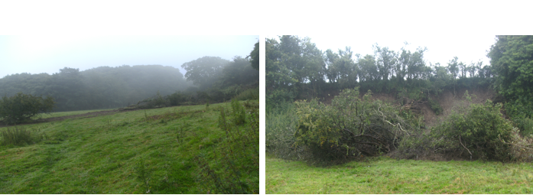
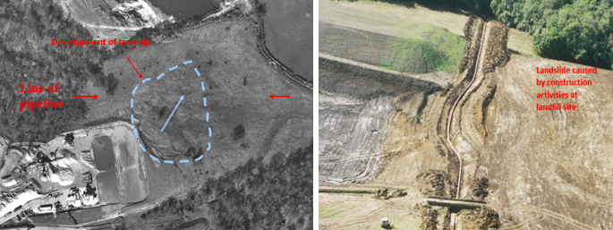

Erosion at river crossing
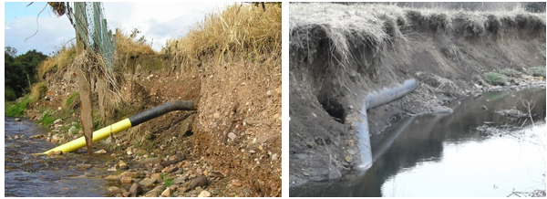

Soil liquefaction
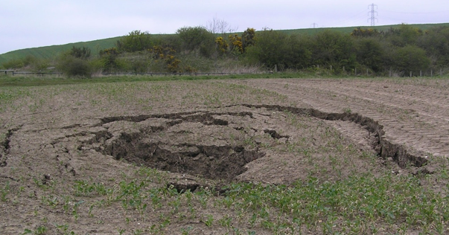

Subsidence
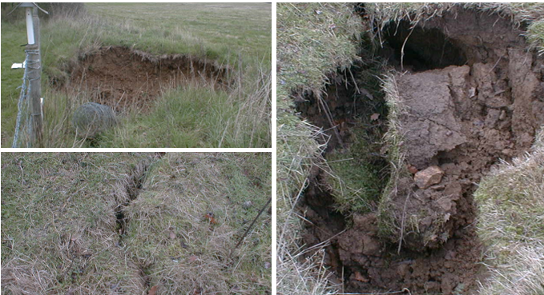

Quarrying
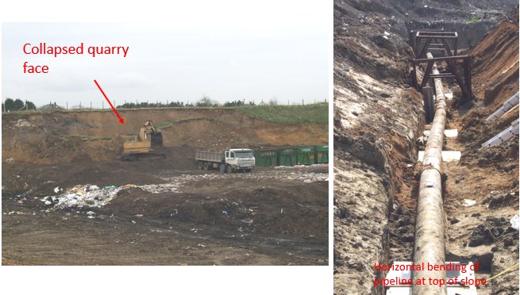

Flooding
