**Good Practice Guide**

UK Drone Use and Legislation

UKOPA/GP/039 Edition A

April 2021

GUIDANCE ISSUED BY UKOPA:

The guidance in this document identifies what is considered by UKOPA to represent current UK pipeline industry good practice within the defined scope of the document. All requirements should be considered guidance and should not be considered obligatory against the judgement of the Pipeline Owner/Operator. Where new and better techniques are developed and proved, they should be adopted without waiting for modifications to the guidance in this document.

Comments, questions and enquiries about this publication should be directed to:

UK Onshore Pipeline Operators’ Association

Pipeline Maintenance Centre

Ripley Road

Ambergate

Derbyshire

DE56 2FZ

E-mail: [enquiries@ukopa.co.uk](mailto:enquiries@ukopa.co.uk)

Website: [www.UKOPA.co.uk](http://www.UKOPA.co.uk)

Disclaimer

This document is protected by copyright and may not be reproduced in whole or in part, by any means without the prior approval in writing of UKOPA. The information contained in this document is provided as guidance only and while every reasonable care has been taken to ensure the accuracy of its contents, UKOPA cannot accept any responsibility for any action taken, or not taken, on the basis of this information. UKOPA shall not be liable to any person for any loss or damage which may arise from the use of any of the information contained in any of its publications. The document must be read in its entirety and is subject to any assumptions and qualifications expressed therein. UKOPA documents may contain detailed technical data which is intended for analysis only by persons possessing requisite expertise in its subject matter.

Copyright @2021, UKOPA. All rights reserved

Revision and change control history

Planned revision:

|  |  |  |  |
| --- | --- | --- | --- |
| Edition | Date | No. of pages | Summary of changes |
| **A** | 07/04/2021 | 15 | Initial Draft |
| **B** | 04/05/2021 | 21 | Initial Revision to include Appendices |
| **C** |  |  |  |
| **1** |  |  |  |

Contents

1. Executive Summary 1

2. Objectives/Scope of Work 3

3. Introduction 4

3.1 Background 4

4. Current Legislation 5

4.1 Open Category – Low Risk – Split into 3 sections – A1, A2 & A3 5

4.2 Specific Category – Increased Risk 7

4.3 Certified Category – High Risk – Equivalent to manned aircraft risk. 7

4.4 Insurance and Legal Governance 7

5. Results 8

5.1 Operational Planning 8

5.2 Privacy and Air Ownership 9

5.3 Data Handling 10

5.4 Incident Reporting and Legal Entities 11

6. Conclusions and Recommendations 12

7. Appendix 14

7.1 Operator Checklist 15

7.2 Category Choice Table 16

7.3 Operational Example Areas 17

8. References 21

# Executive Summary

The purpose of this document is to outline the current regulations regarding the use of remotely operated aerial vehicles under the new European framework that was adopted by the UK Civil Aviation Authority on 1st January 2021. These can also be known as the following in various documentation:

* Drones
* UAS – Unmanned Aircraft System
* SUAS – Small Unmanned Aircraft System
* UAV – Unmanned Aerial Vehicle

The period between 1st January 2021 and 1st January 2023 is known as a transition period where some of the previous licensing regulations still apply. This period also allows the use of aircraft that are currently in production that do not fall under the new aircraft categories.

The previous certification that allowed commercial operations before 1st January 2021 was known as the Permission for Commercial Operations or PfCO. The PfCO is still valid until its first renewal after 1st January 2024 and allows the use of drones up to 20kg in weight. Flights can generally be conducted to within 150m of a congested area and large gatherings of people or 50m from uninvolved people or structures.

Under the new framework there are three main operational categories. These categories are defined by the amount of risk associated with the size and capabilities of the aircraft as well as their intended use.

These categories are as follows:

1. Open category – Low risk

This Category is for drones and their operations that pose the lowest risk and is split into three sub categories:

A1 – Flights over uninvolved people. Depending on the aircraft category, but limited to sub 500g aircraft

A2 – Flights near to people. First certified category, meaning pilots can fly larger drones up to 4kg within 30 m of people. This requires they pass the A2 certificate of competency requirement which is valid for 5 years.

A3 – Far from people. This includes A2 aircraft where the pilot has not completed a competency course.

1. Specific Category – Increased risk

This category is for drones and operations that pose greater a risk than that of the Open category, or where one or more elements of the operation fall outside the boundaries of the Open category.

Pilots must hold a GVC (General Visual Line of Sight Certificate) which lasts 5 years or can have been PfCO holders until 2024.

1. Certified Category – High risk

This category is for operations that pose an equivalent risk to that of a manned aircraft. Permissions to operate under this category would be granted. This would involve operations such as long range flights. At this time, no legislation has been created to allow for this level of operation.

All aircraft must also be labelled with an appropriate operator I.D. regardless of category.

When operating in sensitive areas, the relevant authorities must be informed and any stipulations made by them should be met. This includes the operations conducted in or around CNI**[1]** or COMAH**[2]** sites. In these cases, site personnel and the Police must be contacted and made aware of the operations so as to avoid undue response to a threat of danger.

When operating close to registered aerodromes, the relevant ATC[3] must be informed and operations must then be coordinated with them. **Details of the areas of control around an aerodrome can be found in section 5.2 Privacy and Air Ownership. In short, these consist of 5 km from the end of a runway and 2.5 nautical miles around the entire site. These zones are in effect to an altitude of 2000ft.**

Pipeline operators must assess the appropriate risks in conjunction with Table 4.1, Table Appendix 1 and the operational areas in Appendix 7.2.

# Objectives/Scope of Work

The purpose of this document is to outline the current regulations regarding the use of drones within UK airspace as governed by the Civil Aviation Authority from 1st January 2021.

The information contained within is designed to aid UK pipeline operators in the selection of an appropriate services supplier as well as the correct aircraft and category under which it may be used.

This includes a brief overview of the previous regulations in place before this period and how some certifications and aircraft have been transitioned for use under the new legislation until 1st January 2023, as well as a detailed look into the current legislation and how operations can be conducted going forward.

All information herein is drawn from the CAA**[4]** document CAP722 Version 8 - Unmanned Aircraft Systems Operations in UK Airspace[[5]].

It is important to remember that all aircraft operations in open air are to be conducted under the guidance of the CAA, even though the UK has now adopted the European framework.

# Introduction

## Background

Since November 2019, the UK Civil Aviation Authority**[6]** has introduced the DMARES**[7]** scheme. This scheme made it essential for anyone flying any remotely operated aircraft of 250g or more to pass a multiple choice knowledge test and all owners to register as operators. All pilots then gain a flyer I.D. and all operators gain an operator I.D. The operator I.D. must be attached to any aircraft owned by the operator with characters no smaller than 3mm and in a location that does not require any special tools to gain access.

The purpose of the scheme was to bring accountability to operators of drones above the 250g weight class in case of an incident.

Under the previous regulations pre January 2021, the only way to operate a drone commercially was through the use of certification known as the Permission for Commercial Operations or PfCO for short. This certification is still valid until its first renewal date after 1st January 2024 and is renewed every 12 months.

To gain this certification each pilot was required to complete course followed by a theory assessment and a practical skills test. The operator, which could be the individual or the company the individual pilot was associated with would then be required to submit an operations manual for approval to the CAA. This mast be review and re-submitted every 12 months to retain the certification as an operator.

This certification allows the use of drones up to a weight of 20kg.

The distances of allowable operations are up to **400ft (120m) in height** and within line of site **up to 500m** horizontally. This is **determined by the size of the drone and the pilot’s ability to maintain visual contact** depending on environmental conditions. The aircraft must remain in the pilot’s line of sight at all times. This has not changed and these rules are still in effect. **These are rules that must be strictly obeyed and can be enforced by the Police and CAA with fines or even a prison sentence.**

Under this certification drones can also be flown to within 50m horizontally of people and structures now under the control of the pilot or 150m of a congested area or a gathering of 1000 people or more. The exception to this rule is during take-off and landing. During this time the separation distance can be reduced to 30m as long as no horizontal flight is conducted.

Operators could gain greater freedom to fly outside of these conditions through the approval of an OSC**[8]**. OSC’s were granted on a case by case basis individually assessed and approved by the CAA. There are several parts of an OSC, which included further operational handbooks and in depth risk assessments that are required to be re-submitted and assessed each year.

# Current Legislation

From 1st January 2021 the CAA has adopted the operational framework developed by EASA**[9]**. This new framework has been developed on a risk based system that allows greater freedom of operational flight for lower risk aircraft and was adopted by the CAA to bring the UK into line with European operations.

Following 1st January 2021, changes were also made to the DMARES legislation. Previously, only remote aircraft of a take-off weight of more than 250g required the pilot and operator to be registered and display the operator I.D. on the aircraft.

Under the new framework, all remotely operated aircraft that are not classified as toys required to carry and operator I.D. and be piloted by a registered pilot with a valid flyer I.D. These are renewed every 12 months.

The former PfCO and OSC certifications transfer over under the new legislation as long as they are not allowed to lapse. This means that a renewal is required to keep them valid every 12 months until 2024 when they are phased out. No new PfCO’s will now be issued.

We are currently in a transitional period until 1st January 2023 which allows the use of so called ‘legacy drones’ to be used in line with the current legislation framework. Each new drone will soon be required to carry a CE mark that will define which category it can operate under. At this time there are no drones commercially available that are marked for use under this new framework.

There are certain rules that **must** be followed, unless special permission is obtained from the CAA in the ‘Certified Category’ which is not yet operational. These are:

* Maximum flight altitude of 120m or 400ft.
* No dropping of objects of any kind.
* No carrying of dangerous goods.

These rules are to be kept at all times unless special permission has been obtained. Failure to comply can result in fines or a prison sentence.

Under the new EASA framework, operations are split into three main categories.

Each of the new categories allow operations depending on the risk involved and the aircraft used and are as follows:

## Open Category – Low Risk – Split into 3 sections – A1, A2 & A3

Subcategory A2 is only attainable through the completion of the A2CofC**[10]** course. This is valid for 5 years and allows operations within this category for the applicable. No Operations Manual is required by the certificate holder.

From 1st January 2023, all aircraft sold will be required to have a class mark. Until this time, all current drones will be classed under the category within which they can operate.

The table below (Table 4.1) outlines the sub categories along with the details of the appropriate class of aircraft and licensing.

|  |  |  |  |  |  |
| --- | --- | --- | --- | --- | --- |
| Type of operation | | Details of drone | | | Pilot |
| **Subcategory** | **Operating area** | **Class details/Class Mark** | **Common models available** | **Operational limitation date** | **Competency** |
| **A1** | Can fly over uninvolved people, but not over crowds  e.g. rural locations and remote AGI’s | Privately built <250g and < 19m/s | N/A | N/A | Read user manual |
| Legacy (pre 1st January 2021) <250g | DJI Mavic Mini |
| C0 <250g and < 19m/s | Not Currently Available |
| No intentional flight over uninvolved people  e.g. rural locations | C1 <900g | Read user manual. Complete online training and test |
| A1 Transitional <500g | DJI Mavic Air | 31 December 2022 | A2 CofC Theoretical test |
| **A2** | No closer than 30m horizontally from uninvolved people or 5m in ‘low speed’ mode in a 1:1 height to distance ratio.  e.g. suburban locations | C2 (can also be used in A3) <4kg | Not Currently Available | N/A | Read user manual. Complete online training and test. Complete self-practical training. A2 CofC Theoretical test |
| No closer than 50m horizontally from uninvolved people  e.g. suburban locations, towns, etc. | A1 Transitional <2kg | DJI Phantom/DJI Mavic | 31 December 2022 |
| **A3** | No uninvolved people within the area of flight.  No flight within 150m horizontally of residential, commercial, industrial or recreational areas. | C3 <25kg | Not Currently Available | N/A | Read user manual. Complete online training and test |
| C4 <25kg |  |
| Privately built <25kg | N/A |  |
| Legacy (pre 1st January 2021) <25kg | DJI Inspire | 31 December 2022 |
| A3 Transitional <25kg | DJI Matrice M300 |

Table 4.1: Open category operational requirements

All of the aircraft that fall into the envelope of the open category can also be flown under the specific category under the same requirements for that category, as long as the aircraft has been included in any relevant risk assessments and documentation.

For more information on operational conditions and allowances, please refer to The Model Drone and Model Aircraft Code. [[11]]

## Specific Category – Increased Risk

For operations of greater risk than that of the Open category, or where one or more elements of the operation fall outside the boundaries of the Open category. Pilots must either hold a valid GVC[12] which lasts for 5 years or have previously held a PfCO until it is phased out in 2024. The operator will then need to hold a valid Operational Authorisation from the CAA to operate under this category. Operational Authorisations include risk assessments of the proposed operational envelope – these can vary from company to company. These risk assessments determine the operating distances and conditions relevant to that operator, so would need to be reviewed to confirm an operators’ allowable requirements.

## Certified Category – High Risk – Equivalent to manned aircraft risk.

At this time, the law is not in place within the UK to allow this category of operation in unsegregated airspace. Further updates from the CAA will outline the aircraft requirements as well as the pilot training requirements. There will likely be additional aircraft maintenance logs as well as pilot logs that would need to be reviewed before work was undertaken.

At this time, this category is only allowed in segregated airspace, away from all people and other aircraft.

## Insurance and Legal Governance

All categories require a relevant drone specific insurance to be covered for commercial operations. Without this, any incidents would not be covered under a standard liability insurance. Insurances that cover the operation of drones carry the EC785/2004 certification. This certification ensures the minimum requirements are met in line with UK law. This equates to 750,000 insurance units, which at the time of publishing is equivalent to £750,000. This changes with the value of the pound.

If further indemnity is required, this must be agreed individually with the drone operator.

The UK Civil Aviation Authority only has governance of the drone whilst it is flow in the outside air. Any flights that are conducted internally do not require any of the above categories to be taken into account unless the flight path enters into an outside space at any point.

In this instance the Health and Safety Executive would have governance over any operations.

# Results

When undergoing contractor selection, there are a number of factors to consider.

The first is regarding the area that you require the operator to conduct operations. The correct category must be adhered to, especially if operating with in congested areas or close to uninvolved people.

If operating within the open category there are no requirements for having pre-built risk assessments. It is suggested that if using an operator within this category, that the relevant risk assessments are conducted for each type of operation required. These will typically be conducted by the drone contractor and should be provided to the pipeline operator before any operations commence.

It is also noteworthy that a single operator can conduct operations in multiple categories, but that they must have the correct aircraft and certification for each section to allow them to do so.

The final point should be to use the lowest category of drone possible for ease of the operations. This will then also mean conducting operations that are classed as a lower risk whenever possible, which also then means smaller separation distances can be in effect.

## Operational Planning

At this time there are no standardised operational planning documents that are required for any category or sub-category. It would be recommended however, that these be provided for your records in case of incident and for future reference.

These planning documents should include, but are not limited to the following:

* Brief overview of the type of operations to be conducted, including the aircraft used.
* Pre-site survey – this can be done via information about the flight are that can be obtained remotely and does not need to be exhaustive or definite, but will help in planning safe operations before any on-site work is conducted. This should include details such as the type of airspace that any flights are going to be conducted in, as well as predicted ground conditions such as terrain and access.
* Contractors should check to see if there will be any active Notice To Airmen (NOTAMs) active in the area of operations. These can include temporary exclusion zones which can limit operational areas including heights that flights may be conducted. These are always logged with contact details of the requestor, which can be used to coordinate operations within this area if needed.
* On-site survey – some of this can be confirming what was covered on the pre-site survey, but will allow for alterations to be made for situations realised when on site.
* Directions and contact details of the nearest A+E. Be aware this is not always the nearest hospital.
* Details and contact details of the nearest Air Traffic Control centre. This is in case an incident needs to be reported so that correct action can be taken for other aircraft if required.
* Details and contact information of the nearest manned Police station in case of incident.
* Plan of the area to be flown. It is recommended that this is marked with primary and secondary take-off and landing areas, as well as areas that may need to be monitored for safety reasons. Exclusion zones are also recommended to be outlined if applicable. These would be both for the drone and also for personnel or uninvolved people.
* Crew briefing. This need not be overly detailed, but should include a brief statement as to the nature of the operations as well as the responsible persons such as the pilot and observers.
* Operational procedures. These should be a brief overview of how the pilot will conduct operations throughout the task, including start-up and take-off and landing procedures.
* Emergency actions. This should be a section that outlines some possible emergency situations and the actions that would be taken to deal with them. This will ensure the operator has standard safety practices planned for several eventualities. Some of these could be aircraft fire, public incursion or even operator incapacitation.
* In addition to the documents listed above care should be taken to ensure that any flight activities comply with the Operators’ Permit To Work system, and any equipment used is certified as suitable for use in the respective zone, where appropriate. Operators and contractors shall consider the possibility of drones potentially entering a Hazardous Area Zone and shall ensure that their risk assessments and operational plans account for this potential scenario.

Please see Appendix 7.1 for an example operational planning check list.

## Privacy and Air Ownership

In regards to privacy laws, it has been determined that drones do not pose a risk if flown at a sufficient altitude. This is due to the normal view from a drone’s camera being used to view wider areas lacking sufficient detail to be classed as a nuisance.

It is advised however, that when operating within a built up area at lower altitudes, especially if this is residential, that the local police station be advised that operations are being conducted in the area in advance. If possible, local residence or businesses could be informed to reduce the risk of confrontation during operation which could pose a danger to both the operator and the public.

The same care with regards to informing the Police and other relevant parties should be taken when conducting operations in or around Critical National Infrastructure (CNI) sites. This is firstly to ensure operational safety, but also to avoid confusion in regards to potential danger for the site to relevant personnel as well as the Police.

In regards to flights over privately owned land, the CAA is the sole regulator of all UK airspace. All flights fall under the direct jurisdiction of the CAA within the UK, as long as the correct legislation is adhered to and are not flown in a way as to cause a nuisance i.e. low over uninvolved people or to film of photograph private property without the owner’s permission[[13]]. This would then become a Police issue.

The land owner does have a right to refuse a pilot to operate the drone from their land.

Great care should be taken when operations could fall into the exclusions zones in effect around aerodromes.

These are as follows:

A zone with the same dimensions as the Aerodrome Traffic Zone: A 2 or 2.5 nautical mile radius ‘cylinder’ around the aerodrome, extending 2000ft above ground level, centred on the longest runway.

Runway Protection Zones: A rectangle extending 5Km from the threshold of each runway away from the aerodrome, along the extended runway centreline, and 500m either side - also to a height of 2000ft above ground level.

An example of these areas can be seen below.

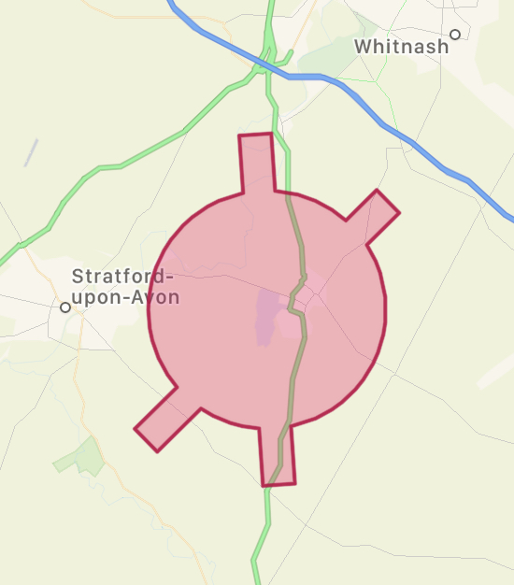

It is worth noting that operations can be conducted within these areas if permission is sought from and given by the controlling air traffic control. They would normally expect to receive the operational area, including flying heights, as well as the times the operations would be conducted. These must be strictly adhered to once agreed. If a greater operational area is needed, or more time is needed, further permissions must be granted.

## Data Handling

Data should be shared in a secure way to comply with company’s individual data protection policies.

This will ensure the quality of the data being shared. Sharing files over email or cloud storage service can sometimes compress or degrade the image or video quality.

Sharing data in this way will also ensure the security of the files contained within which may be a concern with certain CNI’s or areas around MOD sites.

## Incident Reporting and Legal Entities

Consideration should be given in case of an incident, to whom is responsible to undertake any further action. Below is a brief list outlining the overall responsibilities of relevant entities.

It should be noted that although it is generally the responsibility of the drone operator to report any incidents to involving flight to the CAA or AAIB, incidents outside of this remit should be reported directly to the relevant authority by your company.

CAA

Responsible for all areas of flight in the outside air, from when the aircraft is ready to fly and until the aircraft comes to a rest with its primary propulsion system shut down. Minor incident reporting should be carried out via the ECCAIRS 2 online form.

HSE

Responsible for all ground based operations as part of “Safety at Work”. Internal flights/Not in open air e.g. Elios Drone

Air Accident Investigation Branch (AAIB)

Responsible for investigating accidents and serious incidents involving non-military aircraft during flight. Normally called upon/involved by CAA

Police

Police have a responsibility to take action when a drone is being used dangerously or in a way as to cause a nuisance or criminal offence i.e. is a drone was being used to film sensitive assets without permission. People can still behave illegally whilst operating within CAA guidelines.

It should be noted that although it is generally the responsibility of the drone operator to report any incidents to involving flight to the CAA or AAIB, incidents outside of this remit should be reported directly to the relevant authority by your company.

# Conclusions and Recommendations

The following are scenarios that cover multiple situations that may need to be dealt with when using drone services to survey pipeline routes.

A drone must never be flown higher than 400ft (120m) and never further away than 500m from the pilot. This is reduced depending on the size of the aircraft and local conditions such as fog or low cloud as the drone must be kept in visual line of sight of the pilot at all times – This is a strict law and must be adhered to at all times.

**Suburban areas (pipeline running through in back gardens/high rise buildings)**

This primarily depends on the level of equipment needed by the contracting company. If a simple visual inspection is needed, the simplest route would be to use a drone service that can operate in the ‘A1’ category within the ‘Open Category’. This means a drone that is below 250g in weight, such as a DJI Mavic Mini. This drone is allowed in built up areas as well as to be flown over people as long as this does not include any large crowds.

If higher resolution imagery, or any specialised camera equipment is needed, then the best option would be an operator within the ‘Specific Category’. As a general rule these permissions have a 50m exclusion zone for uninvolved people whilst the aircraft is in flight, or 30m during take-off and landing. Is flying closer than this to people or property, the property owner or person must be informed of the operations before flight commences. This can carried out in advance either in person, or in writing for all properties in the flight area.

High rise buildings would need all people within to be properly informed in advance if the 50m exclusion zone could not be adhered to.

**Rural locations (considerations of with overhead lines, landowners, etc.)**

Proximity to people and building would be the same as the previous example. It would be recommended that during the operational planning phase, any hazards such as tall trees or powerlines be outlines as a risk and appropriate avoidance measures be set. This could include setting a minimum flying height to avoid such hazards.

Flight over private land is allowed without the land owners’ permission as long as the pilot is conducting the flight from outside of the privately owned land. In the UK, the CAA has sole jurisdiction on the use or airspace.

Where possible it is always better to inform land owners first to allay any concerns they may have over the operations.

Other factors to consider would be whether there could be uninvolved people in the area. If this is the case, exclusion zones would apply if using drones larger than 250g in weight, or they would need to be briefed as to the operations either in person or in writing.

**Industrial or commercial areas**

The same considerations should be given as to suburban areas. If using an ‘A1’ class of drone, flight can be conducted with no exclusion zones as these only apply to drones of a flying weight over 250g.

If using larger drones, either exclusion zones must be in place during operation to ensure no uninvolved people are within the flight area, or all people must be informed beforehand.

**Large construction sites or quarries and large estates.**

Permission from the site is required owner when flying a large distance over a site. If only flying over the edge of such a site, no permission would be required if there we no people in the area during the time of flight if using any drone other that an ‘A1 category drone.

Remember that the drone can only be flown whilst it is within 500m or line of sight, whichever is closer, in any horizontal direction.

As these sites are normally under the control of one legal entity, as long as all staff or people on site have been informed of the operations before hand, an exclusion zone need apply regardless of the class of drone used.

**Above ground installation with hazardous zones**

Hazardous zones should be set with exclusion zones to which the drone operator must adhere. It is the responsibility of the site operator to inform the drone operator of the relevant exclusion zones that need to be adhered to. It is important to remember that it is not possible to have an intrinsically safe drone due how they operate.

If such a site is close to other assets or properties not owned by the site operator and if using any drone except in the ‘A1’ category, the either appropriate exclusion zones must be set from the edge of the site, or adjacent property owners and people must be informed in advance.

**Sites with restricted access (bridges, railway cuttings etc.)**

With such sites, consideration must be given primarily to the surrounding areas. If there are possible areas where uninvolved people could be close by with no control of foot traffic, the flight zone must be cordoned off or a drone in the ‘A1’ or ‘A2’ category is recommended.

If the pilot is not stationed on the restricted land during the flight, no special permission is needed to over fly from the land owner. **Although overflight of private land is legally permitted [3], certain land owners, asset owners or railway operators might have specific procedures they may want operators to comply with. Remember, privacy laws must also be considered.**

**MOD land**

Most MOD sites will be restricted ‘no fly’ zones that can be enforced by themselves, the CAA and the Police. These restricted zones can at times extend beyond the boundary of the site.

**It is a legal responsibility to gain operational authorisation for any operations within the restricted area.**

To ensure no unnecessary concern is caused to site personnel if conducting operations nearby, it is advised that all nearby operations, whether within the restricted zone or not, be coordinated with the relevant site authority and personnel.

# Appendix

## Operator Checklist

|  |  |  |  |
| --- | --- | --- | --- |
| **SITE NAME** |  | **Job Number** |  |
| **Contact Name/ No.** |  | **Office Address** |  |
| **Email Address** |  |
| **Job Location(s)** |  | **Type of Work Required** |  |
| **Vehicle Access** | Y/N | **Task Date (Flexible?)** |  |

|  |  |  |
| --- | --- | --- |
| **ITEM** | **ACTION** | **FINDING** |
| **INSURANCE** | Operators Insurance meets EC785/2004 |  |
| **AIRSPACE** | Within Controlled Aerodrome Boundaries? |  |
| **TERRESTRIAL PROXIMITIES** | Near Public Land/Footpaths or built up areas etc. |  |
| **AIR PROXIMITIES** | Other Aircraft (Aerodromes, Model Flying Sites, Heli Pads etc.) |  |
| **NOTAMs** | Active Notice To Airmen (NOTAM)? |  |
| **HAZARDS** | Live Firing, High Intensity Radio Transmissions, Gas Venting etc. |  |
| **RESTRICTIONS** | Nuclear Power Stations, Prisons, CNI’s, MOD etc. |  |
| **SENSITIVITIES** | Recreational areas, Local By Laws |  |
| **OBSTRUCTIONS** | Wires, Buildings, Masts, Other |  |
| **PEOPLE** | Local Habitation/ Industrial Areas, Site Personnel? |  |
| **PERMISSION** | Local Authority, Land Owner |  |
| **LIVESTOCK** | Local Farms/Nature Reserve Restrictions |  |
| **ACCESS** | Right of Way, Gates, Footpaths, Bridleways |  |
| **PLANNING DOCUMENTATION** | Planning Documents Received From Operator Including Emergency Scenarios |  |
| **RISK ASSESSMENTS** | Risk Assessments Received From Operator |  |

## Category Choice Table

|  |  |  |
| --- | --- | --- |
|  | Points To Consider | Operational Category |
| **Operational Area** | Is flight within built up  area or over people? | Y – Only use A1 Open Category or Specific Category with special permissions  N – Use lowest possible category |
| Is flight potentially close to uninvolved people? | Y – Use A1 or A2  N – Use lowest class possible |
| Is flight on a closed site? | Y – Contact and coordinate with relevant site personnel. If briefed, any class can be used.  N – Conduct flights within operational guidelines with lowest class possible in line with relevant separation distances. |
| Is flight within the restricted  zone of an aerodrome? | Y – Contact and coordinate with relevant aerodrome or Air Traffic Control to obtain relevant separation distances required to determine operational class.  N – Conduct flights within operational guidelines with lowest class possible. |
| Is flight near to a restricted zone such as an MOD site? | Y – Contact and coordinate with relevant site personnel to obtain relevant separation distances required to determine operational class.  N – Conduct flights within operational guidelines with lowest class possible in line with relevant separation distances. |
| Is drone used larger than 4kg? | Y – Only A3 or Specific Category would be allowed. Check individual operators risk assessments and documentation to determine operational abilities and separation distances of using the Specific Category.  N – Check operational class for separation distances. |

Table Appendix 1: Operational Category Table

## Operational Example Areas

Pipeline routes shown in pink showing example of potential areas of operation.

Urban/Built Up Area

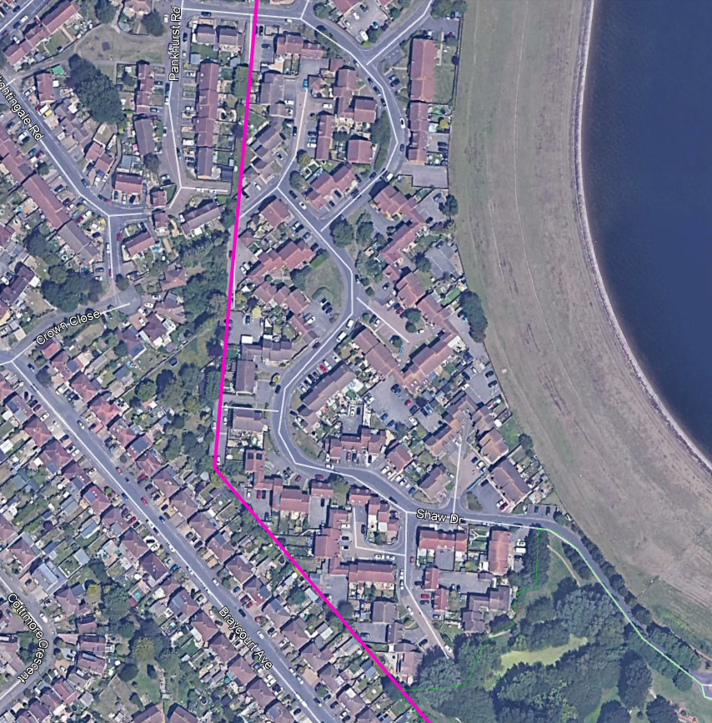

Overflight only possible in such a built up area with an A1 Class of drone or if all people under the flight path and separation distances were advised of the operations in advance. This should include a contact number provided for either the drone operator or pipeline operator to answer any questions.

The exception to this rule is where special permission has been granted by the CAA in line with operating in the Specific Category for flights over built up areas.

Third Party Terminal

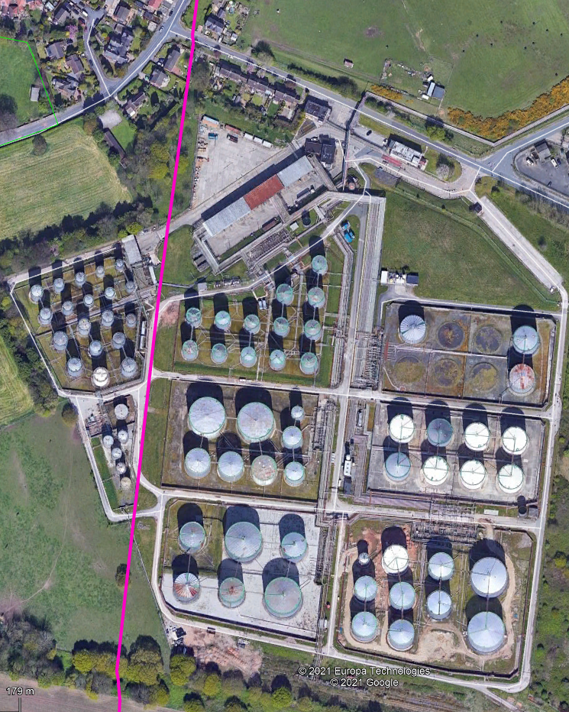

In this scenario it is advised to coordinate flights with site personnel. A minimum height would be advised to avoid the hazardous areas and it is recommended that all personnel operating in the flight area be briefed as to the operations being conducted.

Flights conducted near any of the residential areas or public roadways would need to be treated in the same regards as to urban/built up areas.

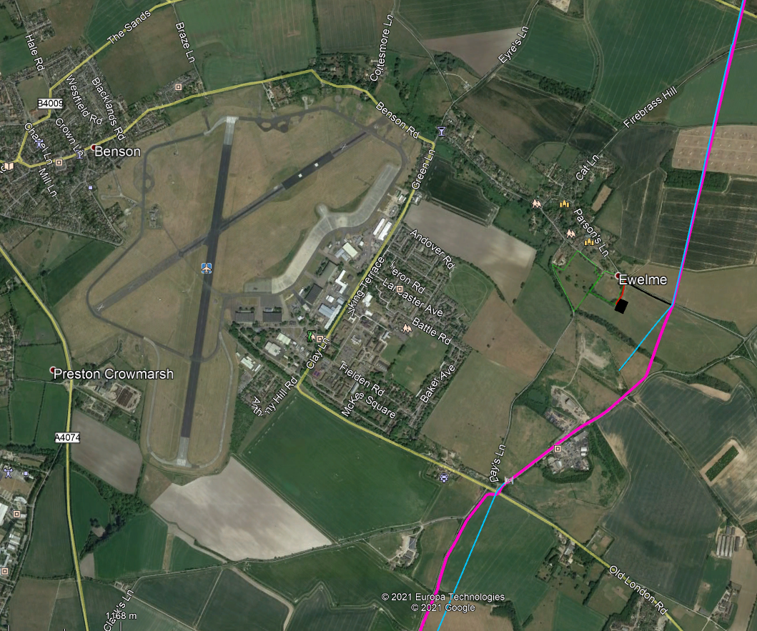Aerodrome/Quarry Site

Flight would be conducted within Aerodrome restricted zone so all operations would need to be requested and coordinated with the relevant air traffic control.

Flights over the quarry (inside the green circle) would require any on site personnel to be briefed if using any other class than A1.

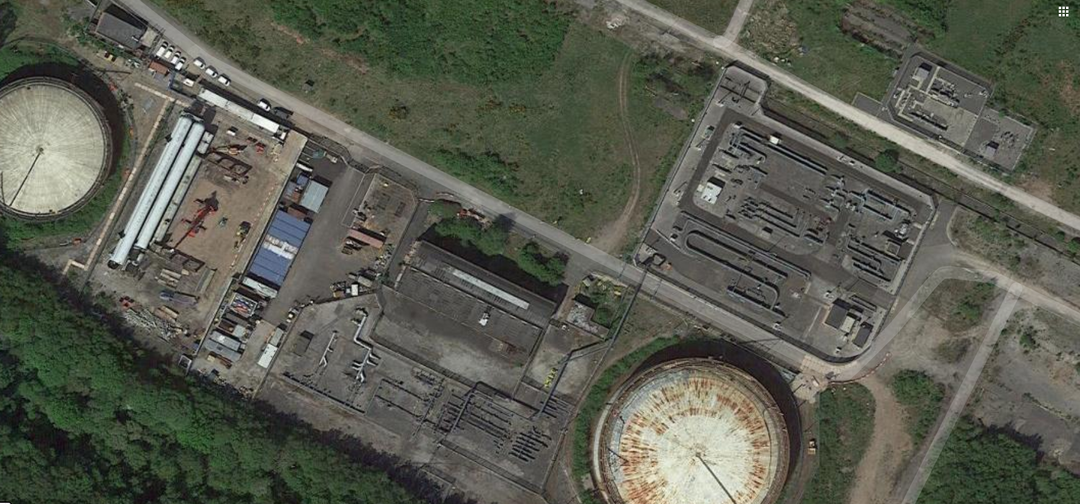Above Ground Storage Installation

Flights over a pipeline operators’ own above ground installation such as the one above would require careful planning in regards to hazardous areas. It is the responsibility of the drone operator and the pipeline company to agree the type of drone to be used in such areas.

All site personnel should be briefed on the operations being conducted.

Operators should keep in mind that no drone is classed as intrinsically safe, so operations around these areas should proceed with caution.

On a site such as the one pictured above there are several things to consider. The hazardous areas will vary in height depending on whether they are over pipework or the tankage. This may mean that the site operator will need to outline to the drone operator that there are different acceptable working heights depending on the asset being over flown in line with the hazardous area exclusion zones.

It is however recommended that a safe minimum height be set for all operations across the whole site. This will avoid any confusion and reduce the risk of any incidents in an emergency situation.

# References

1. Critical National Infrastructure.
2. Control of Major Accident Hazards.
3. Air Traffic Control.
4. Civil Aviation Authority.
5. [] [CAP 722 - Unmanned Aircraft System Operations in UK Airspace - Guidance](https://publicapps.caa.co.uk/modalapplication.aspx?appid=11&mode=detail&id=415)
6. Also known as the CAA
7. **D**rone and **M**odel **A**ircraft **R**egistration and **E**ducation **S**cheme
8. **O**perational **S**afety **C**ase
9. **E**uropean Union **A**viation **S**afety **A**gency
10. A2 **C**ertificate **of** **C**ompetency
11. [] [The Drone and Model Aircraft Code](https://register-drones.caa.co.uk/drone-code)
12. **G**eneral **V**isual Line of Sight **C**ertificate
13. [] [Section 76(1) of the Civil Aviation Act 1982](https://www.legislation.gov.uk/ukpga/1982/16/section/76#commentary-key-3492088a3bfd3b3df2de9d24ad9212f6)