Stallingborough URX Installation
Date of incident: 20/12/14
Description: The installation of Stallingborough URX commenced with the chamber in the YN corner of the level crossing. Due to locating unforeseen services in the dig area, the chamber was moved 1.5m from the designed position.
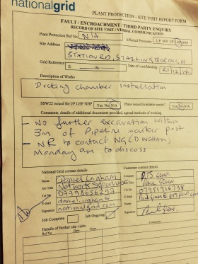
NG Concerns: The excavation was within 3m of a high pressure gas pipeline. NG had not been contacted to inform them of the proposed works or methodology prior to the work.
Design Detail
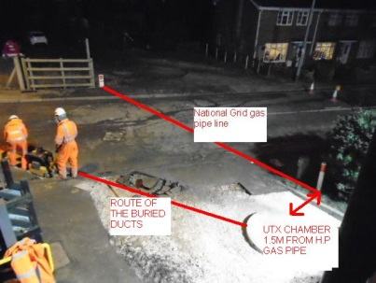
Approx. 4m clear
As Built Detail
Approx. 2m clear
Findings
Design
- No contact with utility provider during the process
- Designer’s Risk Assessment not specific to the risk
- *Observation pit for the chamber not undertaken
Planning and Notification
Notification during design process – 0 Due to breakdown in information passed on from NR
*Notification during planning for build – 0 – Due to breakdown in roles and responsibilities

Confirmation of service location and marking up not undertaken due to breakdown in roles and responsibilities
The details given in the document ‘Gas Transmission Underground Pipelines Guidance’ within the Network Rail buried services pack were not followed
The details given in the National Grid Document – ‘Specification for working in the vicinity of National Grid high pressure gas pipelines and associated installations – requirements for third parties’ were not followed
Execution
- *Unforeseen services were identified during the excavation of the chamber on the 20/12 which led to the chamber being moved from approximately 4m away from the gas main to circa 2m away from the gas main
- *No escalation to the build CRE before moving the chamber
- Early start initiated by QTS prior to attendance of Siemens Supervisor

Proposed Actions
Design
- Service providers to be contacted where high risk services are identified on the design/DRA prior to release of future AFC drawings and clearly noted within the design (Tata – see table)
- AFC drawings already issued to be reviewed for other high risk services (Tata – see table)
- Confirmation that observation pits have been carried out to be given prior to AFC drawings being released (Tata – see table)

Planning and Notification

- Design/Buried Services pack to be reviewed and table to be collated identifying where high risk services are present at other level crossings. An open and closed system is to be used to identify where there are still outstanding service providers to be contacted by the construction team (Build CRE – see table)
- Service providers to be contacted to confirm methodology for each further location identified where applicable (Build CRE – see table)
Execution
- Bulletin to be briefed out to the relevant staff to inform them on the procedure; this includes (Civils WPM, prior to next installation):
  - Stating requirements for notification
  - Escalation requirements

