Recommendations for Destructive Testing of Pipeline Samples to Establish Material and Weld Quality

Contents

1 Introduction 2
2 Purpose of Material Sample Testing Recommendations 2
3 Tensile Tests 2
4 Impact Tests 4
5 Dimensions of Pipe Sample 5

1 Introduction

The application of recommended methods for the assessment of damage and defects in pipelines requires strength and toughness data for the linepipe material and girth welds. The absence of this data results in the application of conservative lower bound assumptions.

The UKOPA PIWG is considering the options for establishing the material and weld quality of older pipelines where there are no construction records. As a first stage, the requirements for destructive testing of material and weld samples cut from old pipelines, or taken from material stocks for such pipelines, are needed.

2 Purpose of Material Sample Testing Recommendations

This document presents the minimum requirements for destructive strength and toughness tests. The test requirements for material and weld samples from pipelines which have no existing construction records are presented.

3 Tensile Tests

Tensile tests to be carried out in accordance with BS EN ISO 3183.

Pipe body material – 2 longitudinal test pieces per sample location, where possible the number of sample locations should represent 0.1% of the pipe spool lengths (typically 12m).

Pipe type:
Longitudinal seam weld – specimens taken at 180º to seam weld
Spiral welded – specimens taken adjacent to weld
Seamless –specimens taken at any location

Test specimen position and orientation is shown in Figure 1 (pipe diameter > 300mm, circumferential) and Figure 2 (pipe diameter ≤ 300mm, axial).

Pipe welds – 2 specimens taken at 90º across the weld (longitudinal seam, spiral, girth welds) per sample weld location (ie longitudinal seam/spiral and girth weld), where possible number of sample locations to represent 0.1% of pipe lengths.

The yield stress (Rt_{0.5}), tensile strength (Rm) and percentage elongation are required.

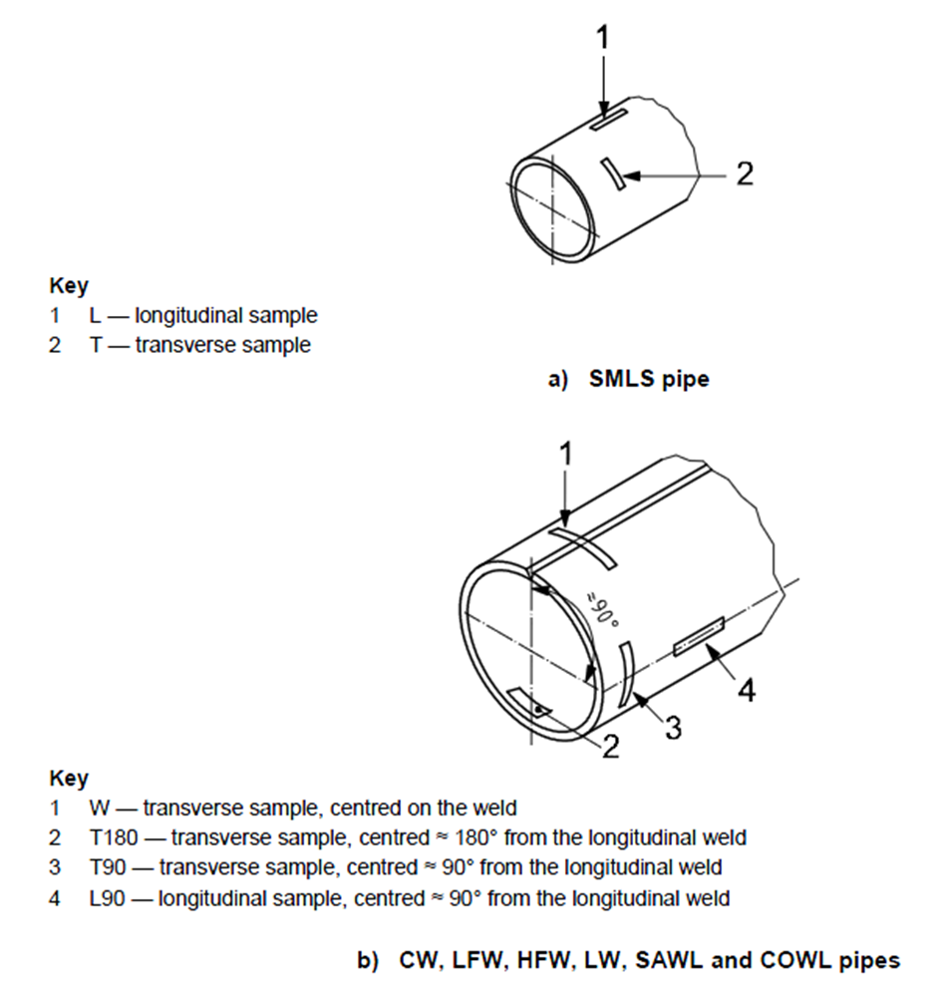
Figure 1 Sample Test Piece Orientations and Locations

Test specimens may be prepared from an oversize flame cut section, machined parallel test section to be a minimum of 15mm from any flame cut edge. The dimensions of the flame cut sample should be no less than 80mm wide x 440mm long. Test specimens should be flattened at ambient temperature. The length of each specimen shall not deviate from flatness by more than 3mm at any point.

Machining dimensions of the test specimen are shown in Figure 2.
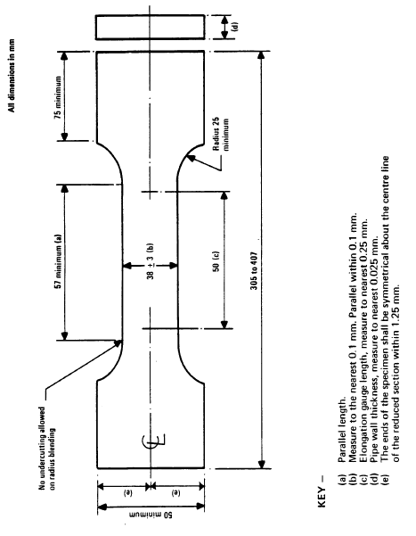

Figure 2 Tensile Test Specimen Dimensions

4 Impact Tests

Charpy impact tests to be carried out in accordance with BS EN ISO 3183.

Pipe body material – 3 transverse test pieces per sample location, where possible number of sample locations to represent 0.1% of pipe lengths.

Longitudinal seam weld - taken at 90º to seam weld
Spiral welded – taken adjacent to weld
Seamless –any location

Pipe welds – 3 specimens taken at 90º across the weld (longitudinal seam, spiral, girth welds) per sample weld (ie longitudinal seam or spiral and girth weld) location, where possible number of sample locations to represent 0.1% of pipe lengths.

The minimum and average impact energy obtained from the sets of 3 test specimens must be recorded.

Three test specimens should be machined from pipe samples of min size 80mm wide x 80 mm long. Test specimen position and orientation is shown in Figure 1. Test specimens shall have the greatest possible transverse width between 10mm and 5 mm. Circumferential pipe specimens will be sub-size, Figure 3 shows a typical 2/3 size specimen used for pipe testing.

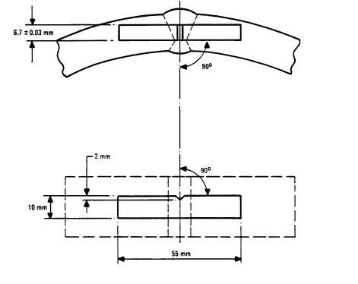
Figure 3 Typical 2/3 Pipe Charpy Test Specimen Dimensions

5 Dimensions of Pipe Sample
In order to extract the above samples, a sample of pipe 600m either side of the girth weld is required.

