**Email from G Leach - 24/06/15 - Pipeline Vulnerability**

This is a text extract from my report on buried pipeline vulnerability:

cid:image001.png@01D0AE9F.A74FEAD0

If we set a cautionary limit at seismic intensity level VIII we would find that only a very small area of North Wales is affected for a return period of 2500 years. This is the return period suggested in PD 6698 for high consequence structures. The equivalent return period in Eurocode 8 is 2000 years for pipelines associated with an exceptional risk to life. The seismic intensity map for a return period of 2500 years is shown below:

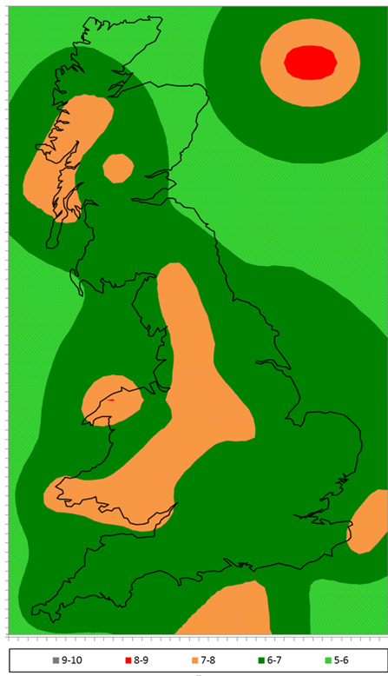

If we can confirm a return period then I believe we have a simple basis for screening buried pipelines based on vulnerability. This approach does not need any consideration of ground type.

The next challenge would be to provide a similar assessment for above-ground installations.

The damage descriptions for intensity level VII for two different scales are:

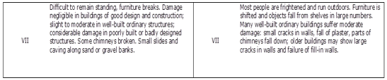

I hope that this helps to illustrate how a vulnerability assessment may be a basis for screening for seismic hazard.

**Email from G Leach – 25/08/15 - Review of German & French Seismic Requirements**

The paper by Engel et. al. ‘Assessing the Hazard to Buried High-Pressure Gas Pipelines from Earthquakes in German Seismic Zones’ is particularly useful in clarifying the German approach to implementing Eurocode 8. The country specific requirements are defined in DIN EN 1998-1/NA(2011) which is the German national annex to EN 1998-1.

The approach in Germany is to exclude pipelines from the provisions of Eurocode 8 for those parts of the country with a calculated reference peak ground acceleration on rock of less than 0.04 g for earthquakes with a return period of 475 years. This criterion excludes most of Germany from the provisions of any seismic design.

Limited areas in western Germany, southern Germany and eastern Germany are zoned with associated reference peak ground acceleration values. The reference values must be altered to account for sub-soil conditions and the hazard category of the conveyed product. A sub-soil map is provided and the relevant amplification factors given. The importance factors (to adjust the seismic action according to hazard) are given in the national annex.

The paper highlights the application of EN 1998-4 Appendix B for calculating transient pipe strain due to travelling seismic waves. An extreme condition assessment is used to indicate that modern pipelines in Germany possess adequate resistance to transient strains due to earthquake generated seismic waves.

The threat posed by permanent ground movements is only likely to occur in exceptional cases but must be considered on an individual basis in the more active seismic zones.

The paper does not discuss the performance of above ground installations other than a general comment that above ground structures experience inertia effects.

The German national annex to EN 1998-1 is available in English at a cost of ~120 euro.

The paper by Fernandez et. al. ‘Pipeline resistance to earthquakes – state of the art, lessons learnt and gap analysis’ is a summary of a state of the art review commissioned by EPRG. It identifies the French regulatory guidelines CT15 from AFPS (French Association for Earthquake Engineering) as significant within Europe. The performance and assessment of above ground installation is not discussed.

In addition to the above I have identified a technical paper dealing with seismic design in France for industrial facilities. This indicates the regulatory requirement to use a seismic zonation map for France developed for Eurocode 8 compliance. The zonation map shows the variation across France of a reference peak ground acceleration on rock for a return period of 475 years.

The paper indicates that for new potentially hazardous industrial installations the earthquake return period for the reference seismic action must be increased to 5000 years. This is calculated using an importance factor applied to the seismic action from the zonation map.  Existing facilities must be retrospectively assessed based on a reference seismic action for a return period of 3000 years. The paper indicates that the regulations permit exclusions if there are no inhabitants or buildings within the hazard zone (minor roads are permitted).  Installations in all seismic zones are covered including in areas of very low seismicity. The paper does not talk about any site specific seismic hazard analysis. The emphasis is on the seismic zonation map.

So, it looks like the French regulatory approach would suggest a 5000 year return period for new hazardous above ground installations. This matches the existing requirements for LNG facilities. For existing installations a return period of 3000 years would be applicable (and this is very close to the 2500 year zonation only available).

**Email from G Leach 02/09/15 – Seismic Design of Industrial Facilities in Germany**

I have a technical paper from 2013 on the requirements in Germany for the seismic design of industrial facilities.

The return period for the determination of a seismic design loading is varied according to:

* Consequence [protection of human lives].
* Consequence [protection of environment].
* Security of Supply.

Each of the above aspects are rated and then the highest return period is selected.

The highest possible return period is ~2000 years for:

* Large-scale off-site consequences for human life associated with volatile and toxic substances.
* Very high requirements regarding availability e.g. emergency power supplies.