**Dent Management Tool – Assessment of Operator Data**

**Contents**

**1** **Introduction** 2

**2** **UKOPA Dent Management Assessment Tool** 2

**3** **Use of Tool for Assessment of In Line Inspection Data** 8

**4** **Assessment of Operator Data** 9

**5** **Conclusions** 11

**6** **References** 12

**Appendix 1 Pipeline Dent Assessment Questionnaire** 13

# **1 Introduction**

The UKOPA Dent Management Strategy (DMS) has been developed to provide guidance for the safe management of pipeline dents. It applies to the assessment of plain dents, dents with associated corrosion and dents associated with welds. Dents associated with gouges are not permitted under the guidance. It applies to pipelines constructed from line pipe material up to and including grade X65 operating at a maximum hoop stress level of 72% specified minimum yield stress (SMYS).

The detailed DMS guidance (detailed in document UKOPA/14/016) has been developed as an interactive Excel-based Dent Management Assessment Tool for the analysis of operator data. A questionnaire was circulated to members during 2014 for collection of operator data. The Dent Management Assessment Tool is described and the results of the application of the tool to assess data provided by pipeline operators are detailed in this report.

# **2 UKOPA Dent Management Assessment Tool**

The UKOPA Dent Management Assessment Tool applies the dent static and fatigue assessment rules detailed in the DMS Guidance document (UKOPA/14/016) to input data to assess the priority for site investigation or to confirm that no further action is required.

The tool is constructed as working spreadsheet entitled “Input Data”, which is used to input data for individual dents as described below. The data and the assessment result is presented when the tool is activated by clicking on the command button labelled “Management Tool”, as shown in Figure 1.

*Note, the current version of the tool requires a full size screen to display correctly.*

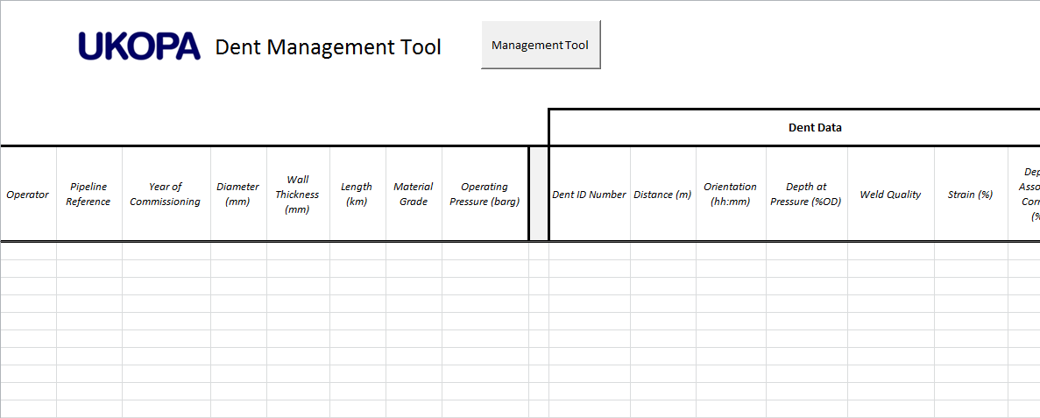

Command button

**Figure 1 – Dent Management Assessment Tool showing Command Button**

The spreadsheet column headers indicate the data required. Data is entered using interactive data input boxes which require data input in sequential order, as shown in Figure 2.

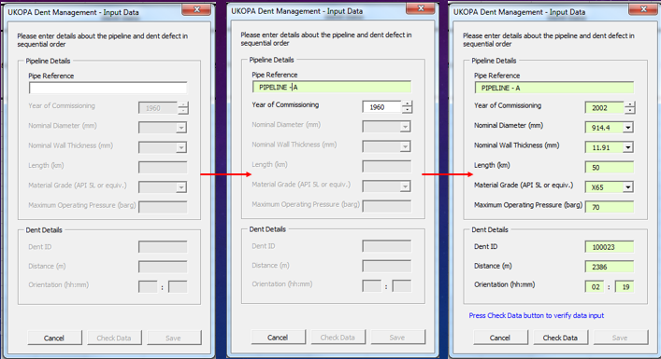

**Figure 2 – Sequential Data Input Boxes**

Where possible, the data is input is selected using drop down lists to avoid errors. On completion of each data input box, the “Check Data” button becomes active, which is used to review the data for potential errors. If the data is confirmed to be acceptable then the “Save” button becomes active, allowing the input data to be transferred to the spreadsheet.

The prioritisation flow chart shown in Figure 3 is then implemented. The flow chart is based on that present in the DMS guidance document. This flow chart takes the user through the series of questions which, together with the input data, allow the dent to be prioritised for investigation.

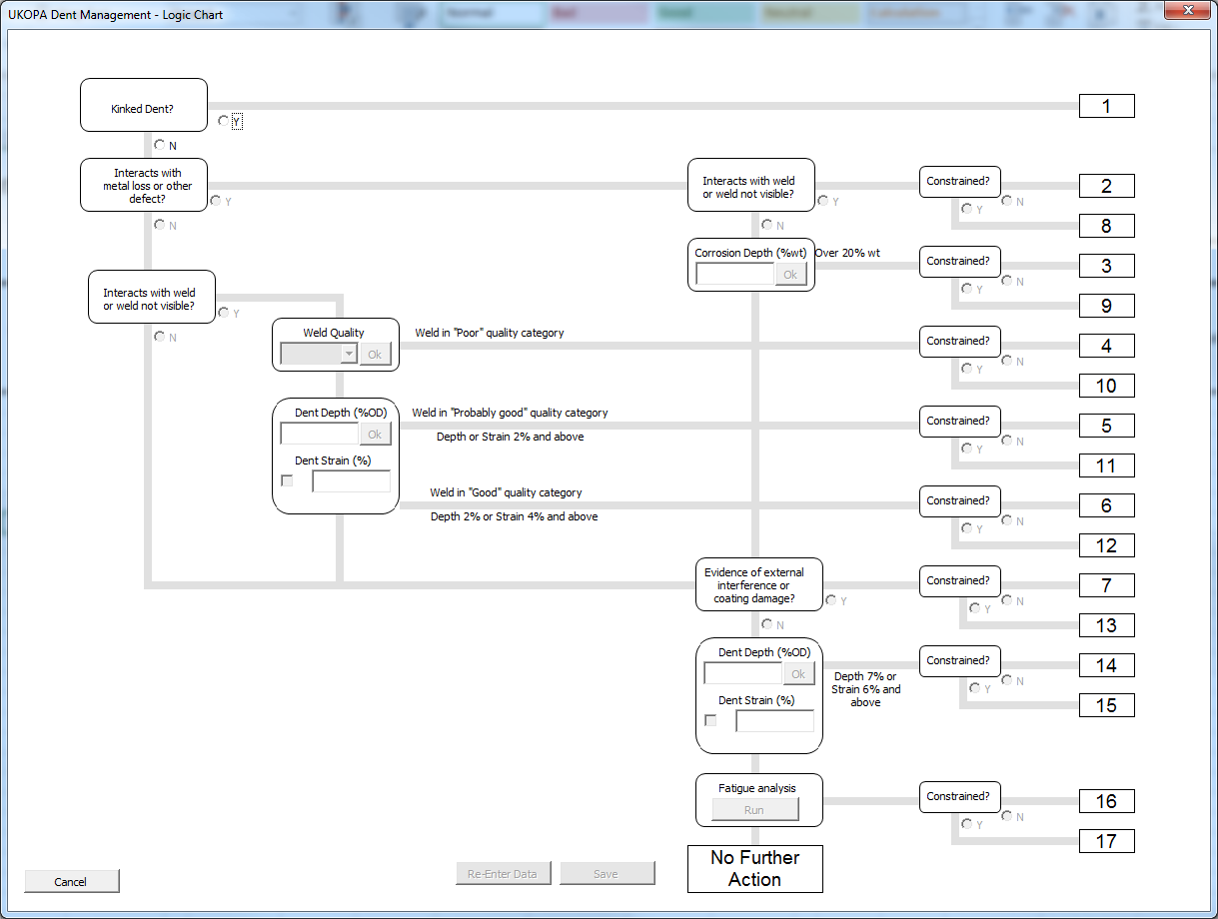

**Figure 3 – Flow Chart for Dent Prioritisation Algorithm**

The user follows the relevant Y/N controls to select the correct path. The flow chart lines shade as the control questions are selected to show the progress through the flow chart. Some questions, such as weld type require a more detailed response, for example weld quality. In such cases relevant selections are provided in drop down boxes. Data is re-entered or corrected by clicking the “Re-Enter Data” control button, this will revert the last response made. The process is shown in Figure 4.

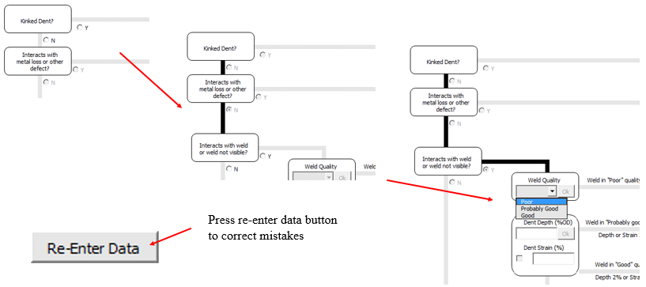

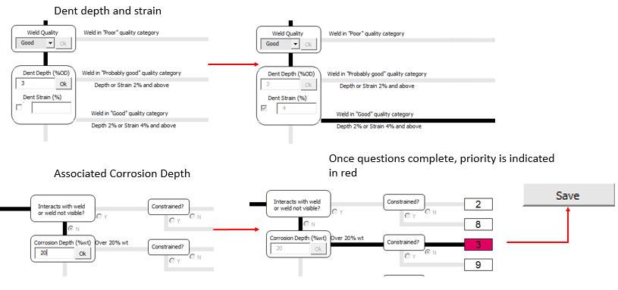

**Figure 4 – Using the Dent Prioritisation Flow Chart**

When the questions are complete, the priority is indicated in red, and the prioritisation is saved to the spreadsheet using the “Save” button.

Where the dent assessment process confirms that the static assessment rules are satisfied but the dent depth is greater than 2% OD or the strain is greater than 4%, a fatigue assessment is required, as shown in Figure 5.

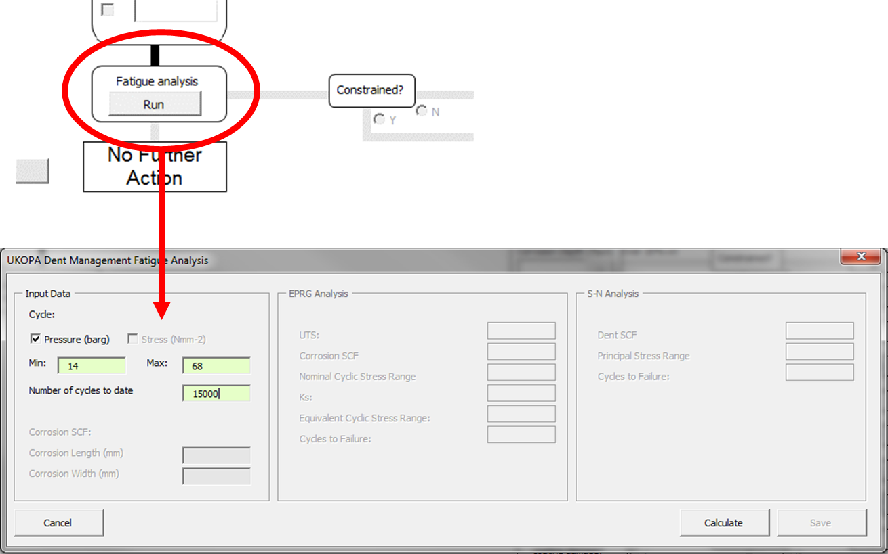

**Figure 5 – Data for Fatigue Assessment**

The pressure or stress cycle data (as chosen by the user) is entered using the interactive data input boxes. Where the dent has associated corrosion a corrosion length and width are required.

The results of the fatigue assessment are presented as shown in Figure 6. The fatigue life is first screened using the EPRG fatigue model, which provides a conservative estimation of the fatigue life. If the EPRG fatigue life is exceeded, a dent SCF is calculated and the BS 7608 Class B S-N curve is used to calculate a more realistic fatigue life.

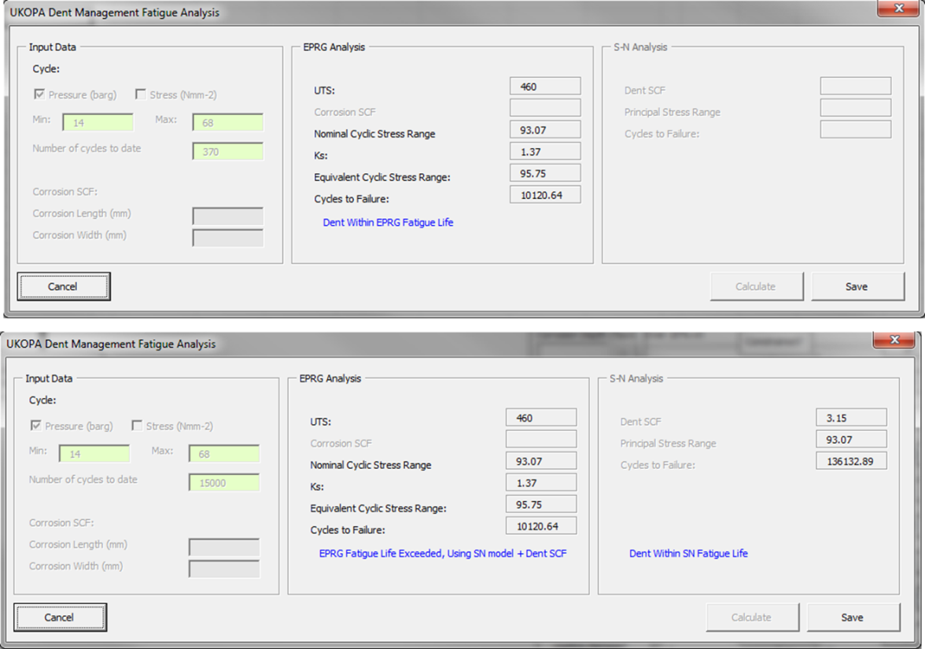

**Figure 6 – Results of Fatigue Assessment**

The results are presented in the spreadsheet as shown in Figure 7. The pipeline and dent data columns are populated by data from the interactive data input boxes and the fatigue calculation results boxes, the questions selected in the flow chart are shown as shaded Yes or No entries, or as N/A if the answer is not required. The last two columns give the priority rating as a number and as a data bar which provides a visual representation.

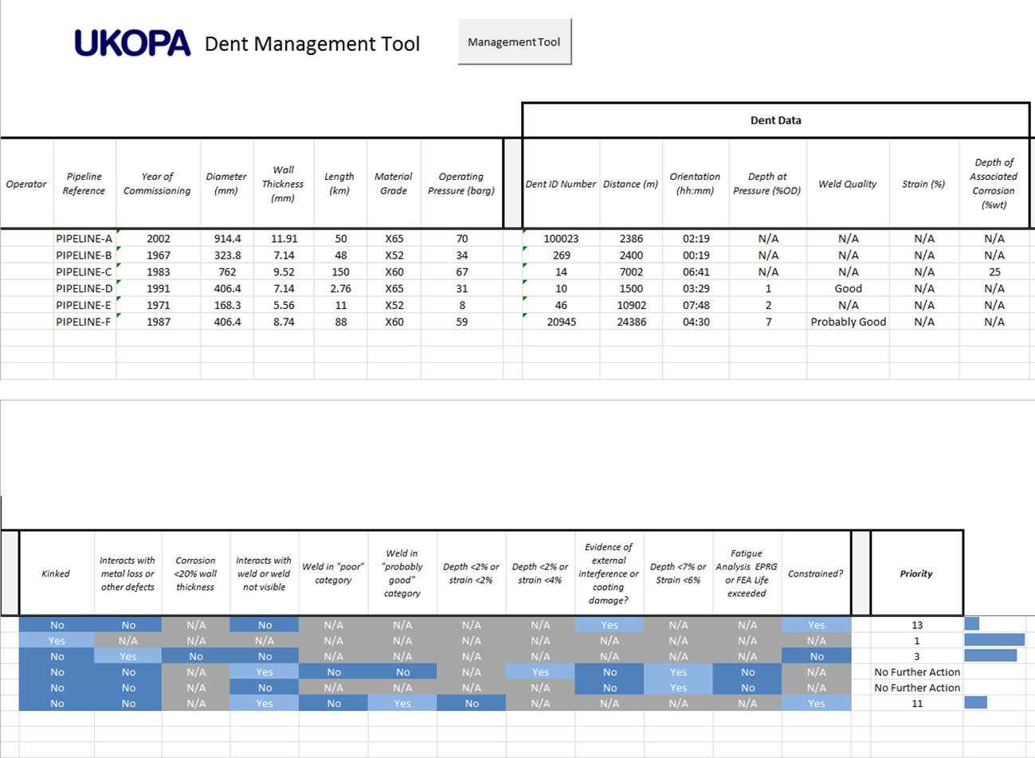

**Figure 7 – Results as Presented by the Dent Assessment Tool**

# **3 Use of Tool for Assessment of In Line Inspection Data**

The worksheet entitled “ILI Dent Assessment” is used to assess and rank data extracted from the in-line inspection (ILI) results report. This worksheet gives the dent priority for investigation as predicted by dent prioritisation algorithm. The layout and data requirements are shown in Figure 8.

Pipeline data is input to the two data boxes at the top of the worksheet. Relevant columns of data Aare then copied from the ILI results file and pasted into columns A to L under the column headings in row 15, following the stated data format given in row 14. Individual columns are left blank if the data is not available.

The tool is activated by clicking on the command button labelled “Management Tool”, as shown in Figure 8, and the prioritisation results and comments are given in Column O.

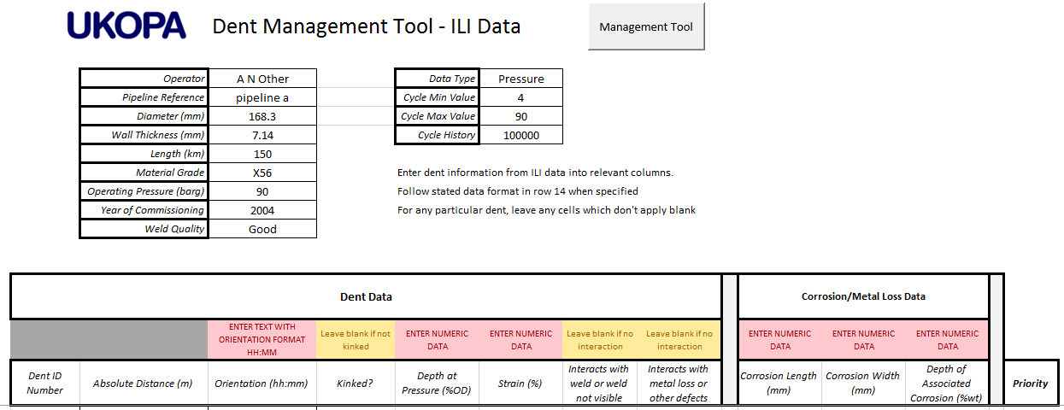

Command Button

Input data

**Figure 8 ILI Dent Assessment - Layout and Data Requirements**

# **4 Assessment of Operator Data**

A questionnaire detailing the data required to carry out a dent assessment was compiled and circulated to operators. The data required is summarised in Appendix 1.

Data returned by operators was analysed using the Dent Management Assessment Tool. Data was returned by 8 gas and liquid pipeline operators. The results are summarised in Table 1, and in the excel file entitled “Operator Data Assessment” inserted as an object below.

The data was compiled and 29 cases were selected for analysis. These included two check cases (Case 25 and Case 26), in which the lines were subject to cyclic pressures but where there were no dent features reported. A dent fatigue assessment in these cases was performed by assuming a dent of 2% OD existed in each pipeline. Note also that Case 28 is reported as repaired, Case 29 is the next largest dent in the same pipeline.

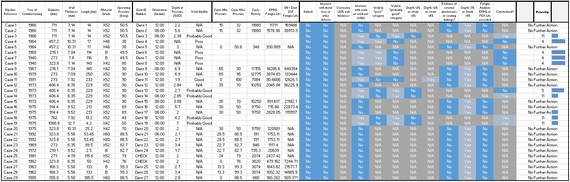

**Table 1 – Dent Management Assessment Tool – Results of Analysis of Operator Data**



Of the 29 dent cases assessed, 18 require no further action, 9 require further investigation and 2 are check cases for a pipeline with no reported dent features, but with an assumed dent of depth 2% OD. A fatigue assessment was carried out for 19 cases; of these, 13 exceeded the EPRG fatigue life assessment but were acceptable when assessed using the calculated dent SCF and the BS 7806 Class B SN curve.

The data included in Table 1 and the excel file covers the largest dents in approximately 2,300 km of gas and liquid pipelines operated by UKOPA members.

# **5 Conclusions**

4.1 The DMS guidance (detailed in document UKOPA/14/016) has been developed as an interactive Excel-based Dent Management Assessment Tool for the analysis of operator data.

4.2 The tool and is application are described for use by UKOPA members.

4.3 The Dent Management Assessment Tool has been used to assess data provided by 8 UKOPA members representing the maximum size dents on 2,300 kms of gas and oil pipelines operated by UKOPA members.

4.4 The results of 29 dent cases selected from the data supplied are presented in terms of the priority for further investigation or confirming no further action.

4.5 Of the 29 dent cases assessed, 18 require no further action, 9 require further investigation and 2 are check cases for a pipeline with no reported dent features, but with an assumed dent of depth 2% OD.

4.6 Fatigue assessment was carried out for 19 cases, of these 13 exceeded the EPRG fatigue life assessment but were acceptable when assessed using the calculated dent SCF and the BS 7806 Class B SN curve.

# **6 References**

1. UKOPA Dent Management Strategy – Guidance. UKOPA/14/016 V1.1 November 2014.
2. UKOPA Dent Management Strategy – Technical Background. UKOPA/14/017 V1.1 November 2014.

# **Appendix 1 Pipeline Dent Assessment Questionnaire**

