Technical Briefing Note
Lower bound for required fatigue assessment of pipeline dents
UKOPA/TBN/010 Edition 1
October 2019

TECHNICAL BRIEFING NOTE GUIDANCE ISSUED BY UKOPA:
This Technical Briefing Note (TBN) identifies what is considered by UKOPA to represent current UK pipeline industry good practice within the defined scope of the document. All information is guidance and should not be considered obligatory against the judgement of the Pipeline Owner/Operator. Where new and better techniques are developed and proved, they should be adopted without waiting for modifications to this TBN.

Comments, questions and enquiries about this publication should be directed to:
UK Onshore Pipeline Operators’ Association
Pipeline Maintenance Centre
Ripley Road
Ambergate
Derbyshire
DE56 2FZ
E-mail: enquiries@ukopa.co.uk
Website: www.UKOPA.co.uk

Disclaimer
This document is protected by copyright and may not be reproduced in whole or in part, by any means without the prior approval in writing of UKOPA. The information contained in this document is provided as guidance only and while every reasonable care has been taken to ensure the accuracy of its contents, UKOPA cannot accept any responsibility for any action taken, or not taken, on the basis of this information. UKOPA shall not be liable to any person for any loss or damage which may arise from the use of any of the information contained in any of its publications. The document must be read in its entirety and is subject to any assumptions and qualifications expressed therein. UKOPA documents may contain detailed technical data which is intended for analysis only by persons possessing requisite expertise in its subject matter.
Copyright @2019, UKOPA. All rights reserved
Revision and change control history
Planned revision:
Edition | Date | No. of pages | Summary of changes
1.0 | 9/10/19 | 21 | TBN produced to support PIWG dent project

Contents
1. Introduction 1
2. Fatigue damage 2
3. Dent fatigue 3
4. Endurance limit 4
5. Endurance limits for pipeline dents - stress cycle 6
6. Endurance limits for pipeline dents - pressure cycles 12
7. Pipeline dents and the IGEM/TD/1 endurance limit 17
8. Conclusions 20
9. References 21

Introduction
Pipelines are thin wall shell structures, and so are susceptible to dents, which are geometric distortions of the pipe wall. The severity of pipeline dents can be assessed by applying the UKOPA dent management strategy. The UKOPA dent management strategy allows the severity of dents to be assessed, both in terms of their ability to withstand static internal pressure loading; and their ability to withstand cyclic internal pressure loading, applied over a prolonged period of time, in other words fatigue loading.
In terms of static internal pressure loading, the UKOPA dent management strategy states a series of acceptable dent depth (or strain) limits for plain dents and dents associated with other pipeline defects and features such as corrosion or welds. If the depth or strain associated with a dent lies below the applicable limit, the dent is considered acceptable for pipeline operation with respect to static internal pressure loading.
In terms of cyclic pressure loading, the UKOPA dent management strategy recommends that, for pipelines which are pressure cycled, a fatigue assessment is performed to assess the remaining operating life of a dent. The fatigue assessment involves calculating an appropriate stress concentration factor (SCF) to account for the presence of the dent and the application of an S-N (Stress-Number of cycles) fatigue curve to determine the number of pressure (stress) cycles to failure.
In normal operation, a pipeline will experience static loading, generally corresponding to the nominal operating pressure, and therefore, for any dents in the pipeline, the static pressure loading rules in the UKOPA dent management strategy are always applicable. In normal operation, a pipeline will also experience periods of higher and lower pressure, which translate to stress cycles. When assessing the number of stress cycles to failure, the fatigue endurance limit of the pipeline steel identifies the magnitude of cyclic stress below which fatigue damage will not occur. This limit is used to identify stress the level below which a fatigue assessment is not required. The endurance limit is also applicable to dented pipelines; however, its value is affected by the presence of the dent. For certain dented pipelines therefore, depending upon the magnitude of pressure cycling experienced, a fatigue assessment will not be required.
The UKOPA dent management strategy, however, does not take into account the endurance limit of pipeline steels. Furthermore, the available data on the endurance limit for dented pipeline steels is sparse. The options available for pipeline operators are therefore to either perform a fatigue assessment for every dent, potentially resulting in unnecessary calculations, or to apply the endurance limit indicated by the fatigue design S-N curve included in IGEM/TD/1 [1].
The aim of this note is to determine a lower bound threshold for which a fatigue assessment is required for pipeline dents in the UKOPA dent management strategy. Limiting values for fatigue damage in dented pipelines are derived and the applicability of the IGEM/TD/1 fatigue design curve is considered.

Fatigue damage
Fatigue damage to a material occurs due to the repeated application of alternating values of high and low stress, known as cyclic stresses. Each single stress value experienced by the material is not large enough to cause the material to fail in isolation; however, the repetitive action of stressing and de-stressing, causes the initiation of small cracks within the material. Once initiated, fatigue cracks will grow with each successive stress cycle, which can potentially result in failure. The susceptibility for the initiation of fatigue cracks is dependent upon a potential source for the defects within the material, and the presence of a stress concentration. Consequently, the fatigue design of welded joints is of particular importance.
Failure as a result of fatigue damage is dependent upon both the magnitude of the cyclic stresses, the number of cycles experienced by the material, and the presence of local geometric discontinuities. For each stress cycle magnitude, there are a set number of cycles at that stress that a material can experience before a failure occurs. Note that although the number of cycles until failure for any given stress cycle magnitude is a constant, the timescale for fatigue failure will also depend upon the frequency of that the material experiences those cycles. The S-N curve presents the failure locus for a material in terms of the magnitude of the stress cycle, S, and the number of stress cycles. S-N curves are plotted on a logarithmic scale and are obtained by testing small scale fatigue samples or coupons, which are subjected to a regular sinusoidal stress in a testing machine until failure. Each test counts the number of cycles to failure and generates a single S-N point. The S-N curve is derived from a linear regression of the results. An example of an S-N curve, taken from the gas pipeline code IGEM/TD/1, is shown in Figure 1.
Figure 1 – S-N curve from IGEM/TD/1
For pipelines, cyclic stresses predominantly occur due to variations in the internal pressure during operation. The cyclic stress loading associated with a pipeline can be calculated using records of the internal operating pressure by converting the values to a circumferential hoop stress using Barlow’s formula. Any potential fatigue damage can then be assessed by applying an appropriate S-N curve.
The recognised and accepted S-N curves applied in the UK are published in a number of standards. Generic curves are published in the fatigue design code BS 7608 [2] and the defect assessment code BS 7910 [3]. The generic curves in these standards are separated into classes which are used to represent plain steel and various steel welded, bolted and rivetted joints in plate and tubular structures. The classes of S-N curves in each standard are equivalent. In addition, a pipeline specific S-N curve (Figure 1) is included in IGEM/TD/1 [1].

Dent fatigue
Pipeline dents are permanent geometric distortions of the pipe wall caused by an impact between the pipeline and an external object. A pipeline dent represents an area of local stress and strain concentration. Consequently, the stresses experienced within a dent under cyclic pressure loading differ from those experienced by undented pipe. The fatigue life of a dented pipeline has been shown to be lower than that of undented pipe [4].
The circumferential hoop stress in an undented pipe wall under cyclic loading is not representative of the stress within a dent under the same loading, therefore with regards to fatigue analysis, a simple conversion from the internal operating pressure to the stress using Barlow’s formula is no longer appropriate.
The stress within a dent under cyclic loading must instead be approximated by applying an appropriate SCF to the hoop stress. SCFs are typically a function of the dent depth, dent shape, internal operating pressure, diameter to wall thickness ratio and whether the dent is constrained or unconstrained. Dent SCFs are derived through Finite Element Analysis (FEA) [5]. The UKOPA dent management strategy indicates that the most accurate representation of the fatigue life of a dent is achieved by combining an SCF derived by GL Noble Denton (now DNV-GL) with a Class B, E, or F (depending on dent location) S-N curve from BS 7608 to determine the number of pressure cycles to failure [6] [7].
The dent SCF derived by GL Noble Denton is defined as the ratio between the maximum principal stress range in any one pressure cycle (corresponding to the maximum and minimum operating pressure within the cycle) experienced by the dent, to the hoop stress range during the same cycle in the nominal undented section of the pipeline.
The SCF increases as the dent depth, H_{r}, increases where H_{r} is the dent depth measured at the pipeline operating pressure, after spring back and re-rounding.
For a dent depth ratio defined by H_{r}/D the SCF is given by:
$SCF=\frac{∆σ}{∆σ_{hoop}}=1.8\ln\left(88\frac{H_{r}}{D}+1\right)+1$ (1)
Where:
Δσ = maximum principal stress range in any one pressure cycle (in N/mm²)
Δσ_{hoop} = hoop stress range in the same pressure cycle remote from stress concentrations (in N/mm²)
D = outside diameter of the pipeline (in mm)
Equation (1) gives an upper bound SCF for a single smooth dent.
Having calculated the SCF, the number of cycles to failure for a specific stress range, N, can be determined from:
$C={(SCF.∆σ)}^{m}.N$ (2)
Which is the form of the S-N curve with the SCF included. C and m are constants whose values depend upon the particular S-N curve selected.

Endurance limit
The endurance limit, S_{e}, of a material is defined as the magnitude of stress cycle for which the material will not fail by fatigue under circumstances in which it is forced to endure an infinite number of stress cycles. Experimentally, steels have an endurance limit which is approximately half of the ultimate tensile strength, up to a maximum value of 700 N/mm² [8]. For pipelines, if the cyclic stresses experienced during normal operation are below the endurance limit of the pipe steel, there will be no fatigue damage and a fatigue assessment is not necessary.
On an S-N curve, the endurance limit is indicated by the point at high N at which the curve becomes independent of N. The pipeline specific code IGEM/TD/1 [1] defines a value for the endurance limit at 35 Nmm⁻². This limit is applicable to pipelines at the design stage and is shown on the IGEM/TD/1 S-N curve in Figure 2. The IGEM/TD/1 S-N curve is based upon Submerged Arc Welded (SAW) pipe samples with poor geometry (roof topping, plate offset and ovality) and longitudinal, surface breaking defects capable of surviving a hydrotest. The curve was developed on this basis due to a series of historical hydrotest failures which had occurred in pipes with these characteristics and includes a safety factor of 10 on the predicted number of cycles to failure. Consequently, the IGEM/TD/1 S-N curve is considered to be a conservative representation of the fatigue behaviour of pipelines at the design stage.
Figure 2 – S-N curve from IGEM/TD/1 showing endurance limit
For the generic S-N curves in the fatigue design code BS 7608, it is assumed that the endurance limit (termed the non-propagating stress range) is the stress range corresponding to 10⁷ stress cycles. Each S-N curve class in BS 7608 has a different value for the endurance limit. The endurance limits in BS 7608 are shown in Figure 3.
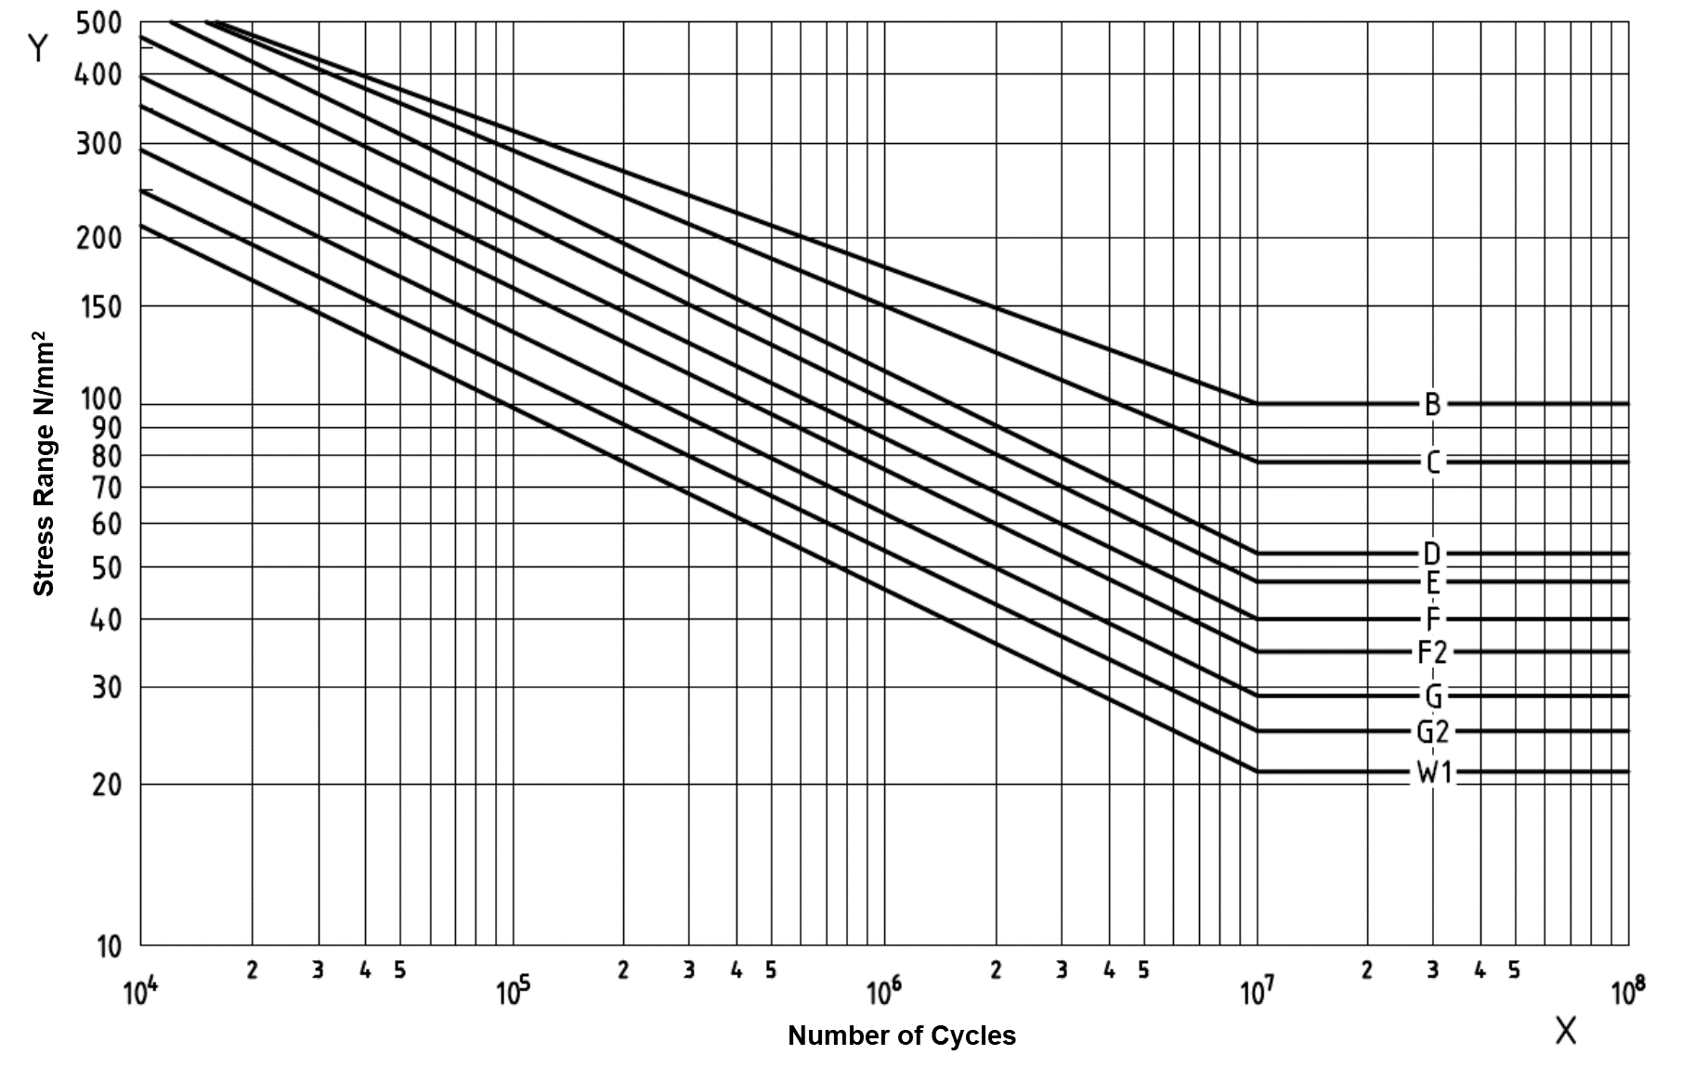
Figure 3 – S-N curves from BS 7608 showing endurance limit
The endurance limit is affected by both the environment (temperature, presence of sea water) and the existence of any defects. In particular, the endurance limit is extremely sensitive to surface condition, residual stresses in welds, and stress concentrations [9] such as dents.

Endurance limits for pipeline dents - stress cycle
The fatigue life of pipeline dents has been studied extensively, with numerous models having been developed to provide estimates of the number of allowable stress cycles that can be safely experienced, for example, the European Pipeline Research Group (EPRG) model [10], PRCI [11], API 1156 [12] and the BS 7608 and SCF method recommended by the UKOPA dent management strategy [6]. Little of this research, however, has directly addressed the endurance limit associated with the dents. In this section endurance limits will be derived for dented pipelines indicating the upper bound values of stress cycle magnitude such that no fatigue damage will occur.
The UKOPA dent management strategy recommends that the fatigue life of a pipeline dent is determined by calculating an appropriate SCF and applying the design S-N curves from BS 7608. The SCF acts as a multiplicative factor to the normal cyclic stress range experienced by the undented pipeline such that the effect of the stress concentration introduced by the dent is taken into account. The SCF allows the design S-N curves, which would normally be applied to undamaged components, to be used to provide an estimation for the fatigue life of a dent.
Provided the stress concentration associated with the dent is considered, the design S-N curves from BS 7608 can provide a realistic representation of dent fatigue behaviour. It is sensible to assume therefore that the endurance limits indicated in BS 7608 can be used to give a reasonable estimate of the endurance limits of dented pipelines.
The S-N curves from BS 7608 recommended by the UKOPA dent management strategy for pipeline dent fatigue assessment are given in Table 1. The curves are selected depending on whether the dent is located in plain pipe, the seam weld or the girth weld:
Location | Class | m | Constant, C
Plain pipe | B | 4.0 | 1.01x1015
Seam weld | E | 3.0 | 1.04 x 1012
Girth weld | F | 3.0 | 6.33 x 1011
Table 1 – S-N curves for application to pipeline dents
BS 7608 defines the endurance limit as the stress range corresponding to 10⁷ cycles. The form of the S-N curves is:
$C={(∆σ)}^{m}.N$ (3)
and rearranging (3) gives the stress range in terms of the allowable number of cycles:
$∆σ={\left(\frac{C}{N}\right)}^{\frac{1}{m}}$ (4)
Therefore, by substituting each of the values from Table 1 into equation (4) and setting N to 10⁷, the endurance limits for the BS 7608 S-N curves can be derived. The endurance limits for the class B, E and F design curves are shown in Table 2:

Location | Class | Endurance limit (Nmm⁻²)
Plain pipe | B | 100
Seam weld | E | 47
Girth weld | F | 39
Table 2 – S-N curve endurance limits
The SCF recommended by the UKOPA dent management strategy (equation 1) was derived by GL Noble Denton using FEA. The SCF is a function of the dent depth as a fraction of the pipeline outside diameter (OD):
$$SCF=\frac{∆σ}{∆σ_{hoop}}=1.8\ln\left(88\frac{H_{r}}{D}+1\right)+1$$
The form of the S-N curves, taking into account the SCF, is given by equation (2):
$$C={(SCF.∆σ)}^{m}.N$$
Which can be rearranged to give the stress range in terms of the allowable number of cycles for a dented pipeline:
$∆σ=\frac{1}{SCF}{\left(\frac{C}{N}\right)}^{\frac{1}{m}}$ (5)
A comparison between equations (4) and (5) therefore indicates that values for the endurance limits of dented pipelines can be derived using:
${S_{e}}_{dent}=\frac{{S_{e}}_{design}}{SCF}$ (6)
Where S_{e dent} is the endurance limit for a dented pipeline (dependent upon dent depth and S-N curve class) and S_{e design} is the corresponding endurance limit for the BS 7608 design S-N curve.
Values for the endurance limits of dents in plain pipe and the pipeline seam weld and weld, have been calculated using equation (6), equation (1) and Table 2, and are shown in Figure 4 and presented in Table 3. In terms of static burst strength, the UKOPA dent management strategy indicates that the largest dent considered to be acceptable for operation is 7% OD. A 7% OD dent is therefore the largest dent which could experience continued cyclic stress throughout the operating life of the pipeline. The calculated endurance limits therefore consider dents up to 7% OD. Note that the acceptability of a 7% OD dent is dependent upon the dent being smooth, located in plain pipe away from the seam and girth welds, and free from any additional defects.
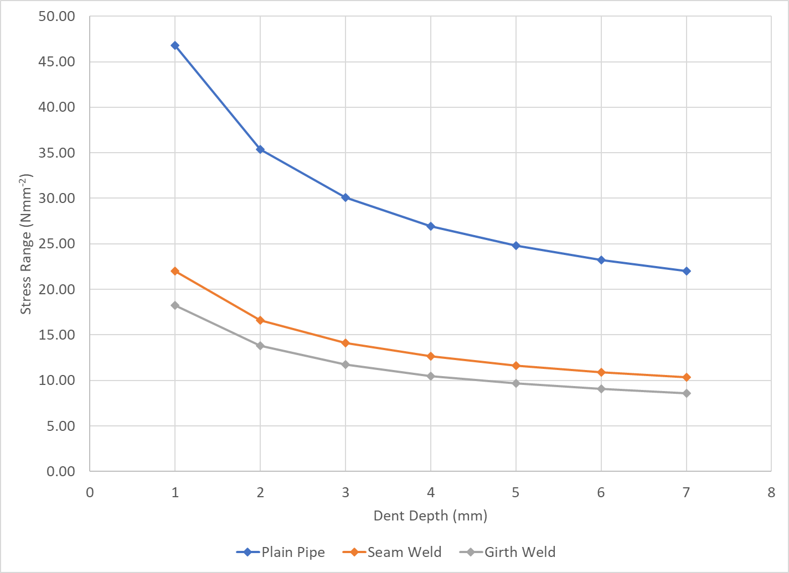
Figure 4 – Calculated dent stress cycle endurance limits
Dent depth  (% OD) | SCF | Plain pipe limit (Nmm⁻²) | Seam weld limit (Nmm⁻²) | Girth weld limit  (Nmm⁻²)
1 | 2.14 | 46.81 | 22.00 | 18.26
2 | 2.83 | 35.37 | 16.62 | 13.79
3 | 3.33 | 30.07 | 14.13 | 11.73
4 | 3.72 | 26.92 | 12.65 | 10.50
5 | 4.04 | 24.78 | 11.65 | 9.66
6 | 4.31 | 23.22 | 10.91 | 9.05
7 | 4.54 | 22.01 | 10.34 | 8.58
Table 3 – Calculated dent stress cycle endurance limits
It is noted that the values in Figure 4 and Table 3 refer to the normal cyclic stress range which would be experienced in undented sections of the pipeline (i.e. a direct conversion from the operating pressure using Barlow’s formula). Figure 4 and Table 3 indicate that for the largest acceptable plain dent under the UKOPA guidance (7% OD), fatigue damage will not occur provided the magnitude of stress cycle is below 22.01 Nmm⁻². This limit increases non-linearly as dent depth decreases such that a plain dent of depth 1% OD can withstand a stress cycle more than double (46.81 Nmm⁻²) that of a 7% OD dent before fatigue damage takes place. For dents on seam welds the endurance limits are significantly lower than for plain pipe; the calculated stress cycle for a 7% OD dent on a seam weld (10.34 Nmm⁻²) is less than half that of a plain dent of equal depth. Furthermore, the stress cycle for a 1% OD dent on a seam weld (22.00 Nmm⁻²) is comparable with that of a 7% OD plain dent. Dents on girth welds show the lowest calculated endurance limits overall with a 7% OD dent on a girth weld only able to withstand a stress cycle of 8.58 Nmm⁻². This rises to 18.26 Nmm⁻² as dent depth is reduced to 1% OD. It is noted that from Figure 4 and Table 3, only dents of depth 1% OD and 2% OD located in plain pipe have a calculated endurance limit in excess of the 35 Nmm⁻² endurance limit for pipelines at the design stage stated in IGEM/TD/1. This point is addressed in Section 7.
Following the completion of a dent fatigue assessment using BS 7608 and the GL Noble Denton SCF, the UKOPA dent management strategy recommends that a safety factor of 10 is applied to the calculated value of fatigue life. The safety factor is applied because pipelines are non-redundant structures and are not readily accessible for the detection of fatigue cracking during operation. Additionally, the S-N curves are derived empirically, and experimental fatigue test data is subject to considerable scatter. Applying the safety factor:
$N_{SF}=\frac{N}{10}$ (7)
Where N_{SF} is the number of allowable cycles with the safety factor applied. Equation (3) therefore becomes:
$C={(∆σ)}^{m}.{10N}_{SF}$ (8)
And rearranging to for the stress range gives:
$∆σ={\left(\frac{C}{{10N}_{SF}}\right)}^{\frac{1}{m}}$ (9)
The endurance limits for the BS 7608 S-N curves with a safety factor applied can be derived by setting N_{SF} equal to 10⁷ and substituting the values from Table 1 into equation (9). The endurance limits with safety factor for the class B, E and F design curves are shown in Table 4:
Location | Class | Endurance limit (Nmm⁻²)
Plain pipe | B | 56.4
Seam weld | E | 21.8
Girth weld | F | 18.5
Table 4 – S-N curve endurance limits with safety factor
From Table 4 and equation (6), values for the endurance limits of dented pipelines in plain pipe, the seam weld and the girth weld, with a safety factor applied, can be calculated. The values are shown in Figure 5 and Table 5 and consider dents up to 7% OD.
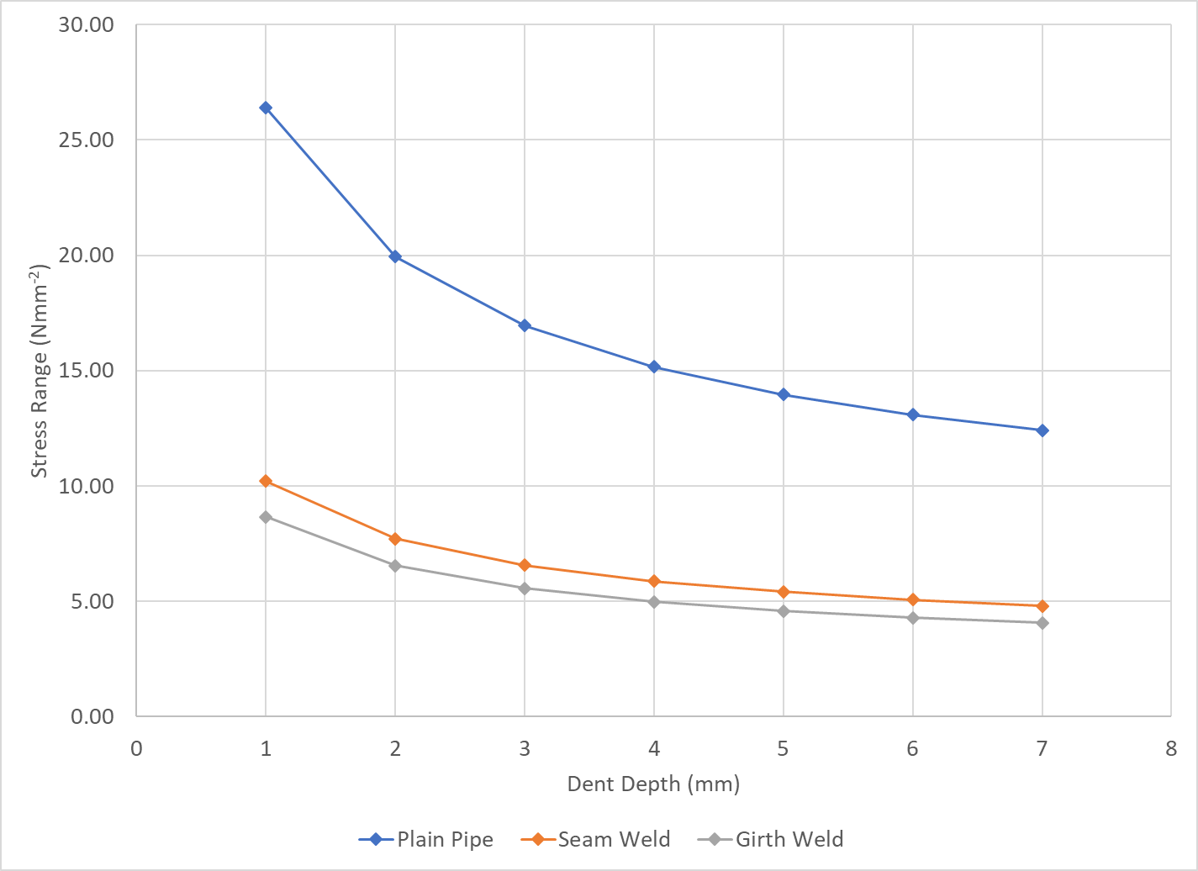
Figure 5 – Calculated dent stress cycle endurance limits with safety factor
Dent depth (% OD) | SCF | Plain pipe limit (Nmm⁻²) | Seam weld limit (Nmm⁻²) | Girth weld limit (Nmm⁻²)
1 | 2.14 | 26.39 | 10.22 | 8.66
2 | 2.83 | 19.94 | 7.72 | 6.54
3 | 3.33 | 16.95 | 6.56 | 5.56
4 | 3.72 | 15.17 | 5.88 | 4.98
5 | 4.04 | 13.97 | 5.41 | 4.58
6 | 4.31 | 13.09 | 5.07 | 4.29
7 | 4.54 | 12.41 | 4.80 | 4.07
Table 5 – Calculated dent stress cycle endurance limits with safety factor
As with Figure 4 and Table 3, the values in Figure 5 and Table 5 refer to the normal cyclic stress range which would be experienced in undented sections of the pipeline (i.e. a direct conversion from the operating pressure using Barlow’s formula). Under the application of a safety factor of 10 the endurance limits are significantly lower than those calculated for Figure 4 and Table 3. Figure 5 and Table 5 indicate that the limits for dents in plain pipe are reduced by a factor of 1.77, the limits for dents on seam welds are reduced by a factor of 2.15, and the limits for dents on girth welds are reduced by a factor of 2.11. It is noted that under the safety factor of 10 none of the dents considered have a calculated endurance limit in excess of the 35 Nmm⁻² endurance limit for pipelines at the design stage stated in IGEM/TD/1. This point is addressed in Section 7.

Endurance limits for pipeline dents - pressure cycles
In this section the stress cycle endurance limits calculated for dented pipelines in Section 5 are translated into pressure cycle endurance limits using Barlow’s formula. The limits are presented in terms of the dent depth and standard pipe sizes listed in Table 6. The limits indicate the maximum allowable size of pressure cycle such that no fatigue damage will occur.
Figure 6, Figure 7 and Figure 8 show pressure cycle endurance limits for dents located in plain pipe, seam welds and girth welds respectively. The limits in Figure 6, Figure 7 and Figure 8 are calculated using Table 3 and therefore do not include a safety factor.
Figure 9, Figure 10 and Figure 11 show pressure cycle endurance limits for dents located in plain pipe, seam welds and girth welds respectively. The limits in Figure 9, Figure 10 and Figure 11 are calculated using Table 5 and therefore include the safety factor of 10.
Pipe Size | Outside diameter (mm) | Nominal wall thickness (mm)
200 | 219.1 | 6.4
250 | 273.1 | 6.4
300 | 323.9 | 7.1
400 | 406.4 | 8.7
450 | 457 | 9.5
600 | 610 | 9.5
750 | 762 | 11.9
900 | 914 | 12.7
1050 | 1067 | 14.3
1200 | 1219 | 15.9
Table 6 – Standard pipe sizes used for pressure cycle calculations, diameter and wall thickness
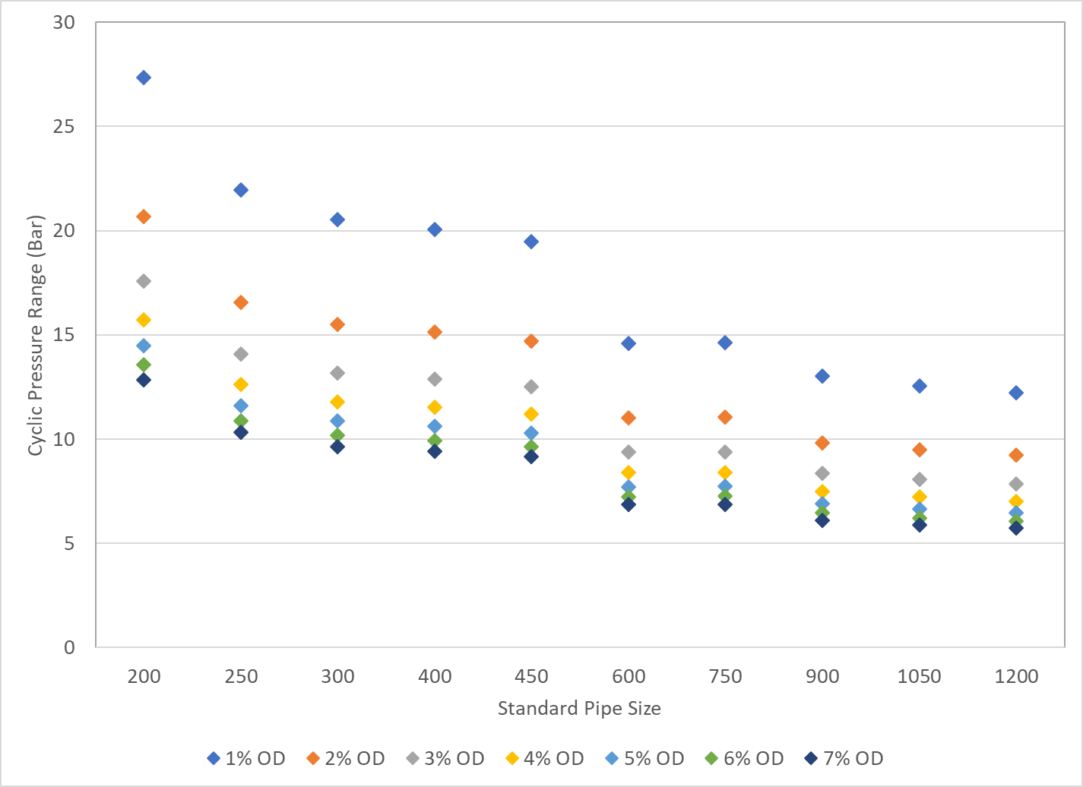
Figure 6 – Calculated pressure cycle endurance limits for dents in plain pipe with no safety factor
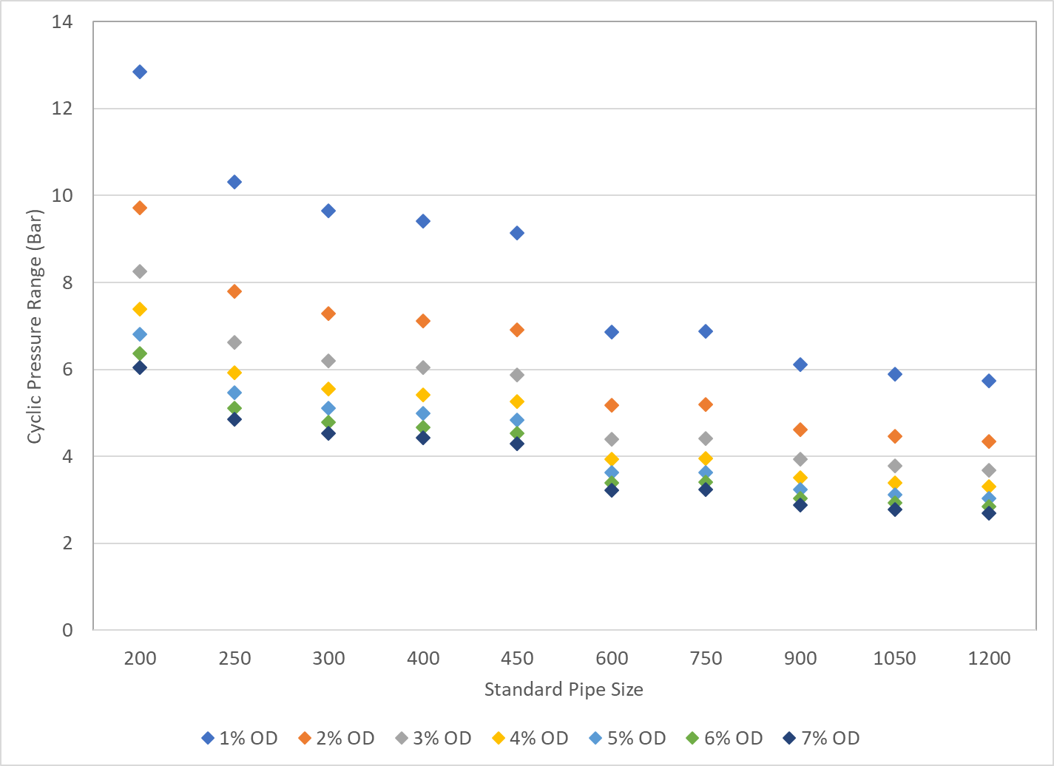
Figure 7 – Calculated pressure cycle endurance limits for dents in seam welds with no safety factor
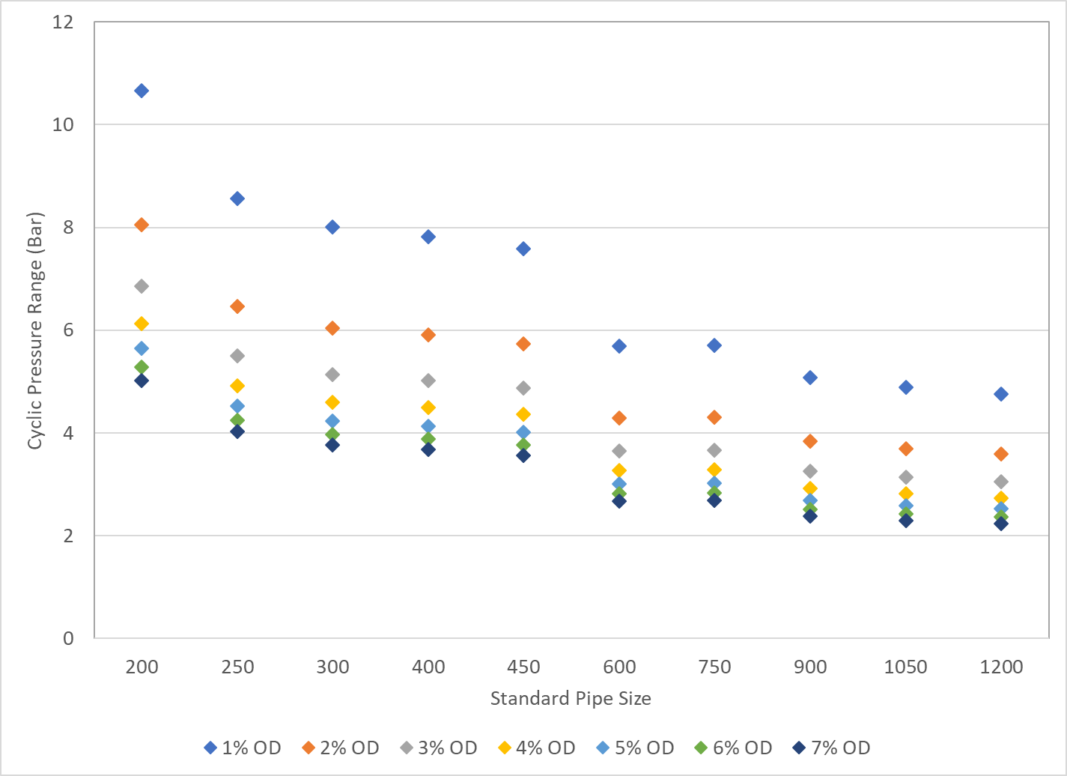
Figure 8 – Calculated pressure cycle endurance limits for dents in girth welds with no safety factor
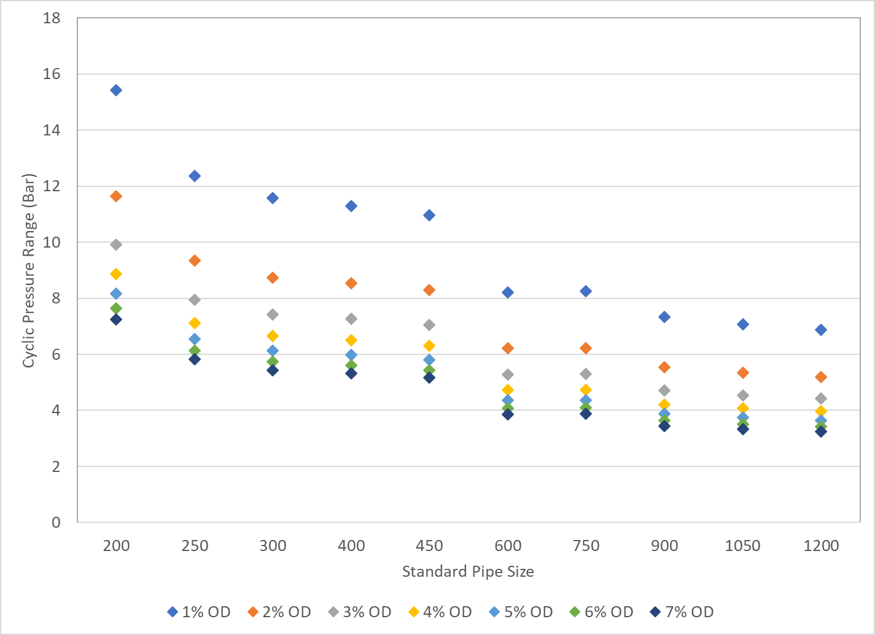
Figure 9 – Calculated pressure cycle endurance limits for dents in plain pipe with safety factor
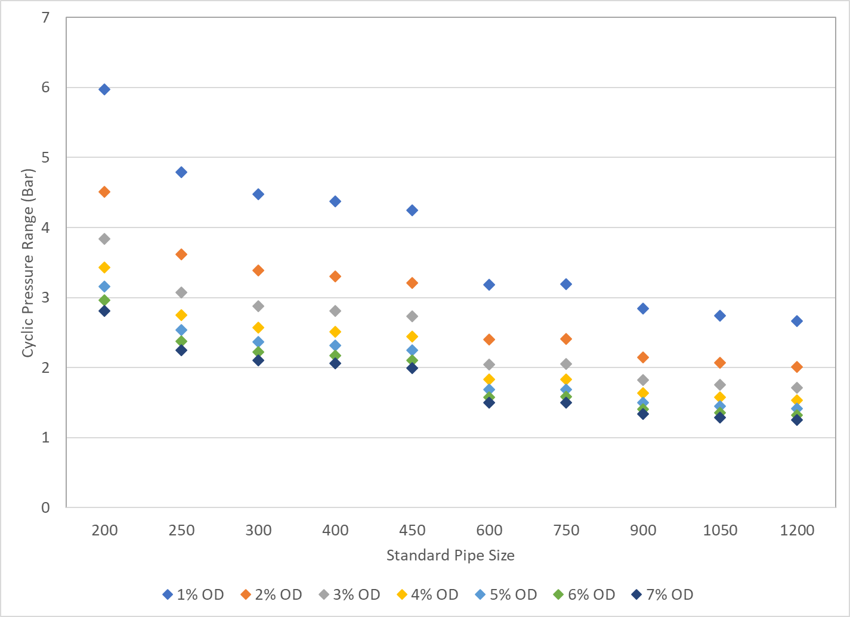
Figure 10 – Calculated pressure cycle endurance limits for dents in seam welds with safety factor
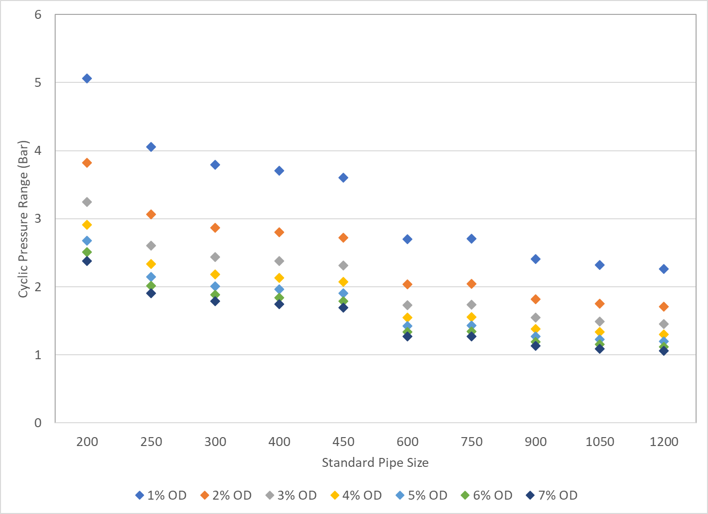
Figure 11 – Calculated pressure cycle endurance limits for dents in girth welds with safety factor
Figure 6 to Figure 11 all show a decreasing trend with increasing standard pipe size in the maximum allowable pressure cycle a dent can withstand before fatigue damage occurs. This trend is because of the ratio between the pipe diameter and the wall thickness which increases from 29.5 for pipe size 200 to 77.2 for pipe size 1200. In other words, pipes of larger diameter are relatively thinner than pipes of smaller diameter. Given the relationship between pressure, diameter, wall thickness and hoop stress, a pipeline which is relatively thin will require a smaller pressure cycle to reach the same stress cycle than a pipeline which is relatively thick.
On each of the figures, the pattern displayed by the dent depth endurance limits within each pipe size is characteristic of the non-linear relationship between dent depth and stress cycle endurance limit observed in Figure 4 and Figure 5. For each case, the pressure range increases with decreasing dent depth.
Between plain pipe, seam welds and girth welds, the changes in calculated pressure cycle for dents of the same size mirror those observed in Figure 4 and Figure 5, with a reduction in the cycle size moving from plain pipe to seam welds to girth welds.
As with Figure 5, the application of a safety factor results in a reduction in the calculated pressure cycle values of 1.77 for dents in plain pipe, 2.15 for dents on seam welds and 2.11 for dents on girth welds.

Pipeline dents and the IGEM/TD/1 endurance limit
As noted in Section 6, although the fatigue life of pipeline dents has been studied extensively, little of the research has directly addressed the endurance limit associated with the dents. A consequence of this is that there exists no guidance for pipeline operators as to whether, once a dent is discovered, a pipeline remains able to withstand the cyclic stresses experienced during operation, or if a fatigue assessment is required.
In the absence of such guidance, an assumption could potentially be made that the endurance limit given in the design S-N curve in IGEM/TD/1, can be applied to determine the requirement for a fatigue analysis (for example a check of the loading history of the pipeline to determine if any completed cycles exceed the stated limits). In this section the endurance limit stated in IGEM/TD/1 is considered to ascertain whether this assumption is appropriate. The endurance limit stated in IGEM/TD/1 is 35 Nmm⁻², as indicated in Figure 2. This would be equivalent to a pressure cycle of 15.3 bar in a 323.9 mm outside diameter, 7.1 mm wall thickness pipeline.
From the analysis in Section 5 it can be seen that if a safety factor is not applied (Figure 4 and Table 3) the calculated endurance limits for dented pipelines are in excess of the 35 Nmm⁻² endurance limit stated in IGEM/TD/1 in only two cases. These cases correspond to dents of depth 1% OD and 2% OD located in plain pipe. Furthermore, under the application of a safety factor of 10 (Figure 5 and Table 5), none of the calculated endurance limits for dented pipelines are in excess of the IGEM/TD/1 endurance limit.
It can therefore be concluded that for a dented pipeline, certain stress cycles below the IGEM/TD/1 endurance limit can cause fatigue damage. The use of the IGEM/TD/1 endurance limit to determine the necessity for a fatigue assessment could therefore potentially result in a situation whereby a dent is passed as fit for continued operation but continues to suffer from fatigue damage.
The severity of any fatigue damage, however, must be considered with respect to the projected operating life of the pipeline. A dent which suffers fatigue damage but whose fatigue life exceeds that of the pipeline would not necessarily be cause for concern. To ascertain whether the IGEM/TD/1 endurance limit can be applied to determine the requirement for a fatigue analysis in a dented pipeline, the dent fatigue life must be considered.
Assuming the limit were applicable, a fatigue analysis would be required if the cycle loading of the pipeline were to exceed that limit. In this case, the shortest acceptable dent fatigue life would be that for which continuous stress cycling is experienced at the endurance limit value. If this fatigue life were acceptable with regards to the operating life of the pipeline, then the IGEM/TD/1 endurance limit would be considered acceptable to determine the requirement for a fatigue analysis of a dented pipeline.
In accordance with the UKOPA dent management strategy, the most accurate representation of dent fatigue life is determined by applying the S-N curves from BS 7608 in combination with an appropriate SCF. An accurate representation of the fatigue lives of dents under constant cyclic loading at the IGEM/TD/1 endurance limit can therefore be calculated using this method. The form of the S-N curve with the SCF is (equation (2)):
$$C={(SCF.∆σ)}^{m}.N$$
Rearranging equation (2) for N gives:
$N=\frac{C}{{(SCF.∆σ)}^{m}}$ (10)
Equation (10) can be used to determine the number of cycles to failure and therefore the dent fatigue life. In equation (10), Δσ is the cycle magnitude, which in this case is a constant value of 35 Nmm⁻² (the IGEM/TD/1 endurance limit), and the SCF, which is dependent on dent depth, is given by equation (1). The values of C and m depend on the S-N curve class, which is determined by dent location. The class B, E and F curves are used for dents in plain pipe, seam welds and girth welds respectively, and the values are given in Table 1. As noted in Section 5, the UKOPA dent management strategy also indicates that a safety factor of 10 must also be applied to the value of N.
Table 7 shows the calculated fatigue lives for dents up to 7% OD under continuous cyclic loading at the IGEM/TD/1 endurance limit, in terms of the number of cycles to failure. A factor of 10 reduction in the value of N has been applied.
 |  | Cycles to failure under constant cycling at the IGEM/TD/1 endurance limit
Dent depth  (% OD) | SCF | Class B  (Plain pipe) | Class E  (Seam weld) | Class F  (Girth weld)
1 | 2.14 | 3231536 | 248799 | 151433
2 | 2.83 | 1053151 | 107315 | 65318
3 | 3.33 | 550281 | 65952 | 40142
4 | 3.72 | 353235 | 47298 | 28788
5 | 4.04 | 253777 | 36909 | 22465
6 | 4.31 | 195543 | 30355 | 18475
7 | 4.54 | 157963 | 25865 | 15743
Table 7 – Dent fatigue lives under continuous cycling at the IGEM/TD/1 endurance limit – total No. of cycles to failure
Cyclic loading of pipelines is generally considered in terms of the number of cycles completed per day. If it is assumed that one complete cycle takes place per day at the IGEM/TD/1 endurance limit, then the fatigue lives for dents in terms of the number of years to failure can be calculated from Table 7. These values are shown in Table 8.

 |  | Years to failure under constant cycling at the IGEM/TD/1 endurance limit
Dent depth  (% OD) | SCF | Class B  (Plain pipe) | Class E  (Seam weld) | Class F  (Girth weld)
1 | 2.14 | 8847 | 681 | 415
2 | 2.83 | 2883 | 294 | 179
3 | 3.33 | 1507 | 181 | 110
4 | 3.72 | 967 | 129 | 79
5 | 4.04 | 695 | 101 | 62
6 | 4.31 | 535 | 83 | 51
7 | 4.54 | 432 | 71 | 43
Table 8 – Dent fatigue lives under continuous cycling at the IGEM/TD/1 endurance limit – total No. of years to failure
Table 8 indicates that under constant daily cycles at the IGEM/TD/1 endurance limit, the fatigue life of a dented pipeline will range from 8847 to 43 years depending on the depth and location of the dent. Within each curve class, the fatigue life increases with decreasing dent depth. At each dent depth, the shortest fatigue lives are observed for dents in girth welds (Class F), and the calculated fatigue life decreases going from plain pipe to seam weld to girth weld. IGEM/TD/1 assumes the nominal operating life of a pipeline to be 40 years. A comparison between the values in Table 8 and a 40 year operating life should therefore provide a reasonable indication as to the severity of the potential fatigue damage which could be sustained if the requirement for a fatigue analysis of a dented pipeline is judged on the basis of the historical cyclic loading exceeding the IGEM/TD/1 endurance limit.
The IGEM/TD/1 endurance limit will only be appropriate to determine the requirement for a fatigue analysis if the fatigue lives of all dents up to 7% OD in plain pipe and 2% OD in welds exceed the operating life of the pipeline. It is assumed that in accordance with the UKOPA dent management strategy that any dent exceeding 7% OD in plain pipe or 2% OD on welds will be repaired without consideration of the fatigue life.
On this basis, the values in Table 8 indicate that it is appropriate to apply the endurance limit from IGEM/TD/1 to determine the requirement for a fatigue analysis. In plain pipe the shortest fatigue life is that of a 7% OD dent, which is calculated as 432 years, which is more than 10 times the assumed nominal operating life. In seam welds, the shortest relevant fatigue life is that of a 2% OD dent, which is calculated as 294 years or approximately 7 times the assumed nominal operating life. In girth welds the shortest relevant fatigue life is that of a 2% OD dent, which is calculated at 179 years or approximately 4.5 times the assumed nominal operating life.
It is noted that the applicability of the IGEM/TD/1 endurance limit to determine the requirement for the fatigue analysis of a dented pipeline is dependent upon the cyclic loading of the pipeline not exceeding one cycle per day at 35 Nmm⁻².

Conclusions
This note has considered the determination of a reasonable lower bound threshold of cyclic stress at which a fatigue assessment is required for pipeline dents that would not otherwise be repaired as part of the UKOPA dent management strategy. The following conclusions can be made:
- The design S-N curves from BS 7608 in combination with a SCF to account for the presence of the dent can be used to give a reasonable idea as to the endurance limit (the stress range below which no fatigue damage will occur) of a dented pipeline.
- The endurance limit of a dented pipeline is dependent upon the location of the dent (plain pipe, seam weld or girth weld) and the depth of the dent.
- The endurance limit of a dented pipeline decreases with increasing dent depth.
- The endurance limit of a dented pipeline decreases when comparing a dent in plain pipe to a dent in a seam weld and comparing a dent in a seam weld to a dent in a girth weld.
- Under the application of a safety factor, none of the endurance limits for pipelines with dents up to 7% OD are in excess of the endurance limit for pipelines at the design stage stated in IGEM/TD/1. Certain stress cycles below the IGEM/TD/1 endurance limit could therefore cause fatigue damage in dented pipelines.
- An assumption that the endurance limit stated for pipelines at the design stage in IGEM/TD/1 can be used to determine the requirement for a fatigue analysis of a dented pipeline may result in a situation whereby a dent is passed as fit for continued operation but continues to suffer from fatigue damage.
- Consideration of the potential severity of the fatigue damage resulting from the assumption outlined above in comparison to pipeline operating life indicates that the IGEM/TD/1 endurance limit is appropriate as a lower bound threshold of cyclic stress to determine if a fatigue assessment is required for pipeline dents.
- The use of the IGEM/TD/1 endurance limit is dependent upon the cyclic loading of the pipeline not exceeding one cycle per day at 35 Nmm⁻² and any dents exceeding 7% OD in plain pipe or 2% OD in welds being repaired.

References

[1] | IGEM, IGEM/TD/1 Ed 5 Steel pipelines for high pressure gas transmission, IGEM, 2008.
[2] | The British Standards Institution. BS 7608:2014 Guide to Fatigue Design and Assessment of Steel Products, BSI Standards Limited,, 2014.
[3] | The British Standards Institution, BS 7910:2013+A1:2015 Guide to Methods for Assessing the Acceptability of Flaws in Metallic Structures, BSI Standards Limited, 2015.
[4] | A. Cosham, “Assessment Methods for Dents in Pipelines, A Report to The Pipeline Defect Assessment Manual Joint Industry Project, NR99014/4238.1.74/R3,” Penspen Limited, Newcastle upon Tyne, 2001.
[5] | J. H. Liu, “Feasibility Study: Fatigue Assessment of Plain Dent Damage, Report Number: 12505 Issue 1.0,” GL Noble Denton, Loughborough, Leicestershire,, 2013.
[6] | “UK Onshore Pipeline Operators’ Association, Industry Good Practice Guide, Managing Pipeline Dents, UKOPA/GP/004, Edition 1,” UKOPA, Ambergate, 2016.
[7] | “UK Onshore Pipeline Operators’ Association, Application of S-N Curves to Fatigue Assessment of Pipeline Dents, UKOPA Technical Note PIWG/16/032,,” UKOPA, Ambergate, 2016.
[8] | J. E. Shigley and C. R. Mirshke, Mechanical Engineering Design, 6th Edition, Chapter 12., New York,: McGraw-Hill, 2001.
[9] | F. C. Campbell, Elements of Metallurgy and Engineering Alloys, Materials Park, Ohio: ASM International, 2008.
[10] | I. Corder and P. Chatain, “EPRG Recommendations for The Assessment of The Resistance of Pipelines to External Damage, Proceedings of the EPRG/PRC 10th Biennial Joint Technical Meeting on Line Pipe Research,” Cambridge, 1995.
[11] | J. R. Fowler, C. R. Alexander, P. J. Kovach and L. M. Connelly, “Cyclic Pressure Fatigue Life of Pipelines with Plain Dents, Dents with Gouges, and Dents with Welds, PRCI Report PR-201-927/201-9324,” PRCI Catalog Number L51705e, 1994.
[12] | C. R. Alexander and J. F. Kiefner, Effects of Smooth and Rock Dents on Liquid Petroleum Pipelines, API Publication 1156, 1997.

Note that the pressure cycle would differ for pipelines of different diameter and wall thickness in accordance with Barlow’s formula.
Red shading indicates dents which would be repaired regardless of fatigue life in accordance with the UKOPA Dent Management Strategy.
Red shading indicates dents which would be repaired regardless of fatigue life in accordance with the UKOPA Dent Management Strategy.

