Technical Briefing Note
Managing societal risk in the vicinity of high-pressure natural gas pipelines
UKOPA/TBN/02 Edition 1
October 2019

TECHNICAL BRIEFING NOTE GUIDANCE ISSUED BY UKOPA:
This Technical Briefing Note (TBN) identifies what is considered by UKOPA to represent current UK pipeline industry good practice within the defined scope of the document. All information is guidance and should not be considered obligatory against the judgement of the Pipeline Owner/Operator. Where new and better techniques are developed and proved, they should be adopted without waiting for modifications to this TBN.

Comments, questions and enquiries about this publication should be directed to:
UK Onshore Pipeline Operators’ Association
Pipeline Maintenance Centre
Ripley Road
Ambergate
Derbyshire
DE56 2FZ
E-mail: enquiries@ukopa.co.uk
Website: www.UKOPA.co.uk

Disclaimer
This document is protected by copyright and may not be reproduced in whole or in part, by any means without the prior approval in writing of UKOPA. The information contained in this document is provided as guidance only and while every reasonable care has been taken to ensure the accuracy of its contents, UKOPA cannot accept any responsibility for any action taken, or not taken, on the basis of this information. UKOPA shall not be liable to any person for any loss or damage which may arise from the use of any of the information contained in any of its publications. The document must be read in its entirety and is subject to any assumptions and qualifications expressed therein. UKOPA documents may contain detailed technical data which is intended for analysis only by persons possessing requisite expertise in its subject matter.
Copyright © 2019, UKOPA. All rights reserved.
Revision and change control history
Planned revision: January 2024
Edition | Date | No. of pages | Summary of changes
1 | October 2019 | 10 | For publication

Contents
1. Introduction 1
1.1 Scope 1
1.2 Abbreviations 2
2. Requirement for Risk Assessment 3
3. Risk Assessment Methodology 4
3.1 Pipeline Failure Causes 4
3.2 Risk Assessment Process 5
3.3 Quantifying Societal Risk 6
4. Assessing and Managing Societal Risk 7
4.1 Multiple Infringement Locations 9
5. References 10

Introduction
A number of the member companies of UKOPA are responsible for managing steel pipelines which transport high gas at pressures up to 94 bar. High pressure pipelines are major hazard assets and so are subject to safety legislation including the Pipelines Safety Regulations (PSR) [1] which formally classify natural gas pipelines operating at above 8 bar absolute as Major Accident Hazard Pipelines (MAHPs).
Failure of these pipelines could give rise to major incidents involving the release of high-pressure gas resulting in the release of energy potentially leading to the production of missiles and a jet fire if the released gas ignites. This may result in the death and injury of individuals located in the vicinity of these pipelines. This could include: local residents; individuals working in local offices; factories; shops or individuals located in located in schools and hospitals close to the pipeline.
Pipeline operators have a duty under the PSR to manage the risks associated with MAHPs. A key aspect of this risk for high pressure gas pipelines is managing societal risk, i.e. managing the likelihood and consequences of incidents that could result in multiple casualties and or fatalities.
Operators of high pressure natural gas pipelines generally meet this duty by designing, constructing, operating and maintaining their pipelines in line with recognised industry good practice, such as the IGEM/TD/1 [2] and IGEM/TD/3 [3] pipeline standards. Societal risk is considered to be broadly acceptable where these standards are met and the management of societal risk is typically concentrated on areas where these standards are or will be infringed.
Guidance on pipeline quantitative risk assessment (QRA) is available in IGEM/TD/2 [4] and this TBN provides additional guidance on how societal risk in the vicinity of high pressure gas pipelines can be managed to ensure that these risks can be demonstrated to be As Low As Reasonably Practicable (ALARP), based on an original National Grid internal document.

Scope
The guidance in this document is applicable to buried pipelines operated by the UKOPA member containing dry natural gas with Maximum Operating Pressures (MOP) above 7 barg.

Abbreviations
ALARP | As Low as Reasonably Practicable
EGIG | European Gas pipeline Incident data Group
EV | Expectation Value
HSE | Health and Safety Executive
IGEM | Institution of Gas Engineers & Managers
MAHP | Major Accident Hazard Pipeline
MAPD | Major Accident Prevention Document
MOP | Maximum Operating Pressure
PLL | Potential Loss of Life
PSR | Pipelines Safety Regulations
QRA | Quantitative Risk Assessment
SMYS | Specified Minimum Yield Strength
UKOPA | United Kingdom Onshore Pipeline Operators’ Association

Requirement for Risk Assessment
The Pipelines Safety Regulations (PSR) [1] puts the responsibility on the duty holder to manage the risks associated with their assets. This responsibility includes a requirement on the duty holder to understand the risks associated with their operations and to ensure that these risks have been made ALARP.
For high pressure natural gas pipelines, operating at 7 barg and above, UKOPA members generally meet these duties by designing, constructing, operating and maintaining gas pipelines in line with recognised industry good practice including the recommendations of the Institution of Gas Engineers as documented in IGEM/TD/1 [2] and IGEM/TD/3 [3]. This approach is supported by the use of quantitative risk assessment (QRA) to aid decision making and to ensure that the risks are being managed so that they are ALARP.
The principal circumstances where quantitative risk assessment is applied to gas pipelines are outlined below:
- MAPD and QRA: The PSR, 1996 require that operators of pipelines transporting dangerous fluids prepare a Major Accident Prevention Document (MAPD) for their ‘major accident hazard’ pipelines (MAHP), for gas pipelines this applies to all pipelines operating at pressures above 7 barg.
The guidance for the regulations states that the MAPD is a management tool to ensure that the duty holder has assessed the risks from major accident hazards and has introduced an appropriate safety management system to control these risks. In order to support this requirement, pipeline operators may decide to undertake quantitative risk assessments, either along the whole pipeline route or at critical locations or pinch points.
- Code Infringements: Gas pipeline operators generally operate their above 7 barg pipelines in line with the requirements of IGEM/TD/1 and IGEM/TD/3. There may, however, be locations along the pipeline where the requirements of IGEM/TD/1 and IGEM/TD/3 cannot be complied with. This is usually because development has occurred since the pipeline was constructed that has resulted in proximity infringements or population density infringements. There may also be some circumstances where the operator elects to operate the pipeline to a later edition of the code than the one to which the pipeline was originally constructed. In these circumstances it may be appropriate to justify that any non-compliances with the later edition of code are acceptable.
- Land Use Planning: Determining the acceptability of new proposed developments in the vicinity of high-pressure pipelines is the responsibility of the Local Authority. Their advice would be supported by following the methodology provided by the HSE [5].
For new large and/or sensitive developments next to the pipeline the pipeline operator may choose to undertake a quantitative risk assessment in order to put itself in an informed position when discussing the proposed development with the developer, the HSE or the Local Authority.
- Uprating: IGEM/TD/1 allows pipeline operators to uprate pipelines above their nominated Maximum Operating Pressure (MOP) provided it is supported by the appropriate technical justifications. These technical justifications would normally include a quantified risk assessment to demonstrate that the risks to individuals located in the vicinity of the pipeline continue to be acceptable at the uprated pressure.

Risk Assessment Methodology
The methodology that should be used for undertaking a quantitative risk assessment at a given location on a high-pressure gas pipeline is fully described in IGEM/TD/2 [4]. In summary a quantitative risk assessment involves the estimation of the frequency and consequences of a range of hazard scenarios and of the individual and societal risks associated with them. Each assessment has the following basic steps:
- Collect and define cases to be assessed;
- Identify credible failure causes;
- Identify credible failure modes;
- Evaluate failure frequencies;
- Evaluate consequences of failure;
- Evaluate individual and societal risk;
- Assess the acceptability/tolerability of the risks;
- Implement any new mitigation measures required as a result of the assessment; and,
- Record and review results.

Pipeline Failure Causes
In the UK a thorough understanding of pipeline damage behaviour has been developed through extensive operational experience in combination with fault data both for UK pipelines and from other European pipeline operators. This knowledge has enabled detailed predictions of failure frequencies and failure modes to be made for a range of damage causes.
Data collected by UKOPA [6] and the European Gas pipeline Incident data Group (EGIG) [7] has been utilised to determine the most common pipeline failure causes.
The following have been identified as the main potential causes of pipeline failure:
- External interference;
- Corrosion (both internal and external);
- Loss of ground support / ground movement;
- Material or construction defects;
- Over-pressurisation; and,
- Stress Corrosion Cracking (SCC).
For the majority of pipeline risk assessments, the risk is dominated by the risk from a full-bore pipeline rupture. The historical data indicates that the most likely causes of full-bore pipeline rupture are either external interference or ground movement.

Risk Assessment Process
The methodology for predicting pipeline failure frequencies and determining the subsequent consequences of a pipeline failure in terms of hazard ranges for individuals located both out of doors and within buildings is provided in IGEM/TD/2 [4]. A simplified overview of the stages of a risk assessment is shown in Figure 3.1.
Figure 3.1: Overview of Risk Assessment Process
In practice software is normally used for undertaking pipeline quantitative risk assessments. The majority of UK gas pipeline operating companies use a knowledge-based software program called PIPESAFETM [8] which has been developed jointly by an international group of gas transmission companies. The model is based on extensive research into the causes and consequences of transmission pipeline failures, including experimental validation at both small and large scale.
Any QRA software would normally provide an assessment of the calculated levels of individual and societal risk, where:
Individual Risk – this is a measure of the frequency with which an individual at a specified distance from the pipeline is expected to sustain a specified level of harm from the realization of specific hazards.
Normally the individual risk is assessed for the individual that is considered to be at highest risk in the vicinity of the pipeline, usually the individual located nearest the pipeline.
Societal Risk – this is a measure of the relationship between the frequency of incident occurring and the number of casualties that will result.
In most cases for high pressure gas pipelines the individual risk tends to be below or just above the HSE defined broadly acceptable level [9] and therefore managing the risk from high pressure pipelines becomes about managing the level of societal risk within corridors either side of the pipeline defined by the maximum hazard range.

Quantifying Societal Risk
Software models would normally give a measure of societal risk in terms of a table of numbers of individuals that might be affected by the incident (N) and the corresponding frequencies (F) of these numbers of being affected. Frequency in this case being the predicted likelihood per year that the specified number of casualties would be subjected to the specified level of harm, as a consequence of a pipeline failure. It is also common practice to present the results of a societal risk assessment in the form of an FN plot of values of N against the frequency of N or more casualties occurring.
The reason for their being a range of N and F values is because in most cases there would be a range of buildings in the vicinity of the pipeline that could be affected by different points along the pipeline section of concern.
Societal risk can also be quantified in terms of Expectation Value (EV). This is the summation of each of the calculated individual F values multiplied by the corresponding N values. The expectation value is also often referred to as the Potential Loss of Life or (PLL).

Assessing and Managing Societal Risk
As identified in Section 2 the pipeline operator is required to demonstrate that the risks associated with his pipeline have been made ‘As Low as Reasonably Practicable’ or ALARP. As detailed in the HSE’s document Reducing Risks Protecting People (R2P2) [9] following industry good practice such as the requirements of IGEM/TD/1 would normally be accepted as ALARP, i.e. operators would not be expected to undertake additional cost benefit calculations to demonstrate that the risks are ALARP if the pipeline fully complies with the code.
However, ALARP demonstrations would be required at the locations along the pipeline that did not comply with IGEM/TD/1. As identified in Section 2 code non compliances would typically be proximity infringements or population density infringements, or as a consequence of the protection requirements changing in later editions of the code, e.g. requirements for extended protection against external interference damage at major road crossings. These code non-compliances would normally be identified through the 4-yearly IGEM/TD/1 Affirmation of MOP Audit process.
Where non-compliances are identified these should be justified to be ALARP through quantitative risk assessment. This would include demonstrating that the risks associated with non-compliances that might result in societal risk concerns, i.e. high numbers of casualties or fatalities, can be demonstrated to be ALARP.
IGEM/TD/2 [4] specifies a societal risk criterion in the form of an FN curve, see Figure 4.1, which shows the cumulative frequency ‘F’ (usually per year) of accidents causing N or more fatalities. The criterion envelope was developed with the objective of representing an acceptable risk consistent with the design, construction and operation of the high-pressure gas pipelines which are generally in accordance with IGEM/TD/1. In addition, the envelope was intended to be consistent as far as possible with the philosophy adopted by the HSE in its use of individual risk criteria for land-use planning in the vicinity of fixed major hazard installations, in which developments for sensitive (or vulnerable) persons were required to be at a lower risk than for the average population.
Once the FN curve has been calculated for an assessment location, it can be compared with the IGEM/TD/2 societal risk criterion envelope. In cases where the FN curve from an assessment is well within the criterion envelope, the risk would be deemed to be acceptable. However, where the FN curve is close to, or crosses the criteria envelope, it is recommended that a cost-benefit analysis is undertaken in order to demonstrate whether the societal risk is ALARP.
Further details on the recommended approach to cost benefit analysis can be found in UKOPA/GP/025 Application of cost benefit analysis to demonstrate ALARP and the overall ALARP assessment process is shown in Figure 4.2.
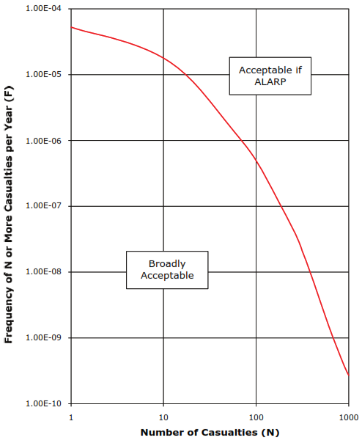
Figure 4.1: IGEM/TD/2 FN Criterion Envelope
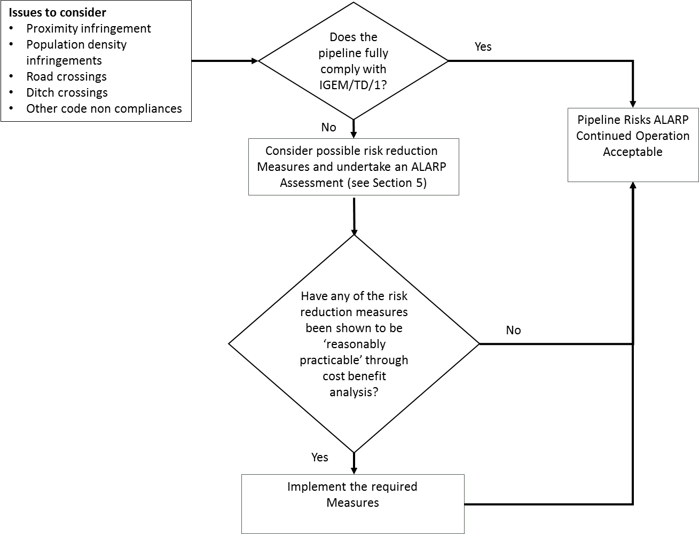
Figure 4.2: Overview of ALARP Assessment Process

Multiple Infringement Locations
There may be some pipelines that have very large numbers of individual infringements. Where this is the case then the societal risk integrated along the length of the pipeline must be considered rather than just considering the risk in isolation for individual infringements. When considering reasonably practicable measures these should be extended to include measures that might reduce the risk along the length of the pipeline, for example increased surveillance along the whole pipeline length, or rerouting of the pipeline taking into account that the risk would be reduced or removed at a number of locations not just individual locations.

References

[1] | SI 1996 No. 825, The Pipelines Safety Regulations 1996, as amended, HMSO.
[2] | IGEM/TD/1 Edition 5 with amendments, Steel pipelines and associated installations for high pressure gas transmission, Communication 1789, Institution of Gas Engineers & Managers, July 2016.
[3] | IGEM/TD/3 Edition 5, Steel and PE pipelines for gas distribution, Communication 1770, Institution of Gas Engineers & Managers, 2014.
[4] | IGEM/TD/2 Edition 2, Assessing the risks from high pressure natural gas pipelines, Institution of Gas Engineers & Managers, 2013.
[5] | Health and Safety Executive, “HSE’S LAND USE PLANNING METHODOLOGY,” [Online]. Available: http://www.hse.gov.uk/landuseplanning/methodology.pdf. [Accessed 15 12 2017].
[6] | G. D. Goodfellow, C. J. Lyons and J. V. Haswell, “UKOPA Pipeline Product Loss Incidents and Faults Reports (1962 - 2016),” UKOPA/17/002, Issue 1.1, February 2018.
[7] | EGIG, “10th Report of the European Gas Pipeline Incident Data Group,” VA 17.R.0395, March 2018.
[8] | M. R. Acton, T. R. Baldwin and E. E. R. Jager, “Recent Developments in the Design and Application of the Pipesafe Risk Assessment Package for Gas Transmission Pipelines,” IPC2002-27196, Proceedings of IPC'02, 4th International Pipeline Conference, Calgary, 2002.
[9] | Anon, “Reducing risks, protecting people. HSE's decision-making process,” HMSO, London, 2001.
[10] | UKOPA, “UK Onshore Pipeline Operators' Association - Industry Good Practice Guide, Cost Benefit Analysis,” UKOPA/GP/xxx.

