Technical Briefing Note
Managing encroaching development and societal risk around ethylene pipelines
UKOPA/TBN/03 Edition 1
February 2019

TECHNICAL BRIEFING NOTE GUIDANCE ISSUED BY UKOPA:
This Technical Briefing Note (TBN) identifies what is considered by UKOPA to represent current UK pipeline industry good practice within the defined scope of the document. All information is guidance and should not be considered obligatory against the judgement of the Pipeline Owner/Operator. Where new and better techniques are developed and proved, they should be adopted without waiting for modifications to this TBN.

Comments, questions and enquiries about this publication should be directed to:
UK Onshore Pipeline Operators’ Association
Pipeline Maintenance Centre
Ripley Road
Ambergate
Derbyshire
DE56 2FZ
E-mail: enquiries@ukopa.co.uk
Website: www.UKOPA.co.uk

Disclaimer
This document is protected by copyright and may not be reproduced in whole or in part, by any means without the prior approval in writing of UKOPA. The information contained in this document is provided as guidance only and while every reasonable care has been taken to ensure the accuracy of its contents, UKOPA cannot accept any responsibility for any action taken, or not taken, on the basis of this information. UKOPA shall not be liable to any person for any loss or damage which may arise from the use of any of the information contained in any of its publications. The document must be read in its entirety and is subject to any assumptions and qualifications expressed therein. UKOPA documents may contain detailed technical data which is intended for analysis only by persons possessing requisite expertise in its subject matter.
Copyright © 2019, UKOPA. All rights reserved.
Revision and change control history
Planned revision: January 2024
Edition | Date | No. of pages | Summary of changes
1 | February 2019 | 12 | For publication

Contents
1. Introduction 1
1.1 Abbreviations 1
2. SCOPE 2
3. Applying the FN Criterion to Obtain Screening Limits 4
4. Population Surveys and Screening Limits 7
5. Site-Specific Societal Risk Analysis 9
6. References 12

Introduction
As codes and standards for cross-country pipelines have developed since the 1960s, assessment of the risk to population living near major accident hazard pipelines (MAHPs) such as natural gas and ethylene has been included as a requirement. This has resulted in design and routing requirements for pipelines, classified as rural (Class 1) areas in standard pipe, with more stringent design requirements in suburban (Class 2) areas including a lower design factor which results in a thicker wall pipe for the same design pressure.
Most of the UK ethylene pipeline network was constructed before the population classification and engineering requirements for Category E substances were published in BS 8010 in 1989 [1], so significant sections are located in Class 2 (suburban) populated areas with a standard wall pipe rather than thicker wall pipe. In addition, subsequent population encroachment has occurred along several sections of the pipeline routes since they were commissioned, potentially resulting in a higher population categorisation.
During 2012-13, ethylene pipeline operators decided that the ethylene network should be subject to population surveys and the resulting population densities compared to maximum allowable population densities based on an assessment of the societal risk FN criterion line published in PD 8010-3 [2]. Comparison with this screening tool allowed any higher population sections to be identified, and some of these sections were subject to site-specific societal risk assessments. Where required suitable additional mitigation measures were identified to reduce the risk.
This TBN explains the way in which ethylene pipeline operators have historically reviewed the risks from existing and encroaching population adjacent to their pipelines. It describes a robust methodology using a published risk criterion to define whether the existing situation is “broadly acceptable” or if further risk reduction needs to be applied to specific populated sections. The same process could be subsequently be applied when new development takes place along the routes of an ethylene pipeline.

Abbreviations
ALARP | As Low as Reasonably Practicable
HSE | Health and Safety Executive
IGEM | Institution of Gas Engineers & Managers
MAHP | Major Accident Hazard Pipeline
MAOP | Maximum Allowable Operating Pressure
MDOB | Maximum Distance to Occupied Buildings
PD | Published Document
SMYS | Specified Minimum Yield Strength
UKOPA | United Kingdom Onshore Pipeline Operators’ Association

Scope
PD 8010-3 pages 14-15 states:
“Societal risk is of particular significance to pipeline operators because the location of pipelines might be close to populated areas, so the impact of multiple fatality accidents on people and society in general should be taken into account. The original routing of the pipeline is expected to have taken into account the population along the route, but infill and incremental developments might increase the population in some sections of the route. Societal risk assessment allows these developments to be assessed against the original routing criteria where a location class 1 area has a population density of up to 2.5 persons per hectare. When the societal risk has increased significantly, the pipeline operator might then need to consider justifiable mitigation measures to reduce the risk.
The criterion for societal risk is expressed graphically as an FN criterion line, showing the cumulative frequency F (usually per year) of accidents causing N or more casualties. For application to pipelines, it is necessary to specify a length over which the frequency and consequences of all accident scenarios are collated.
…
In the absence of product-specific risk curves, it is therefore suggested that the FN criterion line given in Figure 6 should be used to assess societal risk due to MAHPs. This allows the assessment of the residual risk from a specific pipeline to be compared with the risk from the average class 1 pipeline population density (i.e. up to 2.5 persons per hectare) adjacent to each 1 km length of pipeline, where the population is assumed to be located in a strip centred on the pipeline from the MDOB, extending out to the hazard distance of the worst case event from the pipeline.”
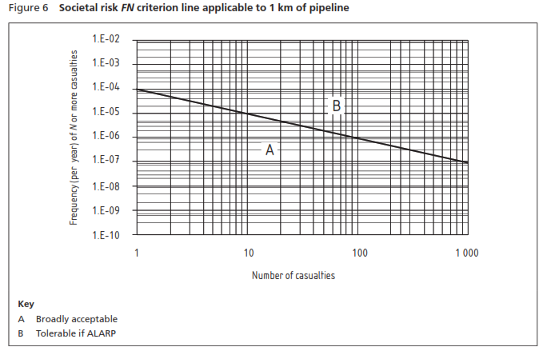
The societal risk criterion line is therefore the limiting risk level which divides the ALARP risk from broadly acceptable, or negligible, risk.
FN curves can be derived for populated sections by assessing the frequency of the various failure mechanisms, the probability of different hole sizes, ignition probability, and consequence events, and from these the frequency of various harmful events causing casualties at various hazard distances from the release point on the pipeline. The calculations generate hazard zones for immediate and delayed fires based on the Maximum Allowable Operating Pressure (MAOP) of the pipeline.
For each release point, there are several events each having a different frequency and each with a different hazard distance. Within each hazard distance (assumed to be circular for fireball and jet fire events, elliptical for flash fire events) any population present are assumed to become casualties. By computing all the different outcomes, each event has its own frequency (f) and causes a different number (N) of casualties at each point along a fixed length of the pipeline.
The various fN pairs are then ordered with respect to increasing number of casualties, N, and the cumulative frequency, F, of N or more people being affected is determined, giving a site-specific FN curve.
The site-specific FN curve can then be compared with the FN criterion line in PD 8010-3 Figure 6. If the FN curve lies below the criterion line, the risk is considered to be broadly acceptable. However, if it crosses the line, then further risk reduction should be considered to reduce the risk. If the cost of reducing the risk proves to be disproportionate using established cost benefit analysis [3], then the risk is considered “as low as reasonably practicable” or ALARP.

Applying the FN Criterion to Obtain Screening Limits
To determine the maximum allowable design factor for a new ethylene pipeline, the population density should be calculated within a strip centred on the pipeline of width equal to eight times the minimum distance to occupied buildings (MDOB) for any 1.6 km length of pipeline. Class 1 areas have a population density equal to less than 2.5 persons per hectare and a maximum allowable design factor of 72% SMYS.
Therefore, a pipeline designed with the maximum design factor of 72% SMYS with an overall population density of 2.5 persons per hectare, i.e. a population density of 3.33 persons per hectare outside the MDOB as shown in Figure 3.1, will just meet the requirements of PD 8010 [4].
Pipeline operating at 72% SMYS
Minimum Distance to Occupied Buildings
Minimum Distance to Occupied Buildings
Maximum Hazard Distance from pipeline
Maximum Hazard Distance from pipeline
Population Density 3.33 persons per hectare in this area
Population Density 3.33 persons per hectare in this area
No Population in this area
No Population in this area
Figure 3.1: Class 1 Population Density Limit with No Population inside MDOB
This case should then align with the maximum population density that still meets the FN criterion line in PD 8010-3 [2].
Several of the UK ethylene pipelines were assessed by increasing the MAOP to a level that the design factor became 72% SMYS and the population density set at 2.5 persons per hectare. In each case the societal risk FN curve was assessed and it was shown that the curves lay just below the PD 8010-3 criterion line, see Figure 3.2.
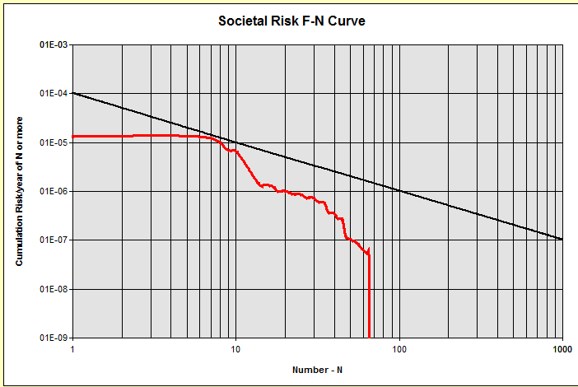
Figure 3.2: Limiting FN curve for 72% SMYS design factor and 2.5 persons/hectare
This demonstrated that a pipeline that just satisfies the design factor and population density requirements of PD 8010-1 also meets the societal risk requirements of PD 8010-3.
However, most of the ethylene pipelines in the UK have a design factor which is significantly below the maximum of 72% SMYS. As a result the societal risk FN curve is well below the PD 8010-3 criterion line for a population density of 2.5 persons per hectare.
It is therefore possible to increase the population density beyond 2.5 persons per hectare, and still meet the PD 8010-3 FN criterion line. This allows a higher population to be tolerated next to lower stressed pipelines.
By incrementally increasing the uniform population above 2.5 per hectare until the derived FN curve just touches the criterion line, it is then possible to derive the limiting population which just meets the PD 8010-3 criterion line for the actual pipeline parameters. This uniform population density can then typically be applied for screening purposes in 100 m sections as shown in Figure 3.3. The screening process was carried out to a distance of approximately 300 m each side of the pipeline (this being the typical maximum HSE outer zone distance for ethylene pipelines).

Maximum Population
= 12 persons in this section

= 4 persons per hectare
Pipeline
100 m
300 m
Maximum Population
= 12 persons in this section

= 4 persons per hectare
100 m
300 m
NO POPULATION IN THIS SECTION
Pipeline
100 m
300 m
Maximum Population
= 24 persons in this section

= 8 persons per hectare
100 m
300 m
Figure 3.3: Uniform Population Density Example
Because several hazard scenarios have a maximum hazard distance less than 50 m, if for example there is a buffer zone of 50 m between the pipeline and the population, the outer area population can be higher and still meet the criterion, as shown in Figure 3.4.

Maximum Population
= 30 persons in this section
= 12 persons
per hectare
Pipeline
100 m
300 m
Maximum Population
= 30 persons in this section
= 12 persons
per hectare
100 m
300 m
No Population
No Population
50 m
50 m
NO POPULATION IN THIS SECTION
Pipeline
100 m
300 m
Maximum Population
= 60 persons in this section
= 24 persons
per hectare
100 m
300 m
No Population
50 m
Figure 3.4: Population Density with 50 m Buffer Zone
If there is population within 50 m of the pipeline (i.e. no buffer zone) the highest level of risk is applied to this population and so the maximum population density within the whole 300 m hazard zone is relatively low.
If there is no population within 50 m of the pipeline but there is population between 50 m and 100 m (i.e. a 50 m buffer zone) the limiting population between 50 m and the hazard distance of 300 m can be significantly higher than with no buffer zone, and still meet the FN criterion line limit.
Similarly, if there is no population within 100 m, but there is within 200 m, the limiting population between 100 m and the hazard distance of 300 m can be higher still, although the increase is less significant than between no buffer and 50m buffer, because the reduction in risk between 50 m and 100 m is less significant. A smaller reduction applies for the case where there is no population within 200 m, but there is some within 300 m.

Population Surveys and Screening Limits
Population surveys along the route of the ethylene pipelines have typically been carried out by two methods:
- Aerial Survey
Surveys were carried out of several of the ethylene pipelines using a fixed wing aircraft. Specific population density figures were required for the model. The most effective data gathering method for current real-world evidence of buildings along the pipelines was a current aerial photographic survey. To improve analysis, the images were captured georeferenced oblique photography, to provide detail of the building elevation profile. Seeing the vertical face of the building makes categorisation much easier, quicker and most importantly much more accurate.
Population Data from these aerial obliques was used to derive populations in the various sectors around the pipeline. The results were either plotted on an aerial survey image, if available, or transferred to Google Earth maps showing the pipeline route and black dots within the specified hazard zone. Every populated building was identified and could be interrogated to show details and population count. The results were further analysed to show the population in 100 m steps along the pipelines within specified distances from the pipeline, as shown below.
The resulting population within any 100 m step was then compared with the maximum permitted populated calculated from the PD 8010-3 risk criterion line for the population proximity (within 50 m, 50-100 m, 100-200 m, 200-300 m). If the actual population was below the specified limit, the result was “OK” and if above the limit the result was “Exceeded”.
In the case shown below, the village section exceeded the limit for Rural (Class 1) population, but this section was constructed in heavy wall pipe, so the population limit was much higher, and this was not exceeded by the village population, so the result was “OK”.

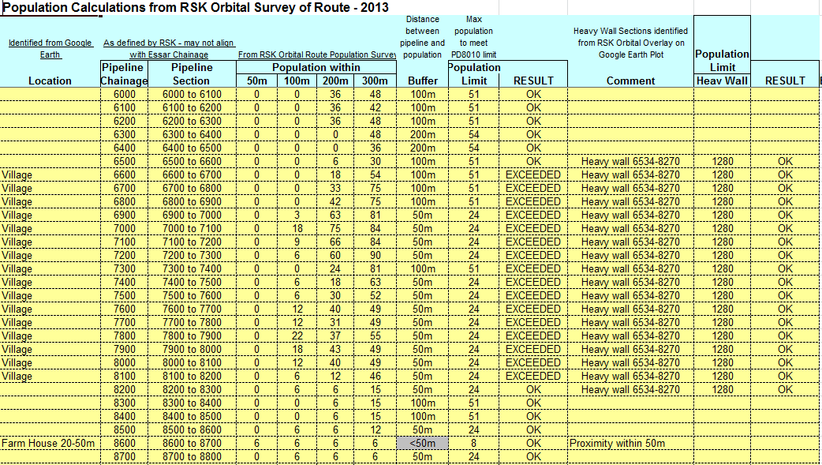
Figure 4.1: Population count from a typical analysis of aerial survey data
Using this approach, some sections which exceeded the limit for extended length could be identified and these were then subjected to site specific assessments. Note that occasional buildings were identified within the 50 m MDOB. In this case the risk was considered acceptable.
- Manual Survey
Detailed maps of the pipeline route were updated with current populated developments, and the population clusters were identified along the pipeline route. Sections which exceeded the population limits were then identified and subjected to site-specific assessments. This method tended to result in more site-specific assessments, as well as taking more time to carry out the route assessment.
Care was applied when clusters of population were identified along the pipeline route, such as large gathering places (e.g. supermarkets, leisure parks or sports stadium) which might have very large populations for limited duration, or large vulnerable populations (schools, hospitals, or care homes) where evacuation in an emergency would be difficult. These were subject to site-specific assessment.
In one case, it was also possible to take account of a lower operating pressure in a downstream section resulting in lower stress levels and therefore pipeline failure rate, so the maximum allowable population was higher.

Site-Specific Societal Risk Analysis
If the actual average population in several adjacent 100 m sections was found to significantly exceed the calculated limits, or a vulnerable population cluster was identified, then a site-specific assessment was carried out. This required detailed population assessment along the identified section such that the location relative to the pipeline could plotted on a chart, and the detailed FN curve calculated for the actual population in that section.
In most cases, the population section was identified using Google Earth and divided into 100 m sections so that the population could be transferred onto the risk grid, as shown in Figure 5.1.
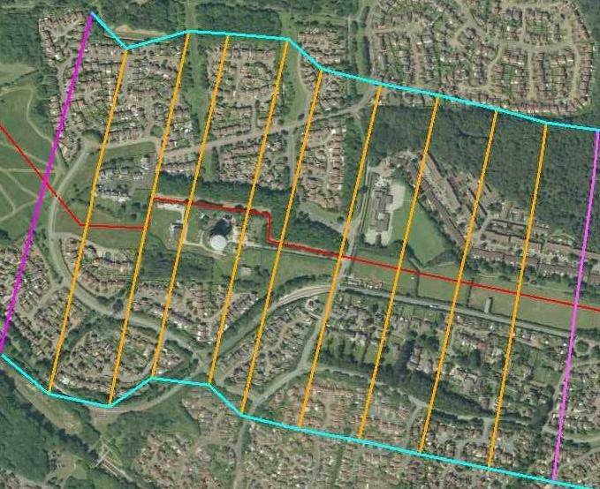
Figure 5.1: Population survey sections plotted on image from Google Earth
This population was then transferred to the location plot as shown in Figure 5.2.
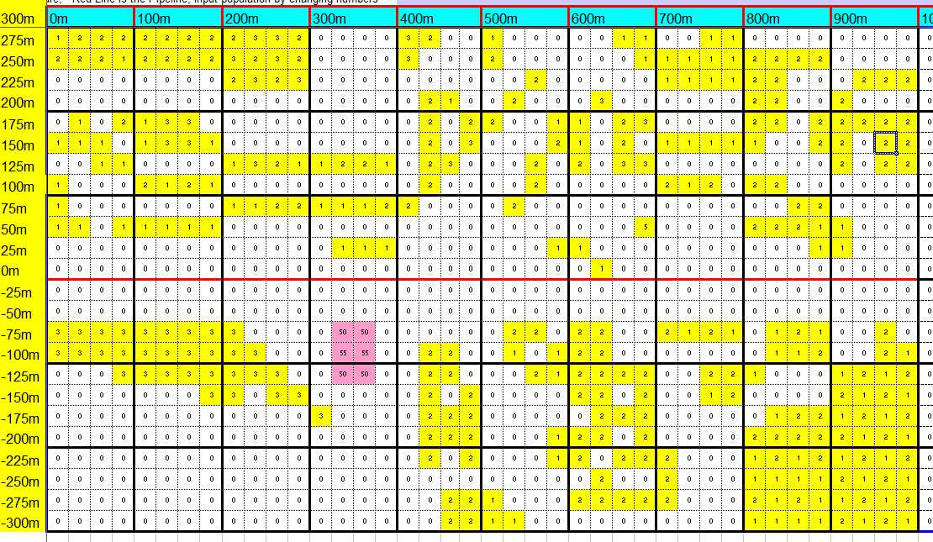
Figure 5.2: Population Location Plot
PIPERISK™ was then used to derive the FN Curve as shown in Figure 5.3.
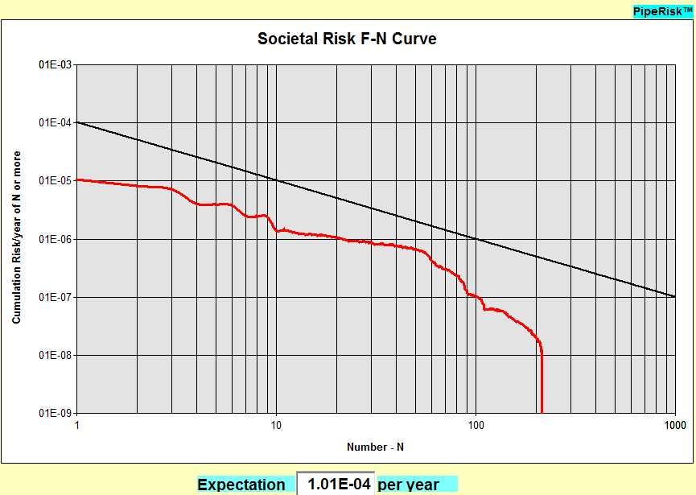
Figure 5.3: FN Curve for the site-specific assessment
The FN curve is significantly below the PD 8010-3 Criterion line, so in this case, the populated section is within the requirements and no further risk reduction need be considered.
A few cases were found to be close to the limit, and in these cases risk reduction measures were recommended. Such measures can include:
- Increase awareness of landowners and occupiers of the location of the pipeline;
- Improve marker posts and visible evidence of the pipeline;
- Increase the surveillance frequency to reduce probability of external interference to the pipeline;
- Increase the depth of cover over the pipeline;
- Provide concrete slabbing over the pipeline;
- Re-lay the pipeline in thick-wall pipe; or,
- Divert the pipeline round the populated areas.
One risk reduction applied to several sections of ethylene pipelines is an increase in surveillance frequency, to weekly rather than 2-weekly. PD 8010-3 provides the following risk reduction curve for external interference resulting from increased surveillance.
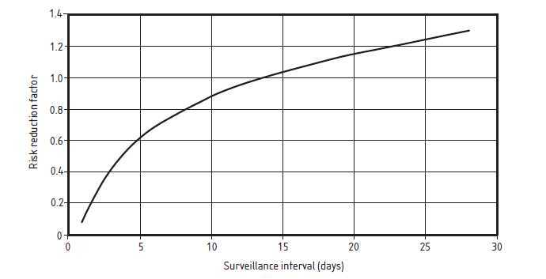
Figure 5.4: PD 8010-3 Figure 11 - Reduction in risk due to increased surveillance frequency

References

[1] | BS 8010-1:1989, Code of practice for pipelines. Pipelines on land: general, British Standards Institution, February 1989.
[2] | PD 8010-3:2009+A1:2013, Pipeline systems. Part 3: Steel pipelines on land and subsea pipelines - Guide to the application of pipeline risk assessement to proposed developments in the vicinity of major accident hazard pipelines containing flammables - Supplement to PD 8010-1:2004, British Standards Institution, July 2013.
[3] | UKOPA, “UK Onshore Pipeline Operators' Association - Industry Good Practice Guide, Cost Benefit Analysis,” UKOPA/GP/xxx.
[4] | PD 8010-1:2015, Pipeline systems - Part 1: Steel Pipelines on land - Code of practice, British Standards Institution, March 2015.

Use of the lower operating pressure along a section of the pipeline is only applicable if a robust justification can be made that the pipeline section will not see the MAOP in normal and abnormal operating conditions, e.g. if instrumented alarms and automatic trip systems are in place to stop the pumps due to unexpected pressure rise.

