Technical Briefing Note
Gasoline pipelines – A risk-based methodology for calculating land use planning zones
UKOPA/TBN/006 Edition 1
February 2019

TECHNICAL BRIEFING NOTE GUIDANCE ISSUED BY UKOPA:
This Technical Briefing Note (TBN) identifies what is considered by UKOPA to represent current UK pipeline industry good practice within the defined scope of the document. All information is guidance and should not be considered obligatory against the judgement of the Pipeline Owner/Operator. Where new and better techniques are developed and proved, they should be adopted without waiting for modifications to this TBN.

Comments, questions and enquiries about this publication should be directed to:
UK Onshore Pipeline Operators’ Association
Pipeline Maintenance Centre
Ripley Road
Ambergate
Derbyshire
DE56 2FZ
E-mail: enquiries@ukopa.co.uk
Website: www.UKOPA.co.uk

Disclaimer
This document is protected by copyright and may not be reproduced in whole or in part, by any means without the prior approval in writing of UKOPA. The information contained in this document is provided as guidance only and while every reasonable care has been taken to ensure the accuracy of its contents, UKOPA cannot accept any responsibility for any action taken, or not taken, on the basis of this information. UKOPA shall not be liable to any person for any loss or damage which may arise from the use of any of the information contained in any of its publications. The document must be read in its entirety and is subject to any assumptions and qualifications expressed therein. UKOPA documents may contain detailed technical data which is intended for analysis only by persons possessing requisite expertise in its subject matter.
Copyright © 2019, UKOPA. All rights reserved.
Revision and change control history
Planned revision: January 2024
Edition | Date | No. of pages | Summary of changes
1 | February 2019 | 18 | For publication

Contents
1. Introduction 1
1.1 Abbreviations 1
2. History of the Development of LUP Zones 3
2.1 Non-Inclusion in the Pipelines Safety Regulations 1996 3
2.2 Joint HSE-UKOPA Discussions 2003-2004 3
2.3 Post-Buncefield Intention to Include Gasoline in PSR Amendment 2010 3
2.4 UKOPA Develops Robust Methodology 3
2.5 HSE Decision Not to Proceed 2012 4
2.6 Current Situation 4
3. Gasoline Pipelines QRA Methodology 5
3.1 Failure Rates 5
3.2 Consequence Analysis 7
4. Derivation of Proposed LUP Zones 13
4.1 Individual Risk 13
5. Application of Societal Risk 16
5.1 PD 8010-3 FN Criterion Line 16
6. References 17

Introduction
At present gasoline pipelines in the UK are not classified as Major Accident Hazard Pipelines (MAHPs) as defined by the Pipelines Safety Regulations (PSR) 1996 [1]. If this situation should change in future, then this Technical Briefing Note (TBN) provides the basis for discussions with the Health & Safety Executive (HSE) when assessing land use planning (LUP) zones.
During the period 2003 – 2010, UKOPA engaged in discussions with the HSE to derive a suitable risk-based methodology for assessing land use planning zones for gasoline pipelines.
This Technical Briefing Note describes the history of this development process, the resulting preferred methodology developed for UKOPA, comparison with HSE published results, and a brief description of a societal risk analysis for gasoline pipelines.

Abbreviations
ALARP | As Low as Reasonably Practicable
BPD | Building Proximity Distance
CD | Consultation Distance
COMAH | Control of Major Accident Hazards
CONCAWE | Conservation of Clean Air and Water in Europe
cpm | change per million
CRR | Contract Research Report
HSC | Health and Safety Commission
HSE | Health and Safety Executive
IGEM | Institution of Gas Engineers & Managers
LD | Lethal Dose
LUP | Land Use Planning
MAHP | Major Accident Hazard Pipeline
MAOP | Maximum Allowable Operating Pressure
PD | Published Document
PSR | Pipelines Safety Regulations 1996
QRA | Quantitative Risk Assessment
RR | Research Report
SLOD | Significant Likelihood of Death
tdu | thermal dose unit
TPA | Third Party Activity
UKOPA | United Kingdom Onshore Pipeline Operators’ Association
VCE | Vapour Cloud Explosion

History of the Development of LUP Zones

Non-Inclusion in the Pipelines Safety Regulations 1996
During discussions with the pipeline industry in the period leading up to the introduction of the Pipelines Safety Regulations (PSR) 1996 [1], the HSE initially proposed to include gasoline in its list of substances which would require notification under the proposed new regulations.
As a result of lobbying by the United Kingdom Petroleum Industry Association (UKPIA), the Health and Safety Commission (HSC) decided that gasoline should be removed from the consultative document until further research into the safety of gasoline pipelines had been conducted. Therefore, the HSE commissioned two comprehensive research studies into the safety of gasoline pipelines, one by Arthur D. Little and the other by WS Atkins. These reports were subsequently published as HSE Contract Research Reports CRR 206 [2] and CRR 210 [3].
HSE therefore decided not to include gasoline as a dangerous fluid in the initial issue of PSR 1996 but to continue to review how it could be included at a later date.

Joint HSE-UKOPA Discussions 2003-2004
HSE started discussions with UKOPA in 2003/4 to develop a satisfactory methodology for calculating land use planning (LUP) zones, but it became apparent there were differences in approach which were not resolved. In particular, there were concerns with the HSE’s proposed methodology which described a 100 metres diameter maximum pool size which was based on bunds for storage tanks and applied illogical PIPIN data for failure rates resulting in larger middle zones for smaller diameter pipelines than for larger diameter pipelines. In July 2004, HSE decided not to proceed with revisions to PSR which would have included gasoline as a dangerous fluid.

Post-Buncefield Intention to Include Gasoline in PSR Amendment 2010
The Buncefield explosion and fire [4] in December 2005 changed the situation and HSE then decided to proceed with amendments to PSR to include gasoline as a dangerous fluid in 2009-2010. Therefore, there was a need to develop a robust methodology which calculated the LUP zones.

UKOPA Develops Robust Methodology
UKOPA gasoline pipeline operators carried out extensive risk assessments over the period 2004 – 2008, and this resulted in a better understanding of the key factors underlying the risks from gasoline pipelines. This allowed key parameters to be identified, and enabled UKOPA to propose a sensible and rational approach to assessing the risks for LUP zones. The methodology is largely based on the comprehensive survey work and methodology proposed by WS Atkins in CRR 210 [3].
The proposed methodology was presented to HSE at Bootle on 2nd November 2007. HSE raised several points, in particular concerning the calculation of the inner zone, the response time for leak identification and pump shutoff, and the use of ground soak-in. Nevertheless, UKOPA gasoline pipeline operators believe the proposed UKOPA methodology provided a sufficiently conservative and rational approach to allow LUP zones to be calculated and HSE were requested to adopt this approach.
After several meetings between UKOPA and HSE during 2008 – 2010, HSE published their cost benefit analysis for including gasoline, their approach to calculating risk zones, and the proposed LUP zones for several pipelines.

HSE Decision Not to Proceed 2012
Following a change in Government in 2010 the Coalition Government made it a key priority to reduce regulation. New guidelines were introduced and HSE, along with other Government departments, reviewed all proposed regulatory measures to ensure that they were in line with the Coalition's objectives. As a result, HSE decided to carry out further engagement with stakeholders and not to progress the proposed amendments to PSR at that time.
In 2012, HSE finally decided not to proceed with the original proposal to include gasoline as a named dangerous fluid under PSR, as the existing regulatory regime was deemed to be sufficient to cover gasoline pipelines.

Current Situation
During the period 2004 – 2012, UKOPA developed two risk assessment guideline documents, IGEM/TD/2 [5] applying to natural gas pipelines and PD 8010-3 [6] applying to other hazardous fluids, to capture all the development work carried out.
It should be noted that HSE assessment methodology does not include the requirement to carry out societal risk analysis for populated sections of pipelines as specified in IGEM/TD/1 [7] for gas pipelines, as societal risk is implicit in their land use planning guidance [8]. However, societal risk analysis provides a robust approach to obtain a decision on whether the risk to the adjacent population is “as low as reasonably practicable” or ALARP, requiring further assessment of risk reduction measures, or “broadly acceptable”, therefore requiring no further consideration of risk reduction.
Recognising that gasoline pipelines (and other oil products transported at high pressure) can impose a risk in populated areas, most UKOPA gasoline pipeline operators have therefore applied the societal risk analysis methodology to their pipeline operations and in some cases have implemented additional risk reduction measures where the risk is estimated to exceed broadly accepted societal risk criteria in PD 8010-3.

Gasoline Pipelines QRA Methodology
The methodology developed by UKOPA for assessing the risk from gasoline pipelines in order to derive land use planning zones is detailed in the sections below.

Failure Rates
Underground steel pipelines are a very safe and reliable way of transporting high pressure liquid fuels, in both Class 1 (Rural) areas and in Class 2 (Suburban) areas [9], especially when compared to road or rail transport.
However, they are subject to several low-probability failure modes, typically:
- External excavation causing damage to the pipeline, usually by unauthorized 3rd party activities – this is the most probable cause of pipeline failure and is approximately four times more likely in suburban areas where service organizations (electricity, telephone, water, sewage etc.) frequently excavate roads and pavements.

- Mechanical failure is a lower probability risk, caused by some inherent weakness in the pipe wall, either from original manufacture of the pipe, or from any damage which occurred during construction work when the pipe was laid in the ground.

- Internal or external corrosion is also a lower probability risk. A corrosion failure is likely to occur as small leak only giving warning before developing into a larger leak.

- Ground movement from natural or man-made causes – this failure mechanism usually occurs where there is a risk of landslide or other ground movement affecting the pipeline route. It is not usually as significant when compared to other failure mechanisms.

- Operational failure – due to operation outside expected design limits, over-pressure, cycling, and fatigue are possible causes. However, design and operating systems, controls and procedures reduce the risk to a lower order of magnitude compared to the main four causes.
Other failure modes are possible, but the first four mechanisms tend to dominate cross-country pipeline failures.

Derivation of Failure Rates
Based on historical data collected by various groups, it is possible to build up extensive databases of failure rates of UK pipelines, such that predictions of failure rates can be obtained for specific pipeline design parameters.
Analysis of CONCAWE data [10], which covers crude oil and product pipelines in Europe, for the period 1971 – 2009 gives the relative contributions to gasoline pipeline failure rates from various causes as shown in Figure 3.1.
Figure 3.1: CONCAWE Causes of Failure (1971 – 2009) – Gasoline Pipelines
Based on a total of 980,000 km.years of exposure, the overall failure rate is 0.26 failures per 1000 km years.
However, more specific failure rates can be derived for the UK gasoline pipelines. External interference failure rates can be derived using UK data from the UKOPA database for Major Accident Hazard Pipelines (MAHPs) for the period 1968 – 2010 [11].
MAHP operators have collected field data on faults due to external interference which did not cause failure. This data can be used to generate probabilistic distributions of dent and gouge damage length and depth. These distributions can be used in fracture mechanics-based failure, or limit-state, equations to predict the leak and rupture frequency of any specific set of pipeline parameters. Although UK gasoline pipelines are not MAHPs and hence fault data for these pipelines has not been collated, there is no reason to believe that the pipeline hit rate and distributions of damage parameters would be any different.
UK gasoline pipelines operators have systems and procedures in place which are of a similar standard to those applied to MAHPs in the UK, e.g. in-line inspection, so failure rates for material and construction defects, external corrosion and natural landslides are taken from failure rates derived from UKOPA data as published in PD 8010-3 [6]. Failure rates due to other causes, including incorrect operations, are generally of a lower order of magnitude, and are dependent on good operating and maintenance procedures.

HSE Failure Rates for Gasoline Pipelines (2015)
In 2015, the Health & Safety Laboratory published research report RR1035 [12] which contains proposed failure rates for calculating land use planning zones by HSE. Table 81from the report is shown below.
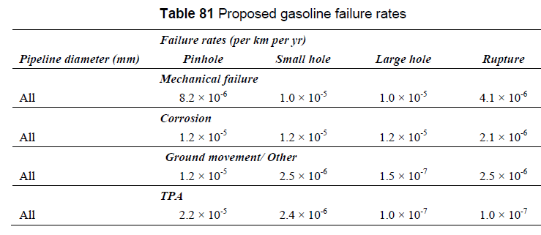
Table 3.1: Table 81 from RR 1035
The table is preceded in the report by the following text:
“It is proposed that the updated analysis of the CONCAWE products data presented in this report is used for the mechanical and corrosion failure modes, whilst that of the UKOPA dataset is used for ground movement and other and third-party activity failure modes. The recommended failure rates are listed in Table 81. This is consistent with the failure rates currently used by MCPIPIN except in the case of third party activity where it is considered that failure rates based on UK data will be more representative for UK pipelines. These TPA failure rates are unlikely to be used, however, as the MCPIPIN TPA predictive model is recommended in this case.”

Consequence Analysis

Release Rates
Release rates are based on HSE analysis of hole sizes which conservatively assumes that pinholes are 0-20 mm equivalent circular diameter holes, small holes defined as 75 mm diameter, large holes as 110 mm diameter, and pipeline rupture which means double-ended open pipe. However, these hole sizes were derived for natural gas pipelines, and for higher density liquids such as gasoline, different hole sizes are relevant.
Hole sizes greater than ~50 mm diameter allow the full pumping rate (typically 300 – 700 m³/hour for 70 – 90 barg) to be released, so holes (small and large re-defined as “punctures”) are assumed to have a discharge rate equivalent to the normal forward flow. Ruptures are assumed to release 150% of the normal forward flow as the pump discharge flowrate increases with reduced head before the pump trips out on overload or is stopped. Small holes are assumed to be 20 mm in diameter.
Analysis of hole sizes recorded from the CONCAWE database (1971 – 2009) indicates that the frequency of different hole sizes is:
- Pinhole 50% of the total leak frequency
- Small hole 25% of the total leak frequency
- Large hole 25% of the total leak frequency
These proportions have been used when dividing failure frequencies from the 3rd party external interference predictive model and from PD 8010 failure data for material and construction defects, external corrosion and natural landslides.
Release rates from the pipeline have been calculated using the standard equation for liquid flow through a sharp-edged orifice [13].
$$F=C_{d}⋅A⋅\sqrt{200000⋅ρ⋅P}$$
where: F = mass flow rate (kg/s)
C_{d} = discharge coefficient (0.6 for holes)
ρ = liquid density (gasoline is ≈ 740 kg/m³)
P = pressure (barg)
A = area of hole (m²)

Ground Soak-in
The size of the pool formed by a gasoline spillage will depend on the extent to which it seeps into the ground. The faster the gasoline seeps into the ground, the smaller the pool is likely to be. The degree to which the gasoline soaks into the ground is largely dependent on the permeability of the soil. Sandy or chalky soils have a high permeability resulting in smaller pool sizes, whereas heavy clay soils have a low permeability with less soak-in.
Also, the dynamic viscosity of gasoline is approximately 4 times less than that of water, and so the coefficient of permeability for gasoline (i.e. the degree to which soak-in occurs) will be a factor of about 4 times greater than that of water.
However, soak-in is significantly reduced when the ground is saturated with rain water or frozen, and spillages in suburban areas will not soak in to road or concrete surfaces. After discussion with HSE the UKOPA methodology therefore conservatively assumes no soak-in occurs following a gasoline spillage.

Immediate Ignition Pool Fires
Pool fires are assumed to be circular and as it is conservatively assumed that no ground soak-in occurs, the pool extends to the maximum diameter dependent on the release rate into the pool. The method assumes a “flat-earth” situation with the pool spreading equally in each direction from the release point.
The equation for calculating the equilibrium diameter of a gasoline pool is as follows [14]:
$$D_{max}=2\sqrt{\frac{m_{r}}{{π⋅m}_{f}}}$$
where: D_{max} = maximum diameter of pool fire (metres)
m_{r} = release rate of gasoline into the pool (kg/s)
m_{f} = burning rate of gasoline (kg/s.m² = 0.067 for large pool fires)
The calculation of thermal effects requires assessment of the size of the pool fire, the height, width and surface emissive power of the flames, the view factor of the observer depending on distance from the flames, and the transmissivity of the atmosphere. Published calculation methods are available for obtaining these, e.g. [14] or [15].

Delayed Ignition Pool Fires
Delayed ignition pool fires are modelled in the same way as immediate ignition pool fires, except that the pool fire ignites when the pool has reached its maximum diameter after the time taken to shut off the flow to the leak or rupture. This is the time taken for the leak detection system to identify the leak and sound an alarm, for the control room operator confirm that a leak is occurring, and for the operator to then stop the pump supplying the leak. For significant leaks or ruptures, a good leak detection system, and a 24/7 manned control room, this time is assumed to be 5 minutes.
The resulting pool diameter is calculated assuming average pool depth of 20 mm, and again assumes no ground soak-in. However, the main limitation of this approach is that the pool size is based on the “flat-earth” assumption that the pool will evenly spread forming a circular pool. In reality the pool will flow downhill and into drains, gullies and ditches and so the flat-earth pool is unrealistic for areas where the pipeline crosses roads and watercourses. Typically, the pool diameter is limited to 100 m to simplistically account for the flaws in the flat earth model [2].
Once the pool diameter has been derived from the flow rate, delay time, and pool depth, the calculation of thermal effects requires assessment of the size of the pool fire, the height, width and surface emissive power of the flames, the view factor of the observer depending on distance from the flames, and the transmissivity of the atmosphere.

Spray Fires
Spray fires are possible for a limited range of hole sizes only. When the hole size is small (less than about 20 mm) the amount released in a spray is small, and the spray distance falls within the assumed pool fire radius. For large holes sizes (greater than about 40 mm) the velocity out of the hole is insufficient to throw the spray far, and so again the spray distance is within the pool fire radius. However, between these hole sizes, a spray of liquid droplets may form, and the spray distance may be significantly greater that the pool fire radius, especially if the angle of the spray is 45° from the vertical.
The WS Atkins report [3] in 1998 discusses spray fires. From USA data, 93% of sprays were found to occur due to 3rd party activities. WS Atkins estimated that 15% of incidents recorded have involved spray releases for some period, and therefore this factor should be used as a conservative estimate in risk assessments. Based on a review of all worldwide accidents involving clean products in pipelines, WS Atkins conclude that the best approach is to apply an empirical model for determining the extent of spray fires. They assume that the consequence model for sprays covers an approximately elliptical area. Their analysis showed that the maximum range of the jet/spray is theoretically proportional to pressure, so they proposed that:
$$Range of spray in metres=2 ×pressure in barg$$
Sprays do not always have this maximum range, and so four cases corresponding to 25%, 50%, 75% and 100% of the maximum range are included in the model, with the maximum width of the ellipse taken to be 80% of the range. This is based on examination of photos, diagrams, and eye witness reports. So, for a pipeline MAOP of 80 barg, the maximum spray distance is 2 x 80 = 160 m, with intermediate distances 120 m, 80 m and 40 m.

Ignition Probability
Extensive analysis of CONCAWE and US Dept of Transport data by both AD Little [2] and WS Atkins [3] showed that ignition probabilities were very low for gasoline pipeline leaks and spillages. Both reports showed that ignition probabilities were higher in suburban areas than rural areas.
Analysis of their data and based on the HSE proposed methodology for land use planning zones in 2010, the following ignition probabilities are applied in the UKOPA methodology.
Fire Type | Ignition Probability
Fire Type | Rural | Suburban
Spray Fire | 0.03 | 0.05
Immediate Ignition Pool Fire | 0.015 | 0.025
Delayed Ignition Pool Fire | 0.015 | 0.025
Table 3.2: Gasoline Fire Ignition Probabilities

Impact on Population
Thermal radiation levels are calculated to assess the impact on the exposed population.
Based on serious accidents which have occurred in the past, the effects on people of high thermal radiation are found to be a function of the thermal radiation intensity, and its duration. For short duration events, such as exposure to large pool fires, the effects have been correlated with the thermal radiation flux to the power four-thirds (4/3) multiplied by the duration. This measure, called the “thermal radiation dose unit”, or tdu, is calculated as follows:
$$Thermal dose unit \left(tdu\right)=I^{\frac{4}{3}}⋅t$$
Where: I = thermal radiation flux (kW/m²)
t = exposure duration (seconds)
HSE methodology [16] calculates the Dangerous Dose effect when calculating the size of land use planning zones, this being the effect which will start to cause fatal injuries to vulnerable members of the population (approximately equivalent to LD01 – lethal to 1% of the population). For their risk assessment they use a thermal dose of 1000 tdu as having “Dangerous Dose” effects for people outdoors.
When calculating societal risks, the level of effect on people is usually measured to LD50 – lethal dose for 50% of the exposed population. HSE have derived 1800 tdu as the thermal radiation level equivalent to “Significant Likelihood of Death” (SLOD), and therefore use this as the equivalent LD50 (50% of the population) thermal radiation level. Therefore, the HSE methodology applies the LD50 dose criterion as if it is the sharp dividing boundary between 0% and 100% fatal injury.
For societal risk analyses, the effect distances are calculated to the 1800 tdu “Significant Likelihood of Death” for calculating the societal risk FN curve to then be compared with societal risk fatality FN criterion lines in PD 8010 Part 3.
Effect distances are calculated for people indoors and outdoors for each of the hazard scenarios. For people inside buildings, it is assumed that 100% fatal effects occur if the building is engulfed in the pool fire. For people in buildings close to the fire, or already outside, it is assumed that they will go outside and try and escape from the high intensity thermal radiation effects of the pool fire.
For people who are escaping outdoors from the fire, thermal radiation levels are calculated for an individual escaping at a speed of 2.5 m/s (9 kph) for 30 seconds until finding shelter (i.e. 75 metres away). The incremental thermal radiation is calculated for each metre along the 75 metres run to shelter (30 seconds exposure). For start distances where the cumulative thermal radiation during the 75 metres run exceeds 1800 tdu, fatal effects are assumed to occur. Therefore, the survival distance at which the observer just receives below 1800 tdu can be calculated.
For vulnerable population, fatal injury effects are assumed to occur at 1000 tdu, and the escape speed is 1 m/s rather than 2.5 m/s.
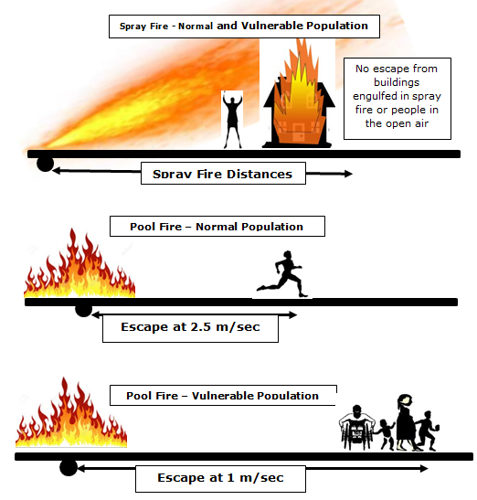
Figure 3.2: Summary of Consequence Analysis for Spray & Pool Fires

Other Consequences
Other possible consequences of a gasoline pipeline release include:
- Flash Fire
This occurs when drifting vapour causes a flammable cloud to form downwind of the release point. It then finds a source of ignition and the burning cloud flashes back to the release point. However, for gasoline, the extent of the vapour cloud is likely to be similar to the spray fire scenarios which are already considered above, although under certain low wind conditions, lighter fractions from gasoline could drift some 100s of metres downwind.
- Vapour Cloud Explosion (VCE)
Under low wind conditions, the drifting cloud of vapour could engulf housing and other obstructed areas in a suburban area. Delayed ignition of the flammable cloud and flame acceleration in the obstructed areas could lead to high explosion overpressures, leading to damage 100s of metres from the release point. However, a detailed hazard analysis by the Health & Safety Laboratory for HSE shows that the risk of this scenario is significantly lower than levels which affect land use planning for pipelines. Therefore, the vapour cloud explosion scenario is not included in the gasoline pipeline QRA methodology.

Derivation of Proposed LUP Zones

Individual Risk
This represents the risk to an individual, located at a specific distance from the pipeline, assumed to be present all the time. It is shown graphically as a cross-section through the pipeline showing the risk at various distances, known as the “Risk Transect”. Individual Risks are often presented in terms of risk of fatality per million years (shortened to Chances per Million per Year or cpm).
HSE have issued a framework for individual risk, in their discussion document “Reducing Risks, Protecting People” [17], as shown in Figure 4.1 below. This framework has been used for the demonstration of ALARP (“As Low As Reasonably Practicable”) for COMAH registered sites in the UK.
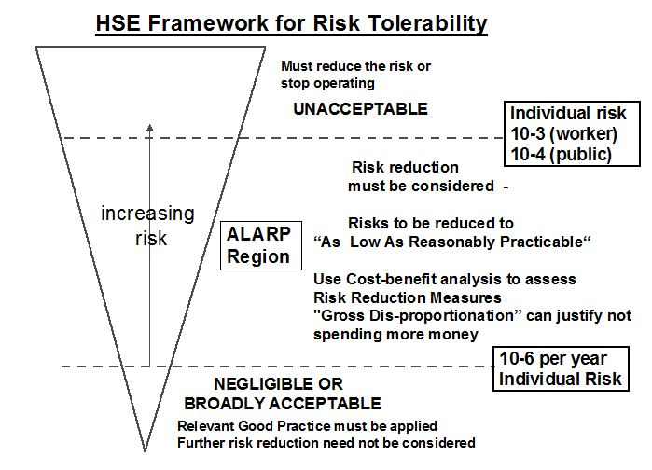
Figure 4.1: HSE Framework for Individual Risk Tolerability
Individual Risk levels were also set by the HSE in the late 1980s to provide guidance on new developments [8] near Major Accident Hazard Pipelines (MAHPs) as defined by the Pipeline Safety Regulations (1996) [1], i.e. those pipelines which transport defined dangerous fluids. These individual risk levels are used to define three zones within an overall land use planning (LUP) consultation distance (CD) and the guidance defines 4 sensitivity levels for developments and the zones that these developments should not be placed in.
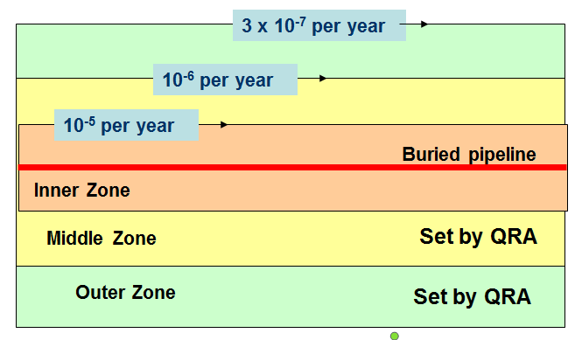
Figure 4.2: Land Use Planning Zones for MAH Pipelines
Zone | Individual Risk Level | Land Use Planning Restrictions
Inner | > 10 cpm | Industrial development only, no residential development
Middle | < 10 cpm and > 1 cpm | Limited residential population only, no large population
Outer | < 1 cpm and > 0.3 cpm | Larger residential development, smaller sensitive developments
 | < 0.3 cpm | No restrictions
Table 4.1: Summary of HSE Land Use Planning Advice
Existing Major Accident Hazard Pipelines (MAHPs), such as high pressure natural gas and dense-phase ethylene, do not show risk levels above 10 cpm or 1 x 10⁻⁵ per year, and therefore do not have inner zones set by quantified risk assessment (QRA). In the past, HSE have set inner zones for pipelines by consequence (e.g. fireball radius) or by separation distance specified by the pipeline Code (e.g. Building Proximity Distance in IGEM/TD/1 [7]).
Unlike gas pipelines, the release rate from a typical ruptured liquid pipeline is not related to pressure, but to the pumped flowrate through the pipeline. Therefore, the characteristic consequence-based hazard zone for a gasoline pipeline could be considered as the equilibrium pool fire radius, even though such a pool would take minutes to form.
The equilibrium pool fire is therefore used to define the proposed inner zone for gasoline pipelines assuming no ground soak-in. Results are shown in Figure 4.3 below.
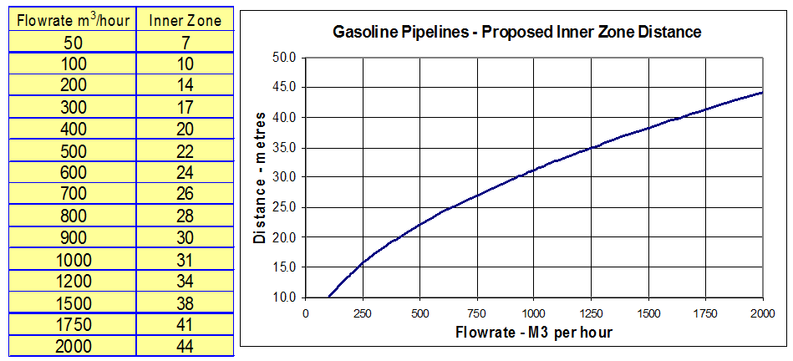
Figure 4.3: Proposed Inner Zones for Gasoline Pipelines
Middle and outer zones are calculated using gasoline pipeline failure rates applied to the consequence analysis for delayed ignition pool fires and spray fires. Results obtained by HSE [18] are shown in Table 4.2.
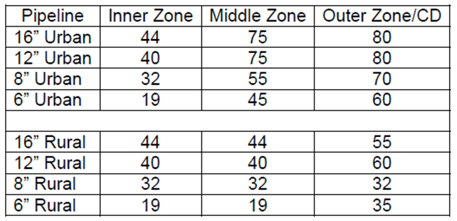
Table 4.2: HSE Calculated LUP Zones for Gasoline Pipelines
By comparison, the methodology described in this report gives the zones shown in Table 4.3.
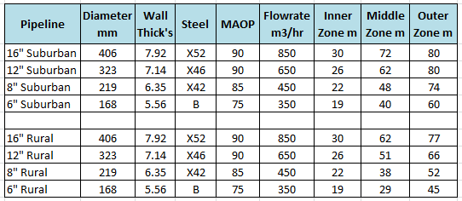
Table 4.3: LUP Zones for Gasoline Pipelines using UKOPA Methodology

Application of Societal Risk
Societal risk is calculated for a specified length of pipeline by superimposing each hazard scenario in turn on the pipeline and adding the number of people within the fatal hazard distance. The location of the hazard scenario is moved incrementally along the length of the pipeline using the failure rate for that increment to obtain the frequency of the number of people affected.
For each release point along the pipeline, there are therefore several events each having a different frequency and each with a different hazard distance. Within each hazard distance (assumed to be circular for pool fires, ellipses for spray fires) any population present are assumed to become casualties.
The total list of frequency and number of fatalities for each increment along the pipeline is then collated and ranked so that the list of cumulative frequency F of N or more fatalities can be obtained. This can then be plotted as the site specific FN curve on a log-log scale.
The advantage of applying societal risk is that it takes into account both the number of people affected by pipeline failure as well as their location relative to the pipeline route.

PD 8010-3 FN Criterion Line
The societal risk criterion line published in PD 8010-3, shown in Figure 5.1, provide guidance on an appropriate societal risk tolerability limit in relation to pipelines containing flammable products other than natural gas in the UK. The risk criterion line is for a 1 km length of pipeline.
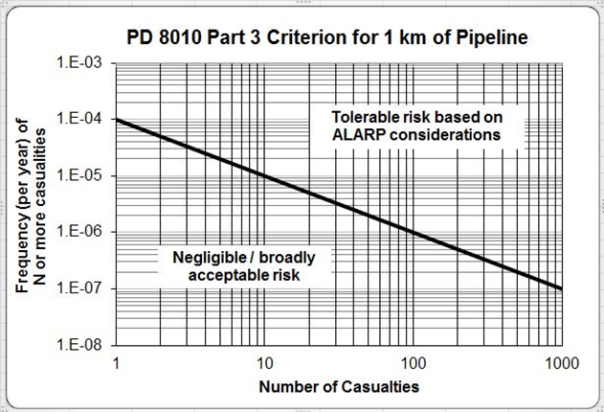
Figure 5.1: PD 8010-3 FN Criterion Line

References

[1] | SI 1996 No. 825, The Pipelines Safety Regulations 1996, as amended, HMSO.
[2] | Contract Research Report 206/1999, “Risks from gasoline pipelines in the United Kingdom,” Prepared by Arthur D Little Limited for the Health and Safety Executive, HMSO, 1999.
[3] | Contract Research Report 210/1999, “Assessing the risk from gasoline pipelines in the United Kingdom based on a review of historical expereience,” Prepared by WS Atkins Safety & Reliability for the Health and Safety Executive, HMSO, 1999.
[4] | Buncefield Major Incident Investigation Board, “The Buncefield Incident 11 December 2005, The final report of the Major Incident Investigation Board, Volume 1,” 2008.
[5] | IGEM/TD/2 Edition 2, Assessing the risks from high pressure natural gas pipelines, Institution of Gas Engineers & Managers, 2013.
[6] | PD 8010-3:2009+A1:2013, Pipeline systems. Part 3: Steel pipelines on land and subsea pipelines - Guide to the application of pipeline risk assessement to proposed developments in the vicinity of major accident hazard pipelines containing flammables - Supplement to PD 8010-1:2004, British Standards Institution, July 2013.
[7] | IGEM/TD/1 Edition 5 with amendments, Steel pipelines and associated installations for high pressure gas transmission, Communication 1789, Institution of Gas Engineers & Managers, July 2016.
[8] | Health and Safety Executive, “HSE’S LAND USE PLANNING METHODOLOGY,” [Online]. Available: http://www.hse.gov.uk/landuseplanning/methodology.pdf. [Accessed 15 12 2017].
[9] | PD 8010-1:2015, Pipeline systems - Part 1: Steel Pipelines on land - Code of practice, British Standards Institution, March 2015.
[10] | CONCAWE, “Performance of European cross-country oil pipelines. Statistical summary of reported spillages in 2010 and since 1971,” Brussels, report no. 8/11, December 2011.
[11] | J. V. Haswell and R. A. McConnell, “UKOPA Pipeline Product Loss Incidents and Faults Report (1962 - 2014),” Ambergate, UKOPA/15/003, Issue 1.1, December 2015.
[12] | Research Report RR1035, “Update of pipeline failure rates for land use planning assessments,” Prepared by the Health and Safety Laboratory for the Health and Safety Executive 2015, HSE Books, 2015.
[13] | Committee for the Prevention of Disasters, “Methods for the calculation of Physical Effects. Due to the releases of hazardous materials (liquids and gases),” CPR 14E, The Hague, Third edition, 2005.
[14] | P. J. Rew and W. G. Hulbert, “Development of Pool Fire Thermal Radiation Model,” HMSO, HSE Contract Research Report No. 96/1996, 1996.
[15] | Mannan, S. eds., Lees' Loss Prevention in the Process Industries, Oxford, UK: Elsevier Butterworth-Heinemann, 3rd Edition, 2005.
[16] | M. Bilo and P. R. Kinsman, “Thermal Radiation Criteria Used in Pipeline Risk Assessment,” Pipes & Pipelines International, vol. 42, no. 5 (November-December), pp. 17-25, 1997.
[17] | Anon, “Reducing risks, protecting people. HSE's decision-making process,” HMSO, London, 2001.
[18] | Health and Safety Executive, “Analysis of responses to the consultation on proposed amendments to the Pipelines Safety Regulations 1996 and the Health And Safety (Fees) Regulations 7 December to 1 March 2010,” [Online]. Available: http://www.hse.gov.uk/consult/condocs/cd228-analysis.pdf. [Accessed 8 August 2018].

Explanation about HSC/HSE relationship
Six items of data are required to allow the external interference failure frequency to be predicted: pipeline diameter; wall thickness; maximum allowable operating pressure (MAOP); steel grade; depth of cover and location class.
This is unrealistic because the response to thermal radiation varies from person to person. Some will survive within the specified LD50 boundary and some fatalities will occur outside this boundary. However, the range over which this occurs for thermal radiation is relatively small, compared to toxic gas exposure, so it is a reasonable assumption to apply to short term thermal radiation effects.
The circumstances that led to the vapour cloud explosion at Buncefield in December 2005 are unlikely to occur from a pipeline release.
Gasoline is not currently defined as a dangerous fluid.
Please note that the equivalent FN criterion for natural gas pipelines, as published in IGEM/TD/1 and IGEM/TD/2 is for a 1.6 km length of pipeline.

