Technical Briefing Note
Application of S-N Curves to Fatigue Assessment of Pipeline Dents
UKOPA/TBN/XXX Edition A
February 2020

TECHNICAL BRIEFING NOTE GUIDANCE ISSUED BY UKOPA:
This Technical Briefing Note (TBN) identifies what is considered by UKOPA to represent current UK pipeline industry good practice within the defined scope of the document. All information is guidance and should not be considered obligatory against the judgement of the Pipeline Owner/Operator. Where new and better techniques are developed and proved, they should be adopted without waiting for modifications to this TBN.

Comments, questions and enquiries about this publication should be directed to:
UK Onshore Pipeline Operators’ Association
Pipeline Maintenance Centre
Ripley Road
Ambergate
Derbyshire
DE56 2FZ
E-mail: enquiries@ukopa.co.uk
Website: www.UKOPA.co.uk

Disclaimer
This document is protected by copyright and may not be reproduced in whole or in part, by any means without the prior approval in writing of UKOPA. The information contained in this document is provided as guidance only and while every reasonable care has been taken to ensure the accuracy of its contents, UKOPA cannot accept any responsibility for any action taken, or not taken, on the basis of this information. UKOPA shall not be liable to any person for any loss or damage which may arise from the use of any of the information contained in any of its publications. The document must be read in its entirety and is subject to any assumptions and qualifications expressed therein. UKOPA documents may contain detailed technical data which is intended for analysis only by persons possessing requisite expertise in its subject matter.
Copyright @2020, UKOPA. All rights reserved
Revision and change control history
Planned revision:
Edition | Date | No. of pages | Summary of changes
A | 25.02.20 |  | Previously PIWG/16/032, transferred to TBN format
B
C
1

Contents
1. Introduction 1
2. Published S-N Curves 2
3. S-N Curves for Application to Pipelines 4
3.1 BS 7608 4
3.2 IGEM/TD/1 4
4. Safety Factors Applied to S-N Curves 5
5. Use of S-N Curves with Dent SCF Equations for Calculation of the Fatigue Life of Dents in Pipelines 6
6. References 9

Introduction
The UKOPA Dent Management Strategy (DMS) includes equations for the calculation of stress concentration factors for dents in pipelines for use with S-N curves. This note considers the published S-N curves available for application to pipelines and the selection and application of the S-N curve in the fatigue assessment of a pipeline dent.

Published S-N Curves
Fatigue performance is characterised by S-N curves, which relate the magnitude of cyclic stress (S) to the number of cycles (N) to failure, for various classified structural details. S-N curves are plotted on a logarithmic scale. S-N curves are obtained by testing of small-scale fatigue samples or coupons subject to a regular sinusoidal stress in a testing machine which counts the number of cycles to failure, each test generates a single S-N point. The results are plotted on a logarithmic scale, and the S-N curve is developed from statistical linear regression of the results. The mean S-N curve and the standard deviation of the data are calculated by the statistical analysis; the design S-N curve is defined as 2 standard deviations below the mean curve, which gives a 97.7% probability of survival.
The recognised and accepted S-N curves applied in the UK are published in a number of standards [1-3]. The classes of S-N curves in these standards are equivalent. The standard BS 7608, which is developed as a generic standard, to be referenced and applied in structure specific design codes. In addition, a pipeline-specific S-N curve is included in the gas pipeline standards IGEM/TD/1.
SN curves are published in the form:
S^{m}N = Constant
S-N curves are classed according to the detail and quality of the material or joint they represent. The detail and quality descriptions given in the standards are used to select the appropriate curve for application to a particular item, component or structure. The S-N curves given in Figure 10 of BS 7608 are shown in Figure 1.
Note, BS 7608 requires that the S-N equation is modified to take account of material thickness and through thickness bending, the effect of temperature, the effect of seawater and the effect of weld toe improvement.
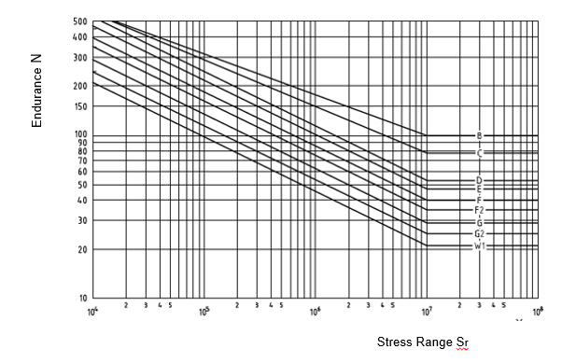
Figure 1 Standard Basic Design Curves given in BS 7608

S-N Curves for Application to Pipelines

BS 7608
BS 7608 S-N curves for application to pipelines are selected according to whether the fatigue assessment relates to a location in plain pipe, the seam weld or the girth weld. The S-N curves typically selected are given in Table 1.
Location | Class | m | Constant
Plain pipe | B | 4.0 | 1.01x10¹⁵
Seam weld | E | 3.0 | 1.04 x 10¹²
Girth weld | F | 3.0 | 6.33 x 10¹¹

Table 1 S-N Curves for Application to Pipelines [1]

IGEM/TD/1
The TD/1 S-N curve was developed as a simple approach which ‘designed out’ fatigue for pipelines subjected to a high level hydrotest (i.e. 105% SMYS) and subsequently operated at a maximum stress of 72% SMYS.
The work carried out to develop the TD/1 fatigue design rules was focused on SAW pipe of poor geometry (roof topping, plate offset and ovality), as a number of hydrotest failures from long defects at the internal (SAW) weld toes had occurred in pipes with these characteristics. It was therefore assumed that pipes entered service with defects typical of SAW pipes with poor geometry and defects of the maximum size that could survive the 105% SMYS hydrotest. The size of defect which would fail at 72% SMYS was determined, and the fatigue life of the pipeline was judged in terms of the number of cycles (or time) to propagate by fatigue from the size which would survive the hydrotest to the size which could fail at 72% SMYS.
An extensive programme of full-scale tests involving SAW pipe of poor geometry and fracture mechanics analysis was conducted. In summary the results of the work identified that:
- The maximum depth of an infinitely long surface breaking defect typical of poor-quality SAW pipe which could survive the 105% hydrotest was 20%.
- The maximum depth of an infinitely long surface breaking defect that would fail at a stress of 72% SMYS was 40%.
- The stress range which would cause propagation of an infinitely long defect of 20% depth to 40% depth over 15,000 cycles is 125 N/mm²
The results of the original work were introduced into TD/1 Edition 2 (1984). In TD/1 Edition 4 (2001) the S-N equation was included:

Safety Factors Applied to S-N Curves
The fatigue design curves in BS 7608 are based on 2 standard deviations below the mean line derived from empirical data. The design S-N curves presented in the document represent safe life design limits, based on lower bound fatigue endurance data and upper bound fatigue lasting data. The S-N curves therefore provide a conservative estimate of fatigue strength, and their application does not depend upon in-service inspection for fatigue damage.
The TD/1 fatigue curve is derived from empirical pipeline fatigue data and fracture mechanics analysis. In deriving the fatigue S-N curve for publication in Edition 4, a safety factor of 10 was applied on the basis that a fatigue crack in a high pressure pipeline would not be detected in routine inspection, and there was no redundancy in a transmission pipeline.
A review of the safety factor in fatigue design rules [5] indicates that where the potential fatigue location is accessible and the consequences are not substantial, the safety factor is 1.0, while in locations where the potential fatigue location is inaccessible and the consequences are significant, the safety factor is increased to 10.
The IGEM/TD/1 S-N curve includes a safety factor of 10 on life. In their report on the validation of the finite element analysis of dent fatigue life for UKOPA [6], Penspen considered the application of S-N curves and safety factors. Figure 7 of the Penspen report plots the predicted cyclic stress in each plain dent against the measured number of cycles to failure, this is repeated in Figure 8 for dents on welds. Figures 7 and 8 of the Penspen report are given in Figure 2 below. The mean regression line through the data effectively represents the ‘ideal’ SN curve for the data. The lower bound line is offset from the mean line by three times the standard deviation of the data, and thus represents approximately a 99.87% probability of survival. This report states that two standard deviations below the mean can be considered to be a sufficient margin of safety for fatigue life, and the relevant S-N curves plotted in Figure 7 and 8 (Figure 2 below) can be used without further safety factors to predict the fatigue life of dents using stresses from finite element analysis.

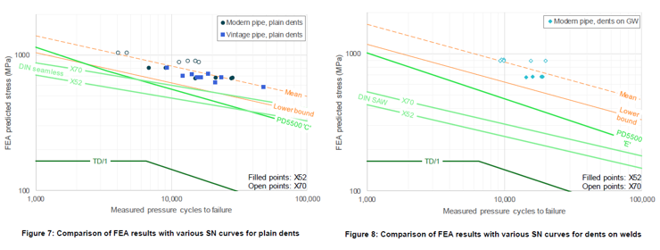
Based on the above it is considered that where S-N curves other than the TD/1 S-N curve are being used to estimate the fatigue life of pipeline dents, a safety factor of 10 on life is applied.
Where a finite element analysis is being carried out to determine the stress cycle, the BS 7608 S-N curves can be applied with no safety factor.

Use of S-N Curves with Dent SCF Equations for Calculation of the Fatigue Life of Dents in Pipelines
The dent SCF equation given the UKOPA dent management strategy and Good Practice Guide is detailed as follows:
The SCF increases as the dent depth H_{o} or H_{r} increases, where
H_{o} = dent depth at zero pressure after removal of indenter and after spring back
H_{r} = dent depth at zero internal pressure after spring back and rerounding
For a dent depth ratio described by H_{o}/D the SCF is given by;
1
For a dent depth ratio defined by H_{r}/D the SCF is given by;
2
= maximum principal stress range (units: N/mm²)
= hoop stress range in the pipe away from stress concentrations (units: N/mm²).
Both equations give an upper bound SCF for a single smooth dent.
Equation 2 is selected for application, as in most cases the dent depth will be measured at pressure.
Two pipeline examples are assessed, and the fatigue life of dents of depths ranging from zero to 10% OD are considered. Applying equation 2, the SCFs are calculated as given in Table 3, and the pipeline cases together with the calculated cyclic pressure calculated for a standard cyclic stress range of 125N/mm² are given in Table 3.
Dent Depth (Hr/D) | 0 | 0.025 | 0.05 | 0.075 | 0.10
Calculated SCF | 1.00 | 3.09 | 4.04 | 4.65 | 5.11
Table 2 Calculated Dent SCFs

OD | WT | Grade | SMYS | UTS | Stress | dP
168.3 | 5.6 | X42 | 289 | 413 | 125 | 83.2
323.9 | 5.6 | X52 | 358 | 455 | 125 | 43.2
Table 3 Pipeline cases
The fatigue lives for dents of different depths located in plain pipe, on the seam weld and on the girth weld are calculated using the appropriate S-N curve and the calculated dent SCF, as given in Table 4. The calculated fatigue lives are plotted in terms of dent depth vs numbers of cycles in Figure 2 and Figure 3.
 | Dent Depth in 168 mm Diameter Pipe
Dent Depth | 0.000 | 0.025 | 0.050 | 0.075 | 0.100
Plain pipe | 21093357 | 230276 | 79533 | 45090 | 30977
Seam weld | 1806765 | 61021 | 27492 | 17962 | 13554
Girth weld | 1099694 | 37141 | 16733 | 10933 | 8250
 | Dent Depth in 324 mm Diameter Pipe
Dent Depth | 0.000 | 0.025 | 0.050 | 0.075 | 0.100
Plain pipe | 289369679 | 3159048 | 1091078 | 618575 | 424963
Seam weld | 12878998 | 434970 | 195968 | 128037 | 96618
Girth weld | 7838852 | 264746 | 119276 | 77930 | 58807
Note: dent depth is given as a proportion of the pipeline outside diameter

Table 4 Calculated Pipeline Dent Fatigue Lives

Figure 2 Dent Fatigue lives in 168 mm Diameter Pipe (calculated at stress range 125 N/mm2)

Figure 3 Dent Fatigue lives in 324 mm Diameter Pipe (calculated at stress range 125 N/mm2)

References

- BS 7608 Guide to fatigue design and assessment of steel products. BSI 2014.
- PD 5500 Specification for Unfired fusion welded pressure vessels. BSI 2015.
- BS 7910 Guide to methods for assessing the acceptability of flaws in metallic structures. BSI 2013.
- IGEM/TD/1 Steel pipelines and associated installations for high pressure gas transmission. IGEM 2008.
- OTC Report 2001/083 Comparison of fatigue provisions in codes and standards. Prepared by Bomel Ltd for HSE, 2001.

