Technical Briefing Note
Effect of Pipeline Surveillance on Risk of 3rd Party Interference
UKOPA/TBN/009 Edition 1
September 2019

TECHNICAL BRIEFING NOTE GUIDANCE ISSUED BY UKOPA:
This Technical Briefing Note (TBN) identifies what is considered by UKOPA to represent current UK pipeline industry good practice within the defined scope of the document. All information is guidance and should not be considered obligatory against the judgement of the Pipeline Owner/Operator. Where new and better techniques are developed and proved, they should be adopted without waiting for modifications to this TBN.

Comments, questions and enquiries about this publication should be directed to:
UK Onshore Pipeline Operators’ Association
Pipeline Maintenance Centre
Ripley Road
Ambergate
Derbyshire
DE56 2FZ
E-mail: enquiries@ukopa.co.uk
Website: www.UKOPA.co.uk

Disclaimer
This document is protected by copyright and may not be reproduced in whole or in part, by any means without the prior approval in writing of UKOPA. The information contained in this document is provided as guidance only and while every reasonable care has been taken to ensure the accuracy of its contents, UKOPA cannot accept any responsibility for any action taken, or not taken, on the basis of this information. UKOPA shall not be liable to any person for any loss or damage which may arise from the use of any of the information contained in any of its publications. The document must be read in its entirety and is subject to any assumptions and qualifications expressed therein. UKOPA documents may contain detailed technical data which is intended for analysis only by persons possessing requisite expertise in its subject matter.
Copyright @2020, UKOPA. All rights reserved
Revision and change control history
Planned revision: 2020
Edition | Date | No. of pages | Summary of changes
1 | 12/09/2019 | 12 | Format conversion from 2005 note

Contents
1. Introduction 1
1.1 Scope 1
1.2 Abbreviations 1
2. Probability of 3rd Party Excavation Reaching the Pipeline 2
3. Method of Analysis 3
3.1 Data from the UKOPA Infringement Database 3
3.2 Derivation of Parameters for Monte-Carlo Simulation 4
4. Results 7
5. Conclusions 8
6. References 9

Introduction
Major hazard pipelines require regular surveillance to reduce the risk of damage to the pipeline by external factors and third parties. PD 8010-1 [1] gives general guidance for the periodic survey of the pipeline route to detect factors that could affect the safety of the pipeline and Section 12.6 of IGEM/TD/1 [2] describes in detail the requirements for aerial survey, vantage survey and full walking survey. IGEM/TD/1 recommends an aerial survey of all pipelines should be undertaken every 2 weeks, unless the frequency is set by a risk-based approach.
Increased surveillance frequency is recognised as a means of reducing the probability that an unauthorised excavation near the pipeline will reach it and cause damage or product loss. However, it is considered a secondary mitigation measure (compared to slabbing or other passive measures), and is dependent on effective management and surveillance systems, so may only be applicable to temporary situations (fairs, festivals, construction activities etc).
This TBN addresses the degree to which the risk of external interference to a pipeline due to 3rd parties can be reduced by increasing the frequency of surveillance. In this context the risk assessment process considers the probability of a third-party excavation reaching and damaging the pipeline; it does not address the probability of product loss occurring because this is dependent of other factors concerning the design and construction of the pipeline itself.

Scope
This TBN is a recreation of a briefing paper written for the Risk Assessment Working Group (RAWG) in 2005 [3]. The briefing paper is referenced and the results are included, in IGEM/TD/2 [3] and PD 8010-3 [4]. Minor updates have been made to references.

Abbreviations
FARWG | Fault and Risk Working Group
IGEM | Institution of Gas Engineers & Managers
PD | Published Document
RAWG | Risk Assessment Working Group (predecessor to FARWG)
TBN | Technical Briefing Note
UKOPA | United Kingdom Onshore Pipeline Operators’ Association

Probability of 3rd Party Excavation Reaching the Pipeline
The risk of a third-party excavation reaching the pipeline is affected by three main factors:
- The frequency with which unauthorised excavations occur along a length of pipeline relative to the frequency of surveillance;
- The likely duration of the excavation before it reaches the pipeline; and,
- The surveillance frequency.
Other factors of importance include the possibility of a landowner or member of the public reporting the third party activity to the pipeline operator, the possibility of the third party identifying the pipeline route by markers, and the extent to which the equipment or machinery involved could cause a serious threat to the pipeline. These factors are not directly included in this analysis. In addition, no allowance has been included for the efficiency and reliability of surveillance in identifying and detecting 3rd party excavations, these being dependent on the management and technical systems in operation at the time.

Method of Analysis
The method used to analyse the effect of increased surveillance is the Monte-Carlo simulation method which involves examining the operation over an extended period (1000 years) and generating random events to describe the start of an unauthorised excavation and the duration of the excavation before it reaches the pipeline.
The analysis process consists of the following stages:
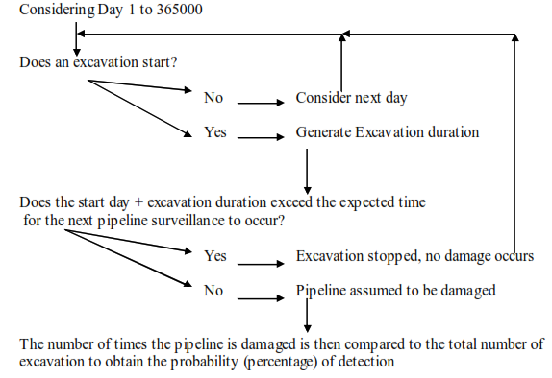

Data from the UKOPA Infringement Database
The June 2005 presentation for the UKOPA Infringement Database is shown below. The total number of infringements was 353.
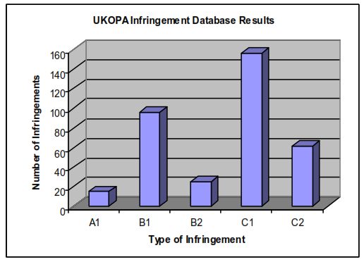
Figure 3.1: UKOPA Infringement Database Results (2005)
The classification of infringements is as per Table 2.1 and Table 2.2.
Category | Type | Description
A | Pipeline damage or leak | Includes damage to wrap or protective sleeve
B | Serious potential for damage | Methods or equipment used could have resulted in significant damage had excavation taken place at pipeline
C | Limited potential for damage | Methods or equipment would not have resulted in serious damage
Table 2.1: UKOPA Infringement Database infringement classification
Location Category | Location Description
1 | Within pipeline wayleave or easement.  Typically, this is the zone within which the pipeline operator has legal rights, including a requirement by the landowner to notify planned work (although this may be different for non-Pipelines Act pipelines laid by Statutory Undertakers).
2 | Within pipeline operators’ zone of interest, but outside the pipeline wayleave or easement.  This is the area within which the operator would have reasonably expected a competent third party to have given notification in the prevailing circumstances.
Table 2.2: UKOPA Infringement Database location classification

Derivation of Parameters for Monte-Carlo Simulation

Frequency of excavations
Data collected over the 2-3 years (to 2005) for the Infringement Database for about 20,000 km of pipelines in the UK indicates that the expected frequency of unauthorised excavations is approximately between 2 and 5 per 300 km length of pipeline (i.e. between 6.7 and 16.7 per 1000 km). The Monte-Carlo models shows that the results are not very sensitive to the excavation rate, and that the higher the number of excavations per year, the lower the probability of detection for a given surveillance frequency.
To allow for under reporting of incidents in the Infringement Database, an excavation frequency of 10 per 300 km length per year (i.e. 33.3 per 1000 km years) has been assumed.

Duration of excavation before reaching the pipeline
Not every excavation will necessarily reach the pipeline. However, in this analysis it is assumed that excavations have a randomly generated duration with an average set for the Exponential Distribution as follows:
$$Duration of excavation= \frac{Average Duration}{-ln{(Random number between 0 and 1)}}$$
From the Infringement Database, it has been assumed that:
- A1 type infringements are caused by relatively short duration excavations which then caused damage to the wrap or pipeline. There are 15 of these events recorded.
- B1 type infringements are caused by events in the easement near the pipeline and are therefore likely to cause damage in a medium timescale but have been detected and stopped before they caused damage. There are 96 of these events recorded.
- B2 / C1/ C2 type infringements are of longer duration because they are outside the easements and / or are unlikely to cause damage to the pipeline. There are 242 of these incidents recorded.
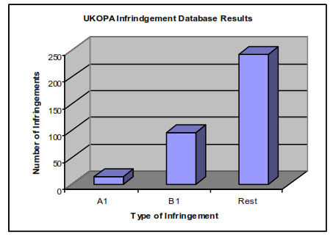
Figure 3.2: Profile of Infringement Types
Various average excavation durations have been calculated using the Monte-Carlo model. They show that the shorter the average duration, the less likely is the surveillance to find and stop the excavation before it reaches the pipeline. After a series of trial and error runs, the best fit for the average excavation duration is 2.5 days, on the basis that:
- Excavation duration less than 1 day is equivalent to an A1 type event;
- Excavation duration 1 days to 2.5 days is equivalent to a B1 type event; and,
- Excavation duration greater than 2.5 days is equivalent to a B2, C1 or C2 event.
The pattern of event frequencies which best fits the average 2.5-day duration is shown in Figure 2.2.
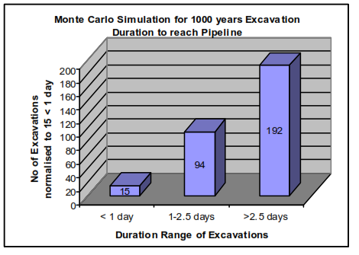
Figure 3.3: Assumed Distribution of Event Durations
This shows that for 15 A1 type events, there would be 94 B1 type events and 192 of the rest, which is similar to the actual experience from the Infringement Database.
It should be noted that due to the way the Exponential Distribution works, the setting of the average duration for an excavation of 2.5 days generates a lower duration with the greatest frequency of such an event. For a simulation of 1000 years, the number of excavations of different duration is shown in Figure 2.3.
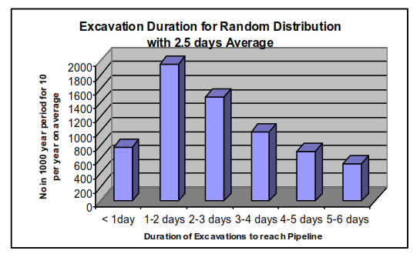
Figure 3.4: Distribution of Excavation Durations
The highest number of events is in the 1 to 2 day duration.
To obtain the simulation results, several different runs were carried out using 1000 year simulation periods. This was found to give similar results when running the same case several times so longer periods were not required to obtain stable results.
Different sets of results have been obtained for different surveillance periods and different key parameters including excavation duration and excavation frequency. However, the optimal results fitting the data for the Infringement Database are for 10 excavations per year with average duration 2.5 days.

Results
The results are presented in terms of risk reduction factor relative to the standard 14 day (2-weekly) surveillance period. Risk reduction factors have been obtained for a generic pipeline route where the following parameters have been applied:
- Typical route length - 200 – 300 kilometres, surveyed at routine intervals;
- Number of unauthorised excavations occurring per year – 10; and,
- Average duration of excavation before reaching pipeline - 2.5 days (used in Exponential distribution to obtain random duration – see Section 3.2.2)
These values have been derived from consideration of the UKOPA Infringement Database.

Conclusions
This TBN has described the application of the Monte-Carlo simulation to derive the effects of increased surveillance frequency in reducing the probability of an unauthorised excavation reaching and damaging an underground pipeline. Data for setting the key parameters has been derived from the UKOPA Infringement database. Results are presented in terms of the Risk reduction factor relative to the standard surveillance frequency of 2 weeks.

References

[1] | PD 8010-1:2015, Pipeline systems - Part 1: Steel Pipelines on land - Code of practice, British Standards Institution, March 2015.
[2] | IGEM/TD/1 Edition 5 with amendments, Steel pipelines and associated installations for high pressure gas transmission, Communication 1789, Institution of Gas Engineers & Managers, July 2016.
[3] | R. A. McConnell, “Effect of Surveillance Frequency on 3rd Party Excavation Rate,” Briefing Paper to UKOPA RAWG, October 2005.
[4] | IGEM/TD/2 Edition 2, Assessing the risks from high pressure natural gas pipelines, Institution of Gas Engineers & Managers, 2013.
[5] | PD 8010-3:2009+A1:2013, Pipeline systems. Part 3: Steel pipelines on land and subsea pipelines - Guide to the application of pipeline risk assessement to proposed developments in the vicinity of major accident hazard pipelines containing flammables - Supplement to PD 8010-1:2004, British Standards Institution, July 2013.

