

Pipeline Services

Draft Version 6 | September 2000
1ST ukopa pipeline damage database interim report

pipeline incident data (leak and rupture)
Confidential | Restricted to distribution List

Prepared for: | Prepared by:
UKOPA | Ray Hicks and Bob Greenwood
FAULT DATABASE MANAGEMENT GROUP | BG Technology Limited  Gas Research & Technology Centre  Ashby Road  Loughborough  Leicestershire  LE11 3GR  United Kingdom
 | Tel: | +44(0)1509 282734
 | Fax: | +44(0)1509 283080
 | E-mail: | ray.hicks@bgtechnology.com
 | Website: | www.bgtechnology.com
Customer Reference:
Include Here

Summary

This interim report presents collaborative pipeline and fault data from BG Transco, Shell UK, BP Amoco and Huntsman ICI for operating experience up to the end of 1998 for Major Accident Hazard Pipelines (MAHPs) within their onshore high pressure steel transmission systems. The incident data presented here is for reported incidents on pipelines, within the public domain and not within a compound, where there was an unintentional loss of product from the pipeline.

A further report will cover predicted failure frequencies based on models of the growth of non product loss defects.
Project Code : 1/01361
Restricted to : Distribution List

Distribution
Name | Company
I. Hayward | BG Technology
R. Owen | BG Technology
A. Francis | BG Technology
R. Hicks | BG Technology
R. Greenwood | BG Technology
R. McConnell | Eutech
R. Ellis | Shell UK
K Thomas | Huntsman ICI
M. Crawford | BP Amoco
B McCullough | HSE
Author(s):
Team Leader:
General Manager :
Recipients of this page may obtain a copy of this report from:
BG Technology Limited, Gas Research & Technology Centre, Ashby Road, Loughborough,
Leicestershire, LE11 3GR. Telephone 01509 282525 Facsimile 01509 283131

Contents

1 INTRODUCTION 1
1.1 Background 1
1.2 Purpose of the Database 1
1.3 Key Advantages 2
2 DESCRIPTION 3
3 Database Content 5
3.1 Pipeline System Data 5
3.1.1 Exposure 5
3.1.2 Transported Products 6
3.2 Product Loss Incident Data 6
3.2.1 Incident Ignition 7
3.2.2 Incident Frequency 8
3.2.3 Frequency per Type of Incident 10
3.2.4 External Interference 13
3.2.5 External Corrosion 16
3.2.6 Detection 20

INTRODUCTION

1.1 Background

One of the key objectives of UKOPA is to develop a comprehensive view on risk assessment and risk criteria as they affect Land Use Planning aspects adjacent to high hazard pipelines. The main multiplier in pipeline risk assessments is the per unit length failure rate which directly relates to the extent of risk zones adjacent to the pipelines. Regulators and consultants who carry out risk assessments for UK pipelines have generally relied on US and European data to provide the basis for deriving failure rates due to the shortage of verified published data relating to UK pipelines.

With the opportunity to pool data UKOPA decided to proceed with the setting up of a UKOPA Pipeline Damage Database during May 1998. A steering group called the Fault Database Management Group (FDMG) was established to define the requirements and to direct the development of the database. This FDMG currently comprises representatives from four companies; BG Transco, Huntsman ICI, BP Amoco and Shell UK. The Health & Safety Executive also support the initiative and are in the process of joining the group.

BG Technology was selected to set-up and manage the database on behalf of UKOPA during November 1998. Development of the database was carried out during 1999 and input database ‘empty shells’ were issued to the participating companies to populate with their own pipeline and fault data. BG Technology pooled the company data into one collaborative database and this report presents the first set of incident data, from the collaborative data, for pipeline incidents resulting in the unintentional release of product (leak database). It is the intention of the group to publish the results of the predictive modelling, using all pipeline damage data, in 2001.

1.2 Purpose of the Database

The purpose of the database is to:

- be able to assign best estimate failure rates to a UK pipeline for risk assessment purposes based on UK pipeline damage data
- estimate leak and pipeline rupture frequencies to a UK pipeline, based on UK pipeline failure rate data
- provide a more realistic and rigorous approach to the design and routing of pipelines
- test design intentions to determine the effect of engineering changes (e.g. wall thickness of pipe, depth of burial, diameter, protection measures, inspection methods and frequencies, design factor, etc.)

Key Advantages

Setting up a new database allows UK pipeline operators to design the database such that it can be used in the most effective way based on their pipeline systems. The capability for the damage data to be processed using predictive models is a way of effectively extending the base data on which the various failure rates are calculated. One of the problems with creating a UK-only database has been the relatively limited population of pipelines and operating experience compared to large databases such as EGIG and CONCAWE. However, by considering all types of pipeline damage, not just leaks and ruptures, and extrapolating to the probability of a leak, the extent of the database can be extended to give a more comprehensive failure frequency profile.

2 DESCRIPTION

The collaborative database has been developed as a Microsoft Visual Basic 5 32-bit executable program using Microsoft Access 97 database files for data storage. ‘Empty shell’ Input Databases have been created for each contributing company to input their own pipeline and fault data.

Users of the application can carry out functions such as the addition, modification, deletion and viewing of pipelines and faults using a series of on-screen forms.

Example screens of the two parts of the database are shown below:

- Pipeline Input Database – Example Screen

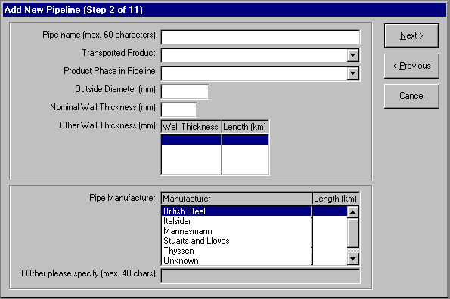

- Fault Input Database – Example Screen

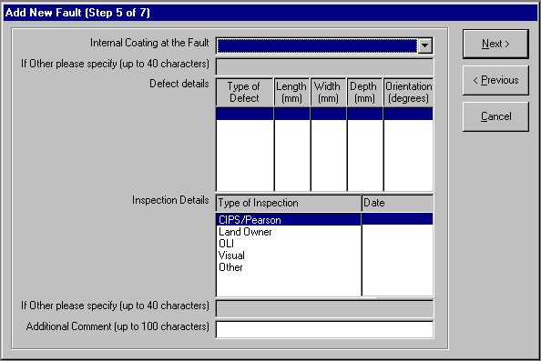
Each company has populated its input database with operating experience up to the end of 1998 and returned the data (.mdb file) to BG Technology for collation and analysis. This process is intended to be carried out on a regular basis and results from the collaborative database will also be published on a regular basis. The next update will be carried out during 2001 and will include pipeline and fault data for 1999 and 2000.

3 Database Content

3.1 Pipeline System Data

3.1.1 Exposure

The total length of the pipeline system (MAHPs), above ground, below ground and elevated, up to the end of 1998 for all participating companies (BG Transco, BP Amoco, Shell UK, Huntsman ICI) is 20,045 km. The exposure in the period 1952 to end 1998 is 518,818 km.yr, as illustrated in Figure 1.

Length of Pipeline which has unknown commissioning date =44.8km. (This has been ignored in the exposure calculations)
Exposure to end 1998 of Elevated Pipeline = 17.9km.yr (included in totals)
Exposure to end 1998 of Above Ground Pipeline = 102.4km.yr (included in totals)

Figure 1

3.1.2 Transported Products

The transported products include (km):

Butane | 19.5 | Propylene | 36.3
CO | 36.3 | LPG | 9.6
Condensate | 24 | Natural Gas (Dry) | 18,333
Crude Oil (Spiked) | 212.6 | Other | 225.8
Ethane | 38.1 | Propane | 19.5
Ethylene | 1045.5 | TOTAL | 20,000

Although the UKOPA database currently comprises only MAHPs, the intention is to include non-MAHPS in the future.

3.2 Product Loss Incident Data

The criteria for a product loss incident on a pipeline are:

- within the public domain and outside the fences of installations
- excluding associated equipment (e.g. valves, compressors) or parts other than the pipeline itself
- there was an unintentional loss of product from that pipeline

A total of 161 product loss incidents were recorded over the period between 1962 and 1998. No product loss incidents were recorded prior to 1962. An annual breakdown of incidents is illustrated in Figure 2.a. The cumulative number of incidents over the period 1962 to 1998 is shown in Figure 2.b.
Figure 2a
Figure 2b

3.2.1 Incident Ignition

There were 8 out of 161 (5%) product loss incidents that resulted in ignition. Table 1 below provides more detail:

Affected Component | Cause Of Fault | Hole Diameter Class
Pipe | Seam Weld Defect | 0-6mm
Pipe | Ground Movement | Full Bore  (18” Diameter Pipe)
Pipe | Girth Weld Defect | 6-20mm
Pipe | Pipe Defect | 0-6mm
Pipe | Unknown | 50⁺mm
Pipe | Lightning Strike | 0-6mm
Bend | Internal Corrosion | 0-6mm
Bend | Unknown | 6-20mm

Table 1 – Incidents that Resulted in Ignition

3.2.2 Incident Frequency

The incident frequency over consecutive 5-year periods is given in Table 2.

Period | Number of Incidents | Total Exposure [km.yr] | Frequency  [Incidents per 1000 km.yr]
1960-1964 | 5 | 7,030 | 0.711
1965-1969 | 15 | 25,980 | 0.577
1970-1974 | 25 | 58,482 | 0.427
1975-1979 | 23 | 73,200 | 0.314
1980-1984 | 34 | 84,620 | 0.402
1985-1989 | 36 | 91,430 | 0.394
1990-1994 | 16 | 96,538 | 0.166
1994-1998 | 9 | 99,730 | 0.090

Table 2

The overall incident frequency by hole size over the period 1960 – 1998 is given in Table 3.

Hole Size Class | Number of Incidents | Frequency  [Incidents per 1000 km.yr]
Full Bore* | 6 | 0.012
≥ 50mm | 16 | 0.031
≥ 20mm | 38 | 0.073
≥ 6mm | 57 | 0.110
0 – Full Bore | 161 | 0.311

Table 3

* Full Bore ≡ diameter of pipeline

The failure frequency over the last 5 years (1994-1998) is 0.090 incidents per 1000km.yr as compared to the overall failure frequency during the period 1960-1998 which is 0.311 incidents per year per 1000 km of pipeline. An overview of the development of this overall failure frequency over the total period of 1960 to 1998 is given in Figure 3. This figure shows the change in the incident frequency in each year being the cumulative total from 1960 onwards. In order to see the results over the last period, without influence of the past, the moving average is calculated only over the past 5 years (1960-1964, 1961-1965, 1962-1966, etc).
Figure 3

3.2.3 Frequency per Type of Incident

Product Loss Incident Frequency by Cause is given in Figure 4.
Figure 4
Product Loss Cause | No. of Incidents
Girth Weld Defect | 33
External Interference | 31
Internal Corrosion | 27
External Corrosion | 26
Unknown | 12
Other | 12
Pipe Defect | 12
Ground Movement | 5
Seam Weld Defect | 3
Total | 161

Table 4 – No. of Product Loss Incidents by Cause
Figure 5 shows the frequency per type of product loss incident (initiating cause) over the period 1960-1998 compared with the frequency over only the last 5 years (1994-1998).

Figure 5
An overview of the product loss incident frequency by cause and size of leak in the period 1952 to 1998 is given in Figure 6.

Construction/Material = Seam Weld Defect + Pipe Defect + Pipe Mill Defect + Damage During Original Construction

Figure 6

3.2.4 External Interference
Figure 6 shows that external interference is one of the main causes of product loss incident data.

3.2.4.1 External Interference per Diameter Class
In Figure 7 the product loss incident frequencies associated with external interference are given per diameter class and by hole size.
Figure 7

Table 5 – Exposure per Diameter Class in km.yr

3.2.4.2 External Interference per Measured Wall Thickness Class

The relationship between product loss incidents caused by third party interference (outside forces on the pipeline) and the wall thickness is shown in Figure 8.

Nb: Maximum wall thickness for loss of product incident caused by external interference is 12.7mm.

Figure 8

Table 6 – Exposure by Wall Thickness Class in km.yr

External Interference per Area Classification

Figure 9

Table 7 – Exposure by Area Classification in km.yr

Nb:
Rural = population density < 2.5 persons per hectare
Suburban and Semi-rural = population density > 2.5 persons per hectare and which may be extensively developed with residential properties
Urban = Central areas of towns or cities with a high population density

3.2.5 External Corrosion

3.2.5.1 External Corrosion per Wall Thickness Class

Figure 10

Table 8 – Exposure by Wall Thickness Class in km.yr

External Corrosion per Year of Construction

Figure 11

Table 9 – Exposure by Year of Construction in km.yr
3.2.5.3 External Corrosion per External Coating Type

Figure 12

Table 10 – Exposure by External Coating Type in km.yr

3.2.5.4 External Corrosion per Type of Backfill

Figure 13

Detection

Figure 14

