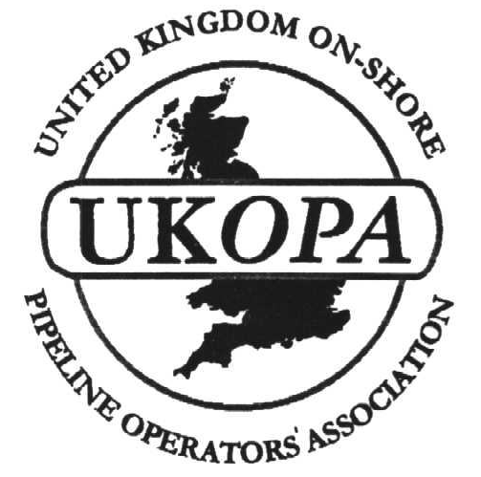
UNITED KINGDOM ONSHORE PIPELINE
OPERATORS ASSOCIATION

UKOPA'S FAULT DATABASE
MANAGEMENT GROUP

invite you to attend a seminar for presentation of :-

RESULTS FROM THE UK PIPELINE LEAK DATABASE

During the last two years, data on leaks and faults on the UK's major high pressure gas pipeline systems have been collated into a single database by BG Technology (now Advantica) , and this is our opportunity to present the Leak Database findings.
- you will obtain a copy of the results from the leak database.
Other papers include
EGIG Database Results and comparison with UKOPA database
Transco use of Pipeline Fault Data
Use of Fault Data in failure modelling

10.00 am (coffee) to 3.30 pm
30 November 2000
Runcorn Heath Conference Centre
£75 per person

Please send your cheque with the form below
(or request an invoice) - acknowledgement, receipt and map sent by return
-------------------------------------------------------------------------------------------------------------
UKOPA Pipeline Failure Database Seminar

to:-
Debbie Taggart, Please reserve ___________ places at the seminar
Pipelines Office,
Huntsman ICI
P O Box 9 NAME________________________________________
Runcorn
Cheshire WA7 4QF
COMPANY________________________________________

ADDRESS______________________________________________

__________________________________________________________________

PHONE NUMBER _____________________________e-mail ________________

Please enclose cheque for £75 per person payable to “UKOPA”

