UKOPA Report
Weld Quality Investigation of Pre 1972 Girth Welds Carried Out by ATCO
UKOPA/RP/004 Edition A
February 2023

REPORT ISSUED BY UKOPA:

Comments, questions and enquiries about this publication should be directed to:
UK Onshore Pipeline Operators’ Association
Pipeline Maintenance Centre
Ripley Road
Ambergate
Derbyshire
DE56 2FZ
E-mail: enquiries@ukopa.co.uk
Website: www.UKOPA.co.uk

Disclaimer
This document is protected by copyright and may not be reproduced in whole or in part, by any means without the prior approval in writing of UKOPA. The information contained in this document is provided as guidance only and while every reasonable care has been taken to ensure the accuracy of its contents, UKOPA cannot accept any responsibility for any action taken, or not taken, on the basis of this information. UKOPA shall not be liable to any person for any loss or damage which may arise from the use of any of the information contained in any of its publications. The document must be read in its entirety and is subject to any assumptions and qualifications expressed therein. UKOPA documents may contain detailed technical data which is intended for analysis only by persons possessing requisite expertise in its subject matter.
Copyright @2023, UKOPA. All rights reserved.
Revision and change control history.
Planned revision: N/A
Edition | Date | No. of pages | Summary of changes
A
B
C
1

Contents
Executive Summary 1
Conclusions 1
1. Introduction 2
1.1 Background to Pipeline Welding in the UK 2
1.2 Weld Quality Testing Carried out by ATCO for the UKOPA Weld Quality Project 2
2. Girth Weld Quality Investigations Carried out by ATCO for UKOPA 3
3. Description of ATCO Weld Quality Testing 4
4. Results 5
5. Conclusions 6
6. References 7
Appendix 1 ATCO Weld Sample Inspection Details 8
Appendix 2 ATCO Weld Sample Test Results 12
A2.1 Summary of Test Results 12
A2.2 ATCO Test Results 15

Executive Summary
The UKOPA weld quality project was carried out to investigate girth weld quality in old (pre 1972) UK pipelines. The UKOPA weld quality project was presented at the IPC conference in September 2016, and a request for support from US operators was made. The Canadian gas pipeline operator ATCO responded and provided weld inspection and material test results from weld samples taken pipelines constructed in the 1950s and 1960s to supplement UKOPA’s work.
This report summarises the results of the weld inspection and material test results provided by ATCO.

Conclusions
The weld inspection and material test results provided by ATCO were similar to the results obtained in the UKOPA weld quality project.
The ATCO weld quality test results confirmed that the welds had adequate strength ductility and toughness, and there was no evidence of in-service material degradation. For the purposes of a weld quality assessment, all of the welds would be considered to be of good quality.
The comparison has provided UKOPA with a unique opportunity to compare the weld quality of pre-1972 UK pipelines with those constructed in Canada from the same era and to the same US standard.
This provides further validation of the hypothesis that girth welds on UK pipelines constructed prior to 1972 meet the then accepted international standards, and these standards remain acceptable for current operation.

Introduction
The UKOPA weld quality project was carried out to investigate girth weld quality in old (pre 1972) UK pipelines. This project was initiated as more than 50% of the pipelines by length included in the UKOPA database were constructed prior to 1972, and in many cases original construction records are not available. The simple approach for the assessment of the quality of pipeline girth welds for which construction quality and inspection records are not available is to assume that girth welds in pipelines constructed prior to 1972 are poor quality, and after this date are good quality. This approach means that a large number of pipeline girth welds on UK pipelines are assumed to be to be poor quality in integrity assessments involving dents, fatigue and ground movement. The consequence of this is that further investigations to confirm girth weld quality involving detailed non-destructive testing (NDT) and destructive testing of samples to measure material properties are required.

Background to Pipeline Welding in the UK
In the 1960s, pipeline construction and welding expertise in the UK was very limited. Early UK pipelines were constructed using American construction companies using American standards. The primary international welding workmanship standard, API 1104 [1] was implemented in 1953. This US standard effectively set the quality of pipeline field girth welds internationally. In the UK, the formal requirement for 100% radiographic inspection of girth welds was introduced in 1969, with full implementation of this requirement generally taken as 1972. This requirement is accepted as resulting in the change in weld quality to current standards, and girth welds fabricated post 1972 are considered to be good quality.
However, as a result of the international use of API 1104 [1] by the pipeline construction industry, it is unlikely that welds fabricated prior to 1972 are of poor quality. The UKOPA weld quality project was carried out to investigate and confirm the quality of girth welds fabricated before 1972.

Weld Quality Testing Carried out by ATCO for the UKOPA Weld Quality Project
The UKOPA weld quality project was carried out to investigate girth weld quality in old (pre 1972) UK pipelines.
The UKOPA weld quality project was presented at the IPC conference in September 2016 [2], and a request for support from US operators was made. The Canadian gas pipeline operator ATCO responded, saying they were involved in a programme of gas pipeline replacement, and would extract and test samples to supplement UKOPA’s work.

Girth Weld Quality Investigations Carried out by ATCO for UKOPA
The Canadian pipeline operator ATCO planned a programme of replacement of a number of natural gas pipelines in Calgary and Edmonton commencing in 2018, and offered to extract, inspect and test a number of pipeline girth welds which were originally constructed in the 1950s and 1960s to US standards in place at the time. The samples offered by ATCO were complimentary to the work carried out in the UKOPA weld quality project and provided the opportunity to compare historic girth welds fabricated in the UK to the API 1104 [1] standard with pipeline girth welds fabricated in Canada to the same standard and in the same period. This comparison allowed confirmation of the results and conclusions of the UKOPA weld quality project.

Description of ATCO Weld Quality Testing
ATCO provided UKOPA with the list of pipelines to be replaced. UKOPA identified samples and provided a scope of work addressing inspection and material investigation. ATCO the tested 9 samples and provided results to UKOPA. Sample details and inspection results are given in Table 1.
ATCO Sample Number | Ref Number | Grade | Comm Date | Defects Notes
162-10 | 1 | API 5L Grade B | 1948 | Porosity and internal undercut
162-16 | 2 | X42 | 1948 | Internal undercut, porosity, slag
163 - 10 | 3 | X42 | 1979 | None noted
164-6 | 4 | API 5L Grade B | 1969 | None noted
190-12 | 5 | Grade A | 1954 | Incomplete penetration, slag, hollow bead, porosity. Lack of fusion, internal undercut
219 Golden Spike | 6 | API 5L Grade G | 1950 | Incomplete penetration, slag and porosity
16x7.9 - 16x8.7- Pembina | 7 | X46 | 1958 | Incomplete penetration, internal concavity
12x6.32 Jumping Pound | 8 | ASTMA1-6Gr. C | 1950 | Slag and porosity throughout entire weld
8 x4.8 – Western Coop Fertilizer | 9 | Grade B | 1964 | Incomplete penetration and porosity
Table 1 ATCO samples Details and Inspection Results
Sample inspection details are given in Appendix 1, mechanical test data is given in Appendix 2.
A summary of the work carried out is:
- Results for 9 samples have been provided by ATCO.
- Sample 3 is 1979, other samples are 1948 – 1969.
- Destructive tests carried out on the parent metal and heat affected zone (HAZ).
- Tensile Tests (Strength and Ductility), Impact Tests (Toughness), Hardness Tests and Chemical Analysis carried out.

Results
The girth welds were fully inspected, and quality confirmed against historical and current weld quality standards. The results of inspection confirmed that the quality of the majority of the girth weld samples was acceptable. A subset of samples, including welds in which defects were identified, were selected for material investigation. The results of the material investigation confirmed that all of the samples tested had good mechanical properties, confirming that the welds had adequate strength, ductility and toughness. No evidence of in-service material degradation was seen, and no signs of fatigue or crack initiation was observed, despite the presence of weld defects which could act as stress concentrators.
A full description of the weld samples is given in Appendix 1, and the weld quality test results are given in Appendix 2.

Conclusions
The weld inspection and material test results provided by ATCO were similar to the results obtained in the UKOPA weld quality project.
The ATCO weld quality test results confirmed that the welds had adequate strength ductility and toughness, and there was no evidence of in-service material degradation. For the purposes of a weld quality assessment, all of the welds would be considered to be of good quality.
The comparison has provided UKOPA with a unique opportunity to compare the weld quality of pre-1972 UK pipelines with those constructed in Canada from the same era and to the same US standard.
This provides further validation of the hypothesis that girth welds on UK pipelines constructed prior to 1972 meet the then accepted international standards, and these standards remain acceptable for current operation.

References

[1] | “API 1104 - Standard for Welding of Pipelines,” American Petroleum Institute, 1953.
[2] | G. Goodfellow, J. Haswell, G. Pailor, P. Davis and R. McConnel, “IPC2016-64697, Development of the UKOPA Strategy for the Management of Ageing Pipelines,” in 11th International Pipeline Conference, Calgary, Alberta, Canada, 2016.

Appendix 1 ATCO Weld Sample Inspection Details
Sample 1 – 162-10in
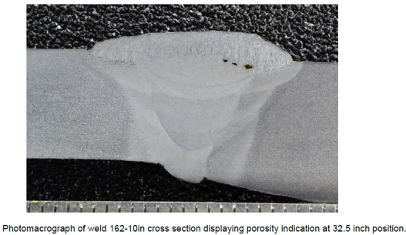
Sample 2 - 162-16in
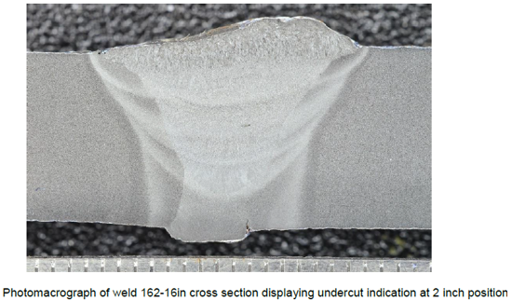
Sample - 162-16in
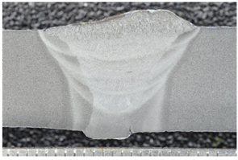 | 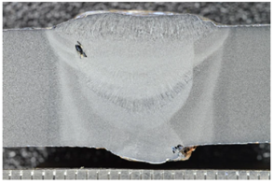
Undercut | Slag
Sample 5 -190-12in
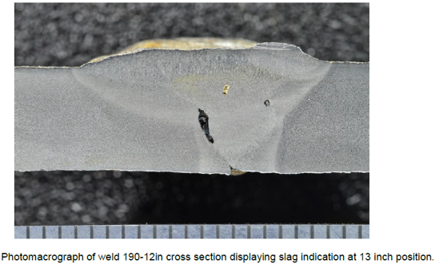

Sample 5 -190-12in
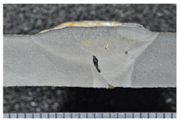 | 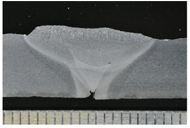 | 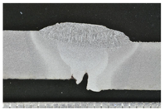
Slag | Incomplete penetration | Incomplete fusion
Sample 6 - 219 – Golden Spike
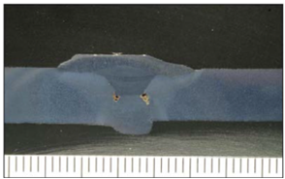 | 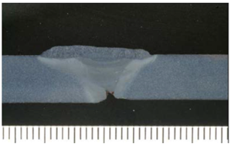
Slag | Incomplete penetration
Sample 7 - 16 x 7.9 mm to 16 x 8.7 mm Pembina Transmission
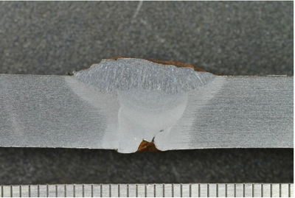
Incomplete penetration

Sample 8 - 12 x 6.4 Jumping Pound
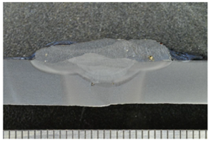 | 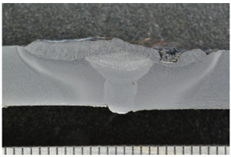
Porosity
Sample 9 - 8 x 4.8 Western Coop Fertilizer
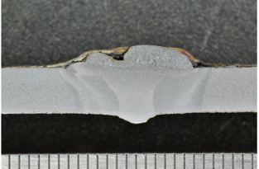
Porosity

Appendix 2 ATCO Weld Sample Test Results

A2.1 Summary of Test Results
ATCO Sample Number | Grade | Comments on parent metal composition | Comments on weld composition | Commission Date | Parent Metal CE | Weld Metal CE
1 | API 5L Grade B | High Sulphur | High Molybdenum, lower silicon | 1948 | 0.322 | 0.302
2 | X42 | High Sulphur | High Molybdenum | 1948 | 0.321 | 0.271
3 | X42 | Meets Spec. | Lower Silicon | 1979 | 0.300 | 0.247
4 | API 5L Grade B | Meets Spec. | High Chromium, Low Molybdenum | 1969 | 0.371 | 0.369
5 | Grade A | Meets Spec. | Low Chromium, Low Molybdenum | 1954 | 0.345 | 0.188
6 | API 5L Grade B | High Carbon, High Sulphur | Low Molybdenum | 1950 | 0.400 | 0.225
7 | X46 | High Carbon | Low Chromium, Low Molybdenum | 1958 | 0.395 | 0.149
8 | ASTM A106 Gr. C | High Carbon | Low Chromium, Low Molybdenum | 1950 | 0.471 | 0.224
9 | Grade B | High Carbon | Low Chromium, Low Molybdenum | 1964 | 0.364 | 0.263
Table 2 Summary of Chemical Test Results on Weld and Parent Metal
ATCO Sample Number | Average Parent HV | Average HAZ HV | Average Weld HAZ
1 | 172.33 | 171.33 | 211.33
2 | 147.33 | 200.00 | 221.00
3 | 182.67 | 181.33 | 177.33
4 | 143.00 | 153.00 | 164.00
5 | 156.67 | 174.33 | 175.33
6 | 158.33 | 176.67 | 168.33
7 | 168.33 | 181.00 | 168.67
8 | 178.33 | 208.67 | 195.67
9 | 161.00 | 153.33 | 153.33
Table 3 Hardness Test Results
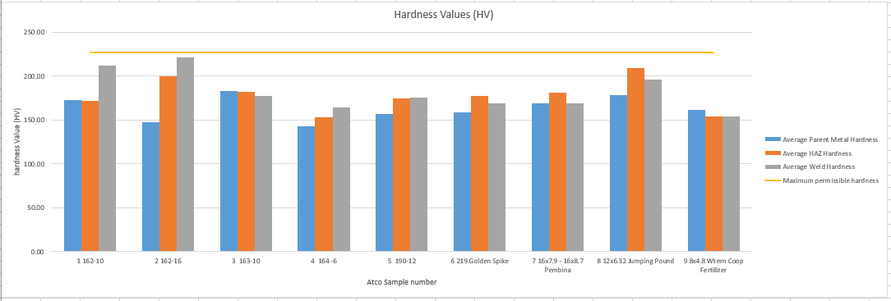
Figure 1 Charpy Test Results
ATCO Sample Number | Average Parent (J) | Average  Weld (J) | Individual Pass? | Average Pass?
1 | 3.3 | 61.0 | Y | Y
2 | 36.7 | 78.0 | Y | Y
3 | 42.0 | 23.0 | Y | Y
4 | 76.0 | 25.3 | Y | Y
5 | 71.0 | 53.0 | Y | Y
6 | 10.0
7 | 3.8 | 55.7 | Y | Y
8 | 33.3 | 26.7 | Y | Y
9 | 28.3 | 31.7 | Y | Y
Table 4 Charpy Test Results

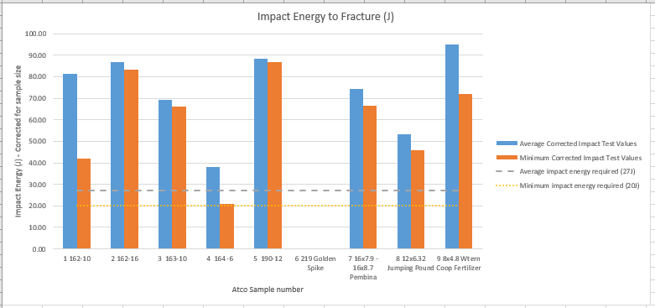
Figure 2 Comparison of % Elongation to Failure
Sample ID | % Elongation to Failure
1 | 33
2 | 38
3 | 32
4 | 39
5 | 39
6 | 25
7 | 26
8 | 29
9 | 31
Average | 32.4
Table 5 Comparison of % Elongation to Failure

ATCO Sample Number | Grade | Min Specified UTS | Observed UTS - Parent | Observed  UTS - Weld | Failure Location
1 | Grade B | 415 | 423 | 465 | Parent
2 | X42 | 415 | 466 | 477 | Parent
3 | X42 | 415 | 551 | 527 | Weld
4 | API 5L Grade B | 414 | 505 | 489 | Parent
5 | Grade A | 331 | 493 | 498 | Parent
6 | API 5L Grade B | 414 | 535
7 | X46 | 434 | 477 | 498 | Weld
8 | ASTM A106 Gr. C | 483 | 582 | 501 | Weld
9 | Grade B | 414 | 472 | 493 | Parent
Table 6 Tensile Test Results
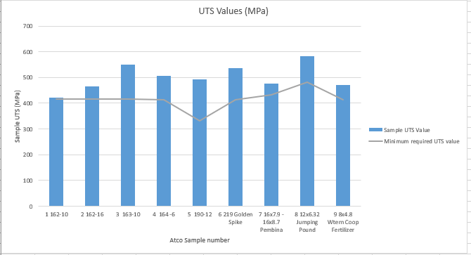
Figure 3 Tensile Test Results

A2.2 ATCO Test Results
The weld samples material test results provided by ATCO are given in the file below, which is provided as an attachment to this report.

