UKOPA Report
Swansea University Fatigue Study for the UKOPA Weld Quality Project
UKOPA/RP/005 Edition A
February 2023

REPORT ISSUED BY UKOPA:

Comments, questions and enquiries about this publication should be directed to:
UK Onshore Pipeline Operators’ Association
Pipeline Maintenance Centre
Ripley Road
Ambergate
Derbyshire
DE56 2FZ
E-mail: enquiries@ukopa.co.uk
Website: www.UKOPA.co.uk

Disclaimer
This document is protected by copyright and may not be reproduced in whole or in part, by any means without the prior approval in writing of UKOPA. The information contained in this document is provided as guidance only and while every reasonable care has been taken to ensure the accuracy of its contents, UKOPA cannot accept any responsibility for any action taken, or not taken, on the basis of this information. UKOPA shall not be liable to any person for any loss or damage which may arise from the use of any of the information contained in any of its publications. The document must be read in its entirety and is subject to any assumptions and qualifications expressed therein. UKOPA documents may contain detailed technical data which is intended for analysis only by persons possessing requisite expertise in its subject matter.
Copyright @2023, UKOPA. All rights reserved
Revision and change control history
Planned revision: N/A
Edition | Date | No. of pages | Summary of changes
A
B
C
1

Contents
Executive Summary 1
Conclusions 1
1. Introduction 2
2. Description of Experimental Studies 3
3. Fatigue Test Results 6
4. Conclusions 9
5. References 10
Appendix 1 Description of Experimental Studies 11
Appendix 2 Experimental Results 12

Executive Summary
UKOPA actioned two research projects to investigate the performance of girth welds in pipelines constructed before 1972:
- Fatigue testing of 10 small scale specimens taken from the pipeline weld samples, and comparison of the results with published S-N Curves carried out by the University of Strathclyde, and
- Comparison of the fatigue performance of old girth welds and equivalent current standard pipeline welds, and an investigation of the type and size of defect in old pipeline girth welds which may pose a threat to pipeline integrity carried out by Swansea University.
This report summarises the results of the fatigue study carried out by Swansea University.

Conclusions
The results of the Fatigue tests carried out in the University of Strathclyde and Swansea University studies show that the fatigue performance of fatigue specimens taken from pre-1972 pipe-weld samples meet current fatigue S-N design criteria.
The fatigue test results obtained from both studies are conservative, as the specimens tested were taken from pipe-weld samples from pipelines which had been in operation for more than 40 years.
The Swansea University study confirms that the fatigue performance of welds containing weld quality defects typical of the welding standards applied to the fabrication of pre-1972 pipelines is acceptable to current fatigue design criteria.

Introduction
Swansea University carried out a study to compare the fatigue performance of historical (pre-1972) girth welds with that of girth welds fabricated and inspected to current pipeline standards. The study utilised the remaining sections of the pipeline weld samples provided for the destructive material testing carried out by Metamet Consultants for UKOPA to investigate the fatigue performance of historical welds. The study used samples taken from historical girth welds from the UKOPA weld quality project, and also compared the results obtained from samples containing defects with those containing no detectable defects, in order to investigate of the type and size of defect in old pipeline girth welds which may pose a threat to pipeline integrity. The study carried out by Swansea University took account of the fatigue test data from the University of Strathclyde study.

Description of Experimental Studies
Four full scale pipe – weld specimens from the UKOPA weld quality project samples were sourced from the samples provided by UKOPA to Metamet Consultants for testing.
A description of the experimental studies is given in Appendix 1.
Details of the samples, which were selected to ensure consistency in the testing, are given in Table 1.
Specimen | B | C | D | E
Commissioned | 1970 | 1970 | 1970 | 1969
Pipe Type | ERW | ERW | ERW | ERW
Grade | X52 | X52 | X52 | X52
Diameter (mm) | 324 | 324 | 324 | 273
WT (mm) | 6.57 | 6.45 | 7.33 | 7.28
Weld type | MMA
Parent CE | 0.22 | 0.15 | 0.24 | 0.28
Weld CE | 0.16 | 0.19 | 0.18 | 0.18
Parent HV | 157.67 | 160.67 | 172.33 | 186.67
HAZ HV | 153.67 | 162.00 | 182.33 | 217.67
Weld HV | 195.33 | 169.67 | 155.00 | 199.67
Elongation | 15.0 | 0.0 | 9.5 | 9.5
Min Specified UTS (MPa) | 460
Measured UTS (MPa) | 481 | 385 | 497 | 591
SMYS (MPa) | 358 | 358 | 358 | 358
AYS (MPa) | 258 | 258 | 258 | 258
Abbreviations:
CE Carbon equivalent
HAZ Heat affected zone
HV Vickers hardness
AYS Allowable Yield stress
Table 1 Detailed of Pipe-Weld Samples used in the Swansea University Study
Three of the samples were commissioned in 1970 with 324 mm diameter and measured wall thicknesses of 6.57, 6.45, and 7.33 mm. One sample was commissioned in 1969 with 273 mm dia and measured wall thickness 7.28 mm. All samples were material grade X52.
All of the pipelines from which the samples were taken were used for gas transportation, so would not have experienced the more onerous pressure cycles typical of liquid pipelines. The samples were X-rayed to identify defects, and small scale specimens were then machined so that identified defects were located at the centre of the specimen. The defects are listed in Table 2. Based on the literature review carried out as part of the study, greater focus was given to external defects such as lack of penetration and misalignment.
External | Code |  | Internal | Code
Cold lap | Lap |  | Porosity | Por
Pack of penetration | LOP |  | Cluster porosity | Cpo
Suck Back | SB |  | Incomplete fusion | IFu
Root undercut | RU |  | Crack longitudinal | CrL
Crown undercut | CU |  | Crack Transverse | CrT
Offset | Off |  | Worm hole | Wor
Mill variation | MV |  | Inclusions | Inc
Poor cap profile | PCP
Excess cap height | ExC
Excess penetration | ExP
Burn through | BT
Spatter | Spa
Poor stop- start | PSS
Incomplete cap filler | ICF
Table 2 Defects in fatigue specimens tested in the Swansea University Study
It is noted that the defects included in the pipe weld samples were identified through inspection as being representative of the workmanship quality required by welding standards at the time of construction.
15 fatigue specimens were taken from the full scale pipe – weld samples, the defects present in each specimen were as follows:
Specimen | Defects
B1 | LOP, Off, BT, PSS, Por, Wor
B2 | LOP, Off, Spa, CrL&T, Inc, Por
C1 | LOP
C2 | LOP
C3 | LOP
D1 | CrL, Por
D2 | Cpo, RU, CU,
D3 | PCP, ExP&C, LOP, IFu, ICF, RU
D4 | CrL, IFu, Por, Wor, ExC
D5 | CU, Por
D6 | SB, RU, LOP
E1 | IFu, Spa, Por, MV, CU
E2 | Wor, Spa, Lap, MV
E3 | Exp, RU, CrT, MV
E4 | LOP, Off, ExC, CRL&T, Lap, PCP, MV, Spa, Por, Inc
Table 3 Details of Weld Quality Defects in Fatigue Specimens Tested in the
Fatigue testing was carried out using a stress range based on analysis of pipeline pressure data for liquid pipelines provided by UKOPA operators:
Maximum stress 180 MPa
Minimum stress 80 MPa
R-Ratio 0.44
Loading Sine wave, 15 Hz (equivalent to that applied in the Strathclyde fatigue tests)
The calculated circumferential pressure was used to characterise the fatigue stress cycle.

Fatigue Test Results
Fatigue results were plotted on the BS 7608 [1] E SN curve. The maximum number of cycles used to define the end of test in event of no failure was 1.2x10⁶, which ensured that run outs were above the mean E SN Curve.
Note: Two of the fatigue tests were conducted with an increased maximum stress of 250 MPa, R Ratio of 0.32, to represent multiple surge pressures. The first test was carried out using the same test methodology (sine wave loading, 15 Hz), the second test investigated increased dwell time at the maximum pressure at a lower frequency (trapezoidal wave, 1 Hz) to provide a more accurate representation of pipeline fatigue stresses.
The fatigue test results are given in Table 4.
Specimen | Loading | Stress (MPa) | Cycles | Comments
B1 | Sine, 15 Hz | 180 | 3.2E+05 | Fractured
B2 | Sine, 15 Hz | 180 | 2.4E+05 | Fractured
C1 | Sine, 15 Hz | 180 | 3.8E+06 | Run out
C2 | Sine, 15 Hz | 250 | 1.2E+06 | Run out
C3 | Trap, 1 Hz | 180 | 1.9E+05 | Stopped*
D1 | Sine, 15 Hz | 180 | 1.4E+06 | Run out
D2 | Sine, 15 Hz | 180 | 2.0E+06 | Run out
D3 | Sine, 15 Hz | 180 | 1.6E+06 | Run out
D4 | Sine, 15 Hz | 180 | 1.2E+06 | Run out
D5 | Sine, 15 Hz | 180 | 1.2E+06 | Run out
D6 | Sine, 15 Hz | 180 | 1.2E+06 | Run out
E1 | Sine, 15 Hz | 180 | 7.5E+05 | Stopped*
E2 | Sine, 15 Hz | 180 | 1.2E+06 | Run out
E3 | Sine, 15 Hz | 180 | 7.7E+05 | Stopped*
E4 | Sine, 15 Hz | 180 | 1.0E+06 | Fractured
Notes: C3, E1 & E3 – stopped due to test rig issues
Table 4 Fatigue Results obtained in Swansea University Study
The fatigue test results are plotted in Figure 1.
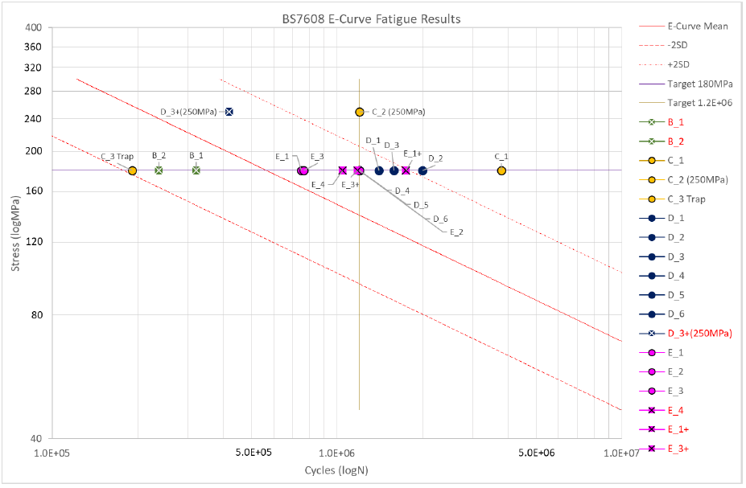
Figure 1 Swansea University Study – Fatigue Test Results Plotted on the E S-N Curve
Full details of the study are given in [2] including microscopy of the specimen fracture surfaces and scanning electron microscope images and CT scan of the defects.
Reference 2 includes a matrix which compares the defects in the fatigue specimens with the fatigue results, shown in Figure 2.
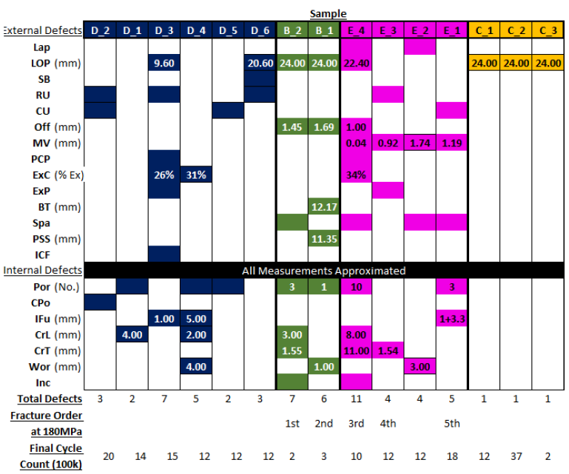
Figure 2 Swansea University Study – Fatigue Specimen Defect Matrix
This assessment shows that the two major defects which were present in all the three fractured specimens were misalignment and lack of penetration. It is noted [2] that similar misalignment and lack of penetration defects were present in specimens which did not fail.
The results of the Swansea University study confirm that the fatigue performance of specimens taken from historical girth welds which includes defects typical of weld quality at the time of construction meet current fatigue design SN curves [1]. All test results survived the E SN curve design line (mean – 2SD). The two specimens which fractured below the mean E curve (B1 and B2) both included misalignment and lack of penetration defects.
Full details of the literature review, experimental studies, and results including examination of defects, microscopy and scanning electron microscope (SEM) and computerised tomography (CT) scan results and the results of a finite element analysis (FEA) study to simulate the stress cycle experienced in a misaligned pipe are given in Appendix 2.

Conclusions
The results of the Fatigue tests carried out in the University of Strathclyde and Swansea University studies show that the fatigue performance of fatigue specimens taken from pre-1972 pipe-weld samples meet current fatigue S-N design criteria.
The fatigue performance of specimens taken from historical girth welds which includes defects typical of weld quality at the time of construction meet current fatigue design SN curves [1]. All test results survived the E SN curve design line (mean – 2SD).
The two specimens which fractured below the mean E curve (B1 and B2) both included misalignment and lack of penetration defects.
The fatigue test results are conservative, as the specimens tested were taken from pipelines which had been in operation for more than 40 years.

References

[1] | “BS 7608 Guide to fatigue design and assessment of steel products,” British Standards Institution, 2014.
[2] | J. York-Fisher, Fatigue Assessment of Historic Weld Defects in Pipelines, Swansea: Swansea Univeristy, M2A, Valero, UKOPA, EPSRC, ESF, 2018.

Appendix 1 Description of Experimental Studies
The description of the fatigue testing carried out by Swansea University is given in the file below, which is provided as an attachment to this report. This presentation was given by MSc Student Joe York-Fisher to UKOPA.

Appendix 2 Experimental Results
The research work was carried out as an MSc study by Swansea University student Joe York-Fisher. The MSc Thesis prepared by Joe York Fisher is given in the file below, which is provided as an attachment to this report.

